PRACTICAL NO 1

**Aim : Setup DirectX 11, Window Framework and Initialize Direct3D Device**

**#Steps :**

>Uninstall

Microsoft vs C++ 2010x86 Redistributable

Microsoft vs C++ 2010x64 Redistributable

Then install DXSDK

**Open visual studio→new project→set. netframework 2.0→windows→windows form application**

Step for adding directx dll file:

Project(project name)->References->Right click->add References->Browse->C drive->window->Microsoft.net->Directx for managed code->1.0.2902.0->select this 3 file

Microsoft.DirectX.Direct3Dx.dll;

Microsoft.DirectX.Direct3D.dll

Microsoft.DirectX.dll;

For paint_event

Properties->click paint

To run initDevice

Project(project name->Build->Paltform target any cpu to X86->Debug->window->Exception setting->Managed Debugging->unlock Loader Lock)

**#Initialize Direct3D Device :**

**Code :**

using Microsoft.DirectX.Direct3D;

using System;

using System.Collections.Generic;

using System.ComponentModel;

using System.Data;

using System.Drawing;

using System.Text;

using System.Windows.Forms;

namespace GpPractical1

{

public partial class Form1 : Form

{

Microsoft.DirectX.Direct3D.Device device;

public Form1()

{

InitializeComponent();

InitDevice();

}

private void InitDevice()

{

PresentParameters pp = new PresentParameters();

pp.Windowed = true;

pp.SwapEffect = SwapEffect.Discard;

device = new Device(0, DeviceType.Hardware, this, CreateFlags.HardwareVertexProcessing, pp);

}

public void Render()

{

device.Clear(ClearFlags.Target, Color.PaleGreen, 0, 1);

device.Present();

}

private void Form1_Paint(object sender, PaintEventArgs e)

{

Render();

}

}

}

**OUTPUT:**

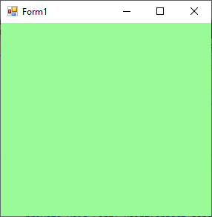

PRACTICAL NO 2

**Aim : Buffers, Shaders and HLSL (Draw a triangle using Direct3D 11)**

**A)Triangle :**

**Code :**

using Microsoft.DirectX;

using Microsoft.DirectX.Direct3D;

using System;

using System.Collections.Generic;

using System.ComponentModel;

using System.Data;

using System.Drawing;

using System.Text;

using System.Windows.Forms;

namespace GpPrcatical2

{

public partial class Form1 : Form

{

Microsoft.DirectX.Direct3D.Device device;

public Form1()

{

InitializeComponent();

InitDevice();

}

public void InitDevice()

{

PresentParameters pp = new PresentParameters();

pp.Windowed = true;

pp.SwapEffect = SwapEffect.Discard;

device = new Device(0, DeviceType.Hardware, this, CreateFlags.HardwareVertexProcessing, pp);

}

public void Render()

{

CustomVertex.TransformedColored[] vertexes = new CustomVertex.TransformedColored[3];

vertexes[0].Position = new Vector4(240, 110, 0, 1.0f);

vertexes[0].Color = System.Drawing.Color.FromArgb(0, 255, 0).ToArgb();

vertexes[1].Position = new Vector4(600, 420, 0, 1.0f);

vertexes[1].Color = System.Drawing.Color.FromArgb(0, 0, 255).ToArgb();

vertexes[2].Position = new Vector4(240, 420, 0, 1.0f);

vertexes[2].Color = System.Drawing.Color.FromArgb(255, 0, 0).ToArgb();

device.Clear(ClearFlags.Target, Color.PaleGreen, 0, 1);

device.BeginScene();

device.VertexFormat = CustomVertex.TransformedColored.Format;

device.DrawUserPrimitives(PrimitiveType.TriangleList, 1, vertexes);

device.EndScene();

device.Present();

}

private void Form1_Paint(object sender, PaintEventArgs e)

{

Render();

}

}

}

**OUTPUT :**

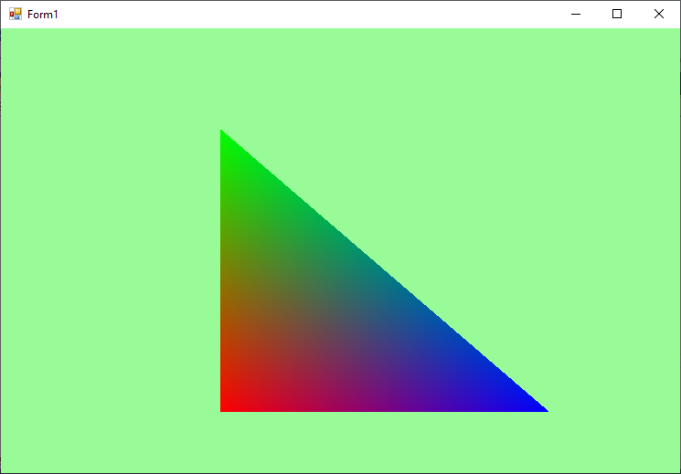

**B)Rectangle :**

**Code :**

using Microsoft.DirectX;

using Microsoft.DirectX.Direct3D;

using System;

using System.Collections.Generic;

using System.ComponentModel;

using System.Data;

using System.Drawing;

using System.Text;

using System.Windows.Forms;

namespace GpPrcatical2

{

public partial class Form1 : Form

{

Microsoft.DirectX.Direct3D.Device device;

public Form1()

{

InitializeComponent();

InitDevice();

}

public void InitDevice()

{

PresentParameters pp = new PresentParameters();

pp.Windowed = true;

pp.SwapEffect = SwapEffect.Discard;

device = new Device(0, DeviceType.Hardware, this, CreateFlags.HardwareVertexProcessing, pp);

}

public void Render()

{

CustomVertex.TransformedColored[] vertexes = new CustomVertex.TransformedColored[3];

CustomVertex.TransformedColored[] vertexes1 = new CustomVertex.TransformedColored[3];

vertexes[0].Position = new Vector4(50, 110, 0, 1.0f);

vertexes[0].Color = System.Drawing.Color.FromArgb(0, 0, 255).ToArgb();

vertexes[1].Position = new Vector4(500, 420, 0, 1.0f);

vertexes[1].Color = System.Drawing.Color.FromArgb(0, 0, 255).ToArgb();

vertexes[2].Position = new Vector4(50, 420, 0, 1.0f);

vertexes[2].Color = System.Drawing.Color.FromArgb(0, 0, 255).ToArgb();

vertexes1[0].Position = new Vector4(500, 420, 0, 1.0f);

vertexes1[0].Color = System.Drawing.Color.FromArgb(255, 0, 0).ToArgb();

vertexes1[1].Position = new Vector4(50, 110, 0, 1.0f);

vertexes1[1].Color = System.Drawing.Color.FromArgb(255, 0, 0).ToArgb();

vertexes1[2].Position = new Vector4(500, 110, 0, 1.0f);

vertexes1[2].Color = System.Drawing.Color.FromArgb(255, 0, 0).ToArgb();

device.Clear(ClearFlags.Target, Color.SteePaleGreen, 0, 1);

device.BeginScene();

device.VertexFormat = CustomVertex.TransformedColored.Format;

device.DrawUserPrimitives(PrimitiveType.TriangleList, 1, vertexes);

device.DrawUserPrimitives(PrimitiveType.TriangleList, 1, vertexes1);

device.EndScene();

device.Present();

}

private void Form1_Paint(object sender, PaintEventArgs e)

{

Render();

}

}}

**OUTPUT :**

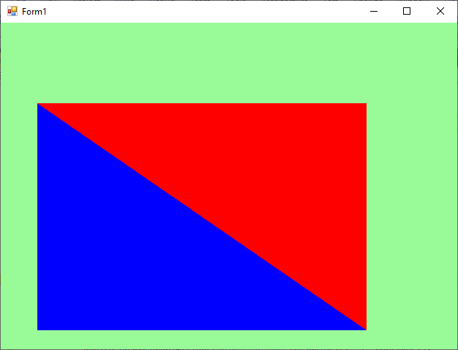

PRACTICAL NO 3

**Aim : Texturing (Texture the Triangle using Direct 3D 11).**

**A)Triangle :**

**Code:**

using Microsoft.DirectX;

using Microsoft.DirectX.Direct3D;

using System;

using System.Collections.Generic;

using System.ComponentModel;

using System.Data;

using System.Drawing;

using System.Windows.Forms;

namespace WindowsFormsApplication2

{

public partial class Form1 : Form

{

private Microsoft.DirectX.Direct3D.Device device;

private CustomVertex.PositionTextured[] vertex = new CustomVertex.PositionTextured[3];

private Texture texture;

public Form1()

{

InitializeComponent();

}

private void Form1_Load(object sender, EventArgs e)

{

PresentParameters pp = new PresentParameters();

pp.Windowed = true;

pp.SwapEffect = SwapEffect.Discard;

device = new Device(0, DeviceType.Hardware, this, CreateFlags.HardwareVertexProcessing, pp);

device.Transform.Projection = Matrix.PerspectiveFovLH(3.14f / 4, device.Viewport.Width / device.Viewport.Height, 1f, 10000f);

device.Transform.View = Matrix.LookAtLH(new Vector3(0, 0, 20), new Vector3(), new Vector3(0, 1, 0));

device.RenderState.Lighting = false;

vertex[0] = new CustomVertex.PositionTextured(new Vector3(0, 0, 0), 1, 1);

vertex[1] = new CustomVertex.PositionTextured(new Vector3(5, 0, 0), 0, 1);

vertex[2] = new CustomVertex.PositionTextured(new Vector3(0, 5, 0), 1, 0);

texture = new Texture(device, new Bitmap("C:/Users/PC12/Documents/Visual Studio 2015/Projects/WindowsFormsApplication2/WindowsFormsApplication2/A/pramod.png"), 0, Pool.Managed);

}

private void Form1_Paint(object sender, PaintEventArgs e)

{

device.Clear(ClearFlags.Target, Color.DarkGreen, 1.0f, 0);

device.BeginScene();

device.SetTexture(0, texture);

device.VertexFormat = CustomVertex.PositionTextured.Format;

device.DrawUserPrimitives(PrimitiveType.TriangleList, 1, vertex);

device.EndScene();

device.Present();

}

}

}

**OUTPUT :**

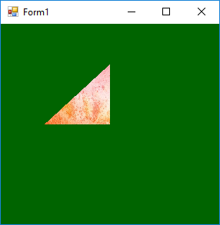

**B)Rectangle :**

**Code :**

using Microsoft.DirectX;

using Microsoft.DirectX.Direct3D;

using System;

using System.Collections.Generic;

using System.ComponentModel;

using System.Data;

using System.Drawing;

using System.Text;

using System.Windows.Forms;

namespace GpPractical3

{

public partial class Form1 : Form

{

Microsoft.DirectX.Direct3D.Device device;

private CustomVertex.PositionTextured[] vertex = new CustomVertex.PositionTextured[3];

private CustomVertex.PositionTextured[] vertex1 = new CustomVertex.PositionTextured[3];

private Texture texture;

public Form1()

{

InitializeComponent();

}

private void Form1_Load(object sender, EventArgs e)

{

PresentParameters pp = new PresentParameters();

pp.Windowed = true;

pp.SwapEffect = SwapEffect.Discard;

device = new Device(0, DeviceType.Hardware, this, CreateFlags.HardwareVertexProcessing, pp);

device.Transform.Projection = Matrix.PerspectiveFovLH(3.14f / 4, device.Viewport.Width / device.Viewport.Height, 1f, 10000f);

device.Transform.View = Matrix.LookAtLH(new Vector3(0, 0, 20), new Vector3(0, 0, 10), new Vector3(0, 1, 0));

device.RenderState.Lighting = false;

vertex[0] = new CustomVertex.PositionTextured(new Vector3(0, 0, 0), 1, 1);

vertex[1] = new CustomVertex.PositionTextured(new Vector3(5, 0, 0), 0, 10);

vertex[2] = new CustomVertex.PositionTextured(new Vector3(0, 5, 0), 3, 0);

vertex1[0] = new CustomVertex.PositionTextured(new Vector3(5, 5, 0), 0, 0);

vertex1[1] = new CustomVertex.PositionTextured(new Vector3(0, 5, 0), 1, 0);

vertex1[2] = new CustomVertex.PositionTextured(new Vector3(5, 0, 0), 0, 1);

texture = new Texture(device, new Bitmap("c:\\users\\tycs\\documents\\visual studio 2015\\Projects\\GpPractical3\\GpPractical3\\image.jpg "), 0, Pool.Managed);

}

private void Form1_Paint(object sender, PaintEventArgs e)

{

device.Clear(ClearFlags.Target, Color.PaleGreen, 0, 1);

device.BeginScene();

device.SetTexture(0, texture);

device.VertexFormat = CustomVertex.PositionTextured.Format;

device.DrawUserPrimitives(PrimitiveType.TriangleList, 1, vertex);

device.DrawUserPrimitives(PrimitiveType.TriangleList, 1, vertex1);

device.EndScene();

device.Present();

}

}

}

**OUTPUT :**

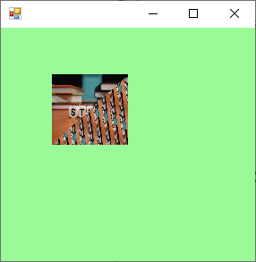

PRACTICAL NO 4

**Aim : Lightning (Programmable Diffuse Lightning using Direct3D 11)**

**Code :**

using Microsoft.DirectX;

using Microsoft.DirectX.Direct3D;

using System;

using System.Collections.Generic;

using System.ComponentModel;

using System.Data;

using System.Drawing;

using System.Text;

using System.Windows.Forms;

namespace GpPractical4

{

public partial class Form1 : Form

{

Device device;

private CustomVertex.PositionNormalColored[] vertex = new CustomVertex.PositionNormalColored[3];

private Texture texture;

public Form1()

{

InitializeComponent();

}

private void Form1_Load(object sender, EventArgs e)

{

PresentParameters pp = new PresentParameters();

pp.Windowed = true;

pp.SwapEffect = SwapEffect.Discard;

device = new Device(0, DeviceType.Hardware, this, CreateFlags.HardwareVertexProcessing, pp);

device.Transform.Projection = Matrix.PerspectiveFovLH(3.14f / 4, device.Viewport.Width / device.Viewport.Height, 1f, 10000f);

device.Transform.View = Matrix.LookAtLH(new Vector3(0, 0, 10), new Vector3(), new Vector3(0, 1, 0));

device.RenderState.Lighting = false;

vertex[0] = new CustomVertex.PositionNormalColored(new Vector3(0, 1, 1), new Vector3(1, 0, 1), Color.White.ToArgb());

vertex[1] = new CustomVertex.PositionNormalColored(new Vector3(-1, -1, 1), new Vector3(-1, 0, 1), Color.White.ToArgb());

vertex[2] = new CustomVertex.PositionNormalColored(new Vector3(1, -1, 1), new Vector3(-1, 0, 1), Color.White.ToArgb());

device.RenderState.Lighting = true;

device.Lights[0].Type = LightType.Directional;

device.Lights[0].Diffuse = Color.PaleGreen;

device.Lights[0].Direction = new Vector3(-0.8f, 0, -1);

device.Lights[0].Enabled = true;

}

private void Form1_Paint(object sender, PaintEventArgs e)

{

device.Clear(ClearFlags.Target, Color.PaleGreen, 1, 0);

device.BeginScene();

device.VertexFormat = CustomVertex.PositionNormalColored.Format;

device.DrawUserPrimitives(PrimitiveType.TriangleList, vertex.Length / 3, vertex);

device.EndScene();

device.Present();

}

}

}

**OUTPUT:**

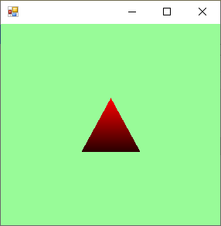

PRACTICAL NO 5

**Aim : Specular Lighting (Programmable Spot Lighting using Direct3D 11)**

**Code:**

using Microsoft.DirectX;

using Microsoft.DirectX.Direct3D;

using System;

using System.Collections.Generic;

using System.ComponentModel;

using System.Data;

using System.Drawing;

using System.Text;

using System.Windows.Forms;

namespace GpPractical5

{

public partial class Form1 : Form

{

private Device device;

public Form1()

{

InitializeComponent(); ;

InitializeDevice();

}

public void InitializeDevice()

{

PresentParameters presentParams = new PresentParameters();

presentParams.Windowed = true;

presentParams.SwapEffect = SwapEffect.Discard;

device = new Device(0, DeviceType.Hardware, this, CreateFlags.SoftwareVertexProcessing, presentParams);

device.RenderState.CullMode = Cull.None;

device.RenderState.Lighting = true;

device.Lights[0].Type = LightType.Spot;

device.Lights[0].Range = 4;

device.Lights[0].Position = new Vector3(0, -1, 0f);

device.Lights[0].Enabled = true;

}

private void Form1_Paint(object sender, PaintEventArgs e)

{

device.Transform.Projection = Matrix.PerspectiveFovLH((float)Math.PI / 4, this.Width / this.Height, 1f, 50f);

device.Transform.View = Matrix.LookAtLH(new Vector3(0, 0, 30), new Vector3(1, 0, 0), new Vector3(0, 5, 0));

CustomVertex.PositionNormalColored[] vertices = new CustomVertex.PositionNormalColored[6];

vertices[0].Position = new Vector3(10f, 12f, 0f);

vertices[0].Normal = new Vector3(0, 2, 0.5f);

vertices[0].Color = Color.Yellow.ToArgb();

vertices[1].Position = new Vector3(-5f, 5f, 0f);

vertices[1].Normal = new Vector3(0, 2, 0.5f);

vertices[1].Color = Color.Blue.ToArgb();

vertices[2].Position = new Vector3(5f, 5f, -1f);

vertices[2].Normal = new Vector3(0, 0, 0.5f);

vertices[2].Color = Color.Pink.ToArgb();

vertices[3].Position = new Vector3(5f, -5f, -1f);

vertices[3].Normal = new Vector3(0, 0, 0.5f);

vertices[3].Color = Color.Green.ToArgb();

vertices[4].Position = new Vector3(10f, 12f, 0f);

vertices[4].Normal = new Vector3(0, 0, 0.5f);

vertices[4].Color = Color.Green.ToArgb();

device.Clear(ClearFlags.Target, Color.PaleGreen, 1.0f, 0);

device.BeginScene();

device.VertexFormat = CustomVertex.PositionNormalColored.Format;

device.Transform.World = Matrix.Translation(-5, -10 * 1 / 3, 0) * Matrix.RotationAxis(new Vector3(), 0);

Console.WriteLine(device.Transform.World.ToString());

device.DrawUserPrimitives(PrimitiveType.TriangleStrip, 3, vertices);

device.EndScene();

device.Present();

this.Invalidate();

}

}

}

**OUTPUT:**

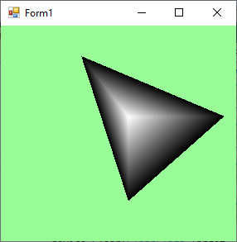

PRACTICAL NO 6-A

**Aim : Loading models into DirectX 11 and rendering.**

**CODE:**

using Microsoft.DirectX.Direct3D;

using System;

using System.Collections.Generic;

using System.ComponentModel;

using System.Data;

using System.Drawing;

using System.Text;

using System.Windows.Forms;

namespace gp23pract6

{

public partial class Form1 : Form

{

Microsoft.DirectX.Direct3D.Device device;

Texture texture;

Microsoft.DirectX.Direct3D.Font font;

public Form1()

{

InitializeComponent();

InitDevice();

InitFont();

LoadTexture();

}

private void InitDevice()

{

PresentParameters pp = new PresentParameters();

pp.Windowed = true;

pp.SwapEffect = SwapEffect.Discard;

device = new Device(0, DeviceType.Hardware, this, CreateFlags.HardwareVertexProcessing, pp);

}

private void LoadTexture()

{

texture = TextureLoader.FromFile(device, "E:\\tiger.jpg");

}

private void InitFont()

{

System.Drawing.Font f = new System.Drawing.Font("Arial", 40f, FontStyle.Underline);

font = new Microsoft.DirectX.Direct3D.Font(device, f);

}

private void Render()

{

device.Clear(ClearFlags.Target, Color.Black, 0,1);

device.BeginScene();

using (Sprite s = new Sprite(device))

{

s.Begin(SpriteFlags.AlphaBlend);

s.Draw2D(texture, new Rectangle(0, 0, 0, 0), new Rectangle(0, 0, device.Viewport.Width,device.Viewport.Height),new Point(0, 0),0f, new Point(0,0), Color.Aqua);

font.DrawText(s, "Enter Text", new Point(10, 150),Color.Red);

s.End();

}

device.EndScene();

device.Present();

}

private void Form1_Paint(object sender, PaintEventArgs e)

{

Render();

}

}

}

**OUTPUT :**

PRACTICAL NO 6-B

**Code :**

using System;

using System.Collections.Generic;

using System.ComponentModel;

using System.Data;

using System.Drawing;

using System.Text;

using System.Windows.Forms;

using System.IO;

using Microsoft.DirectX.Direct3D;

using Microsoft.DirectX;

namespace Model3D

{

public partial class Form1 : Form

{

private Device device;

private PresentParameters pres;

private Mesh mesh;

private Material[] materials;

private Texture[] textures;

public Form1()

{

InitializeComponent();

}

public bool InitializeGraphics()

{

pres = new PresentParameters();

pres.Windowed = true;

pres.SwapEffect = SwapEffect.Discard;

pres.EnableAutoDepthStencil = true;

pres.AutoDepthStencilFormat = DepthFormat.D16;

device = new Device(0, DeviceType.Hardware, this, CreateFlags.SoftwareVertexProcessing,

pres);

device.RenderState.CullMode = Cull.None;

CreateMesh(@"airplane 2.x");

return true;

}

public void CreateMesh(string path)

{

ExtendedMaterial[] exMaterials;

mesh = Mesh.FromFile(path, MeshFlags.SystemMemory, device, out exMaterials);

if (textures != null)

{

DisposeTextures();

}

textures = new Texture[exMaterials.Length];

materials = new Material[exMaterials.Length];

for (int i = 0; i < exMaterials.Length; ++i)

{

if (exMaterials[i].TextureFilename != null)

{

string texturePath = Path.Combine(Path.GetDirectoryName(path), exMaterials[i].TextureFilename);

textures[i] = TextureLoader.FromFile(device, texturePath);

}

materials[i] = exMaterials[i].Material3D;

materials[i].Ambient = materials[i].Diffuse;

}

}

public void DisposeTextures()

{

if (textures == null)

{

return;

}

foreach (Texture t in textures)

{

if (t != null)

{

t.Dispose();

}

}

}

public void SetupMatrices()

{

float yaw = Environment.TickCount / 500.0F;

float pitch = Environment.TickCount / 500.0F;

device.Transform.World = Matrix.RotationYawPitchRoll(yaw, pitch, 0);

device.Transform.View = Matrix.LookAtLH(new Vector3(0, 0, -8), new Vector3(0, 0, 0), new Vector3(0, 1, 0));

device.Transform.Projection = Matrix.PerspectiveFovLH((float)Math.PI / 2.0F, 1.0F, 1.0F, 10.0F);

}

public void SetupLights()

{

device.RenderState.Lighting = true;

device.Lights[0].Diffuse = Color.White;

device.Lights[0].Specular = Color.White;

device.Lights[0].Type = LightType.Directional;

device.Lights[0].Direction = new Vector3(-1, -1, 3);

device.Lights[0].Enabled = true;

device.RenderState.Ambient = Color.FromArgb(0x00, 0x00, 0x00);

}

public void RenderMesh()

{

for (int i = 0; i<materials.Length; ++i)

{

if (textures[i] != null)

{

device.SetTexture(0, textures[i]);

}

device.Material = materials[i];

mesh.DrawSubset(i);

}

}

public void Render()

{

device.Clear(ClearFlags.Target | ClearFlags.ZBuffer, Color.Orchid, 1.0F, 0);

device.BeginScene();

SetupMatrices();

SetupLights();

RenderMesh();

device.EndScene();

device.Present();

}

public void DisposeGraphics()

{

DisposeTextures();

device.Dispose();

}

}

}

**OUTPUT:**

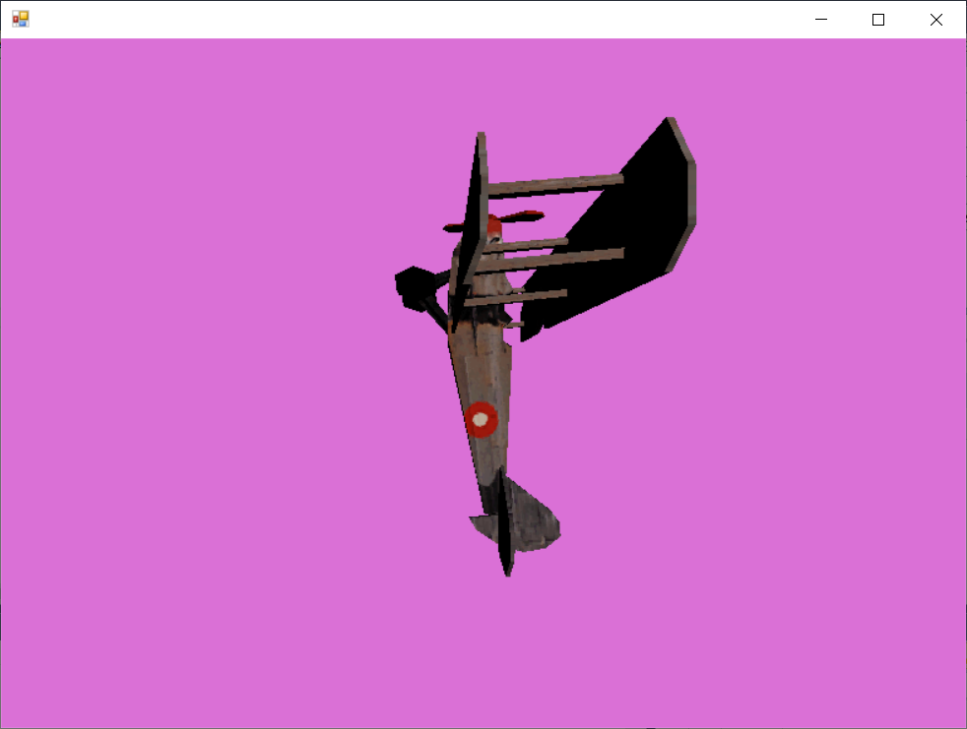

# **Practical No 7**

**AIM:** [**https://unity**](https://unity)**3d.com/learn/tutorials/s/2d-ufo-tutorial**

Open Unity and create new project.

Give project name, set location and select 2D in template. Then click on Create project.

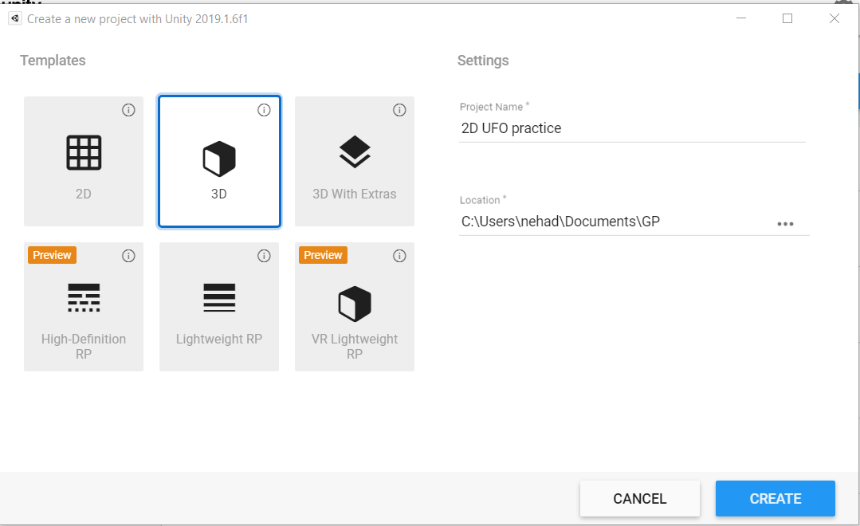

Now, download and import asset from asset store. To do this press ctrl+9 or choose window then click on asset store.

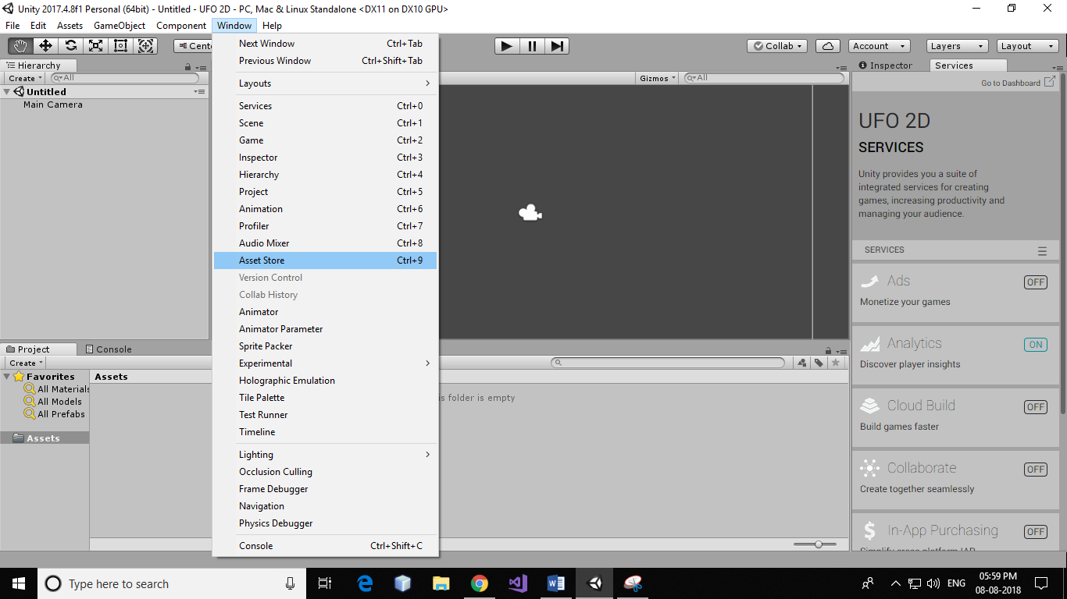

Search for UFO 2D and click on it.

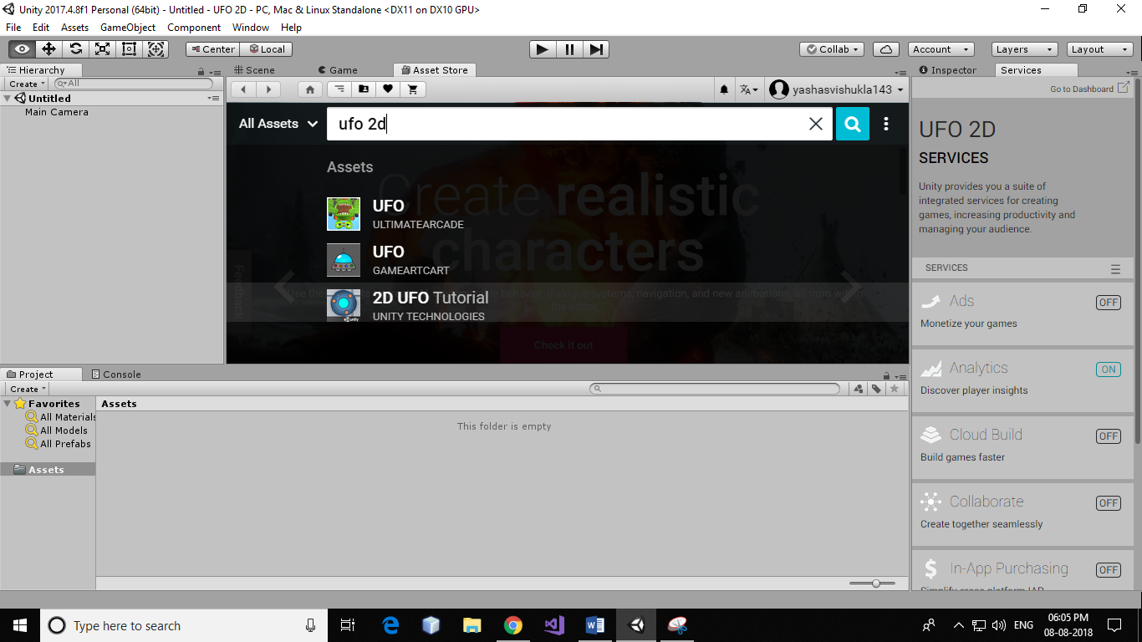

Click on “download” button. Once the download is completed, download button is replaced by “import” button. Click the button a confirmation dialogue will appear, click on “import” again. Next you will be given a choice which assets you would like to import in your project, go ahead with default and hit “import”.

Before doing anything save your scene in Asset->_Completed-Assets->Scene folder.

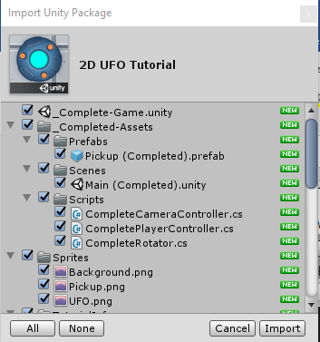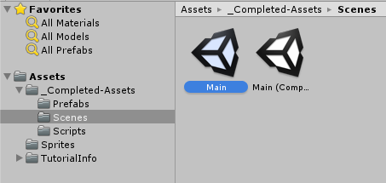

Now navigate to Sprites folder and add your first sprite “Background”. You can add this by simply dragging and dropping “Background” from Sprites folder to Hierarchy.

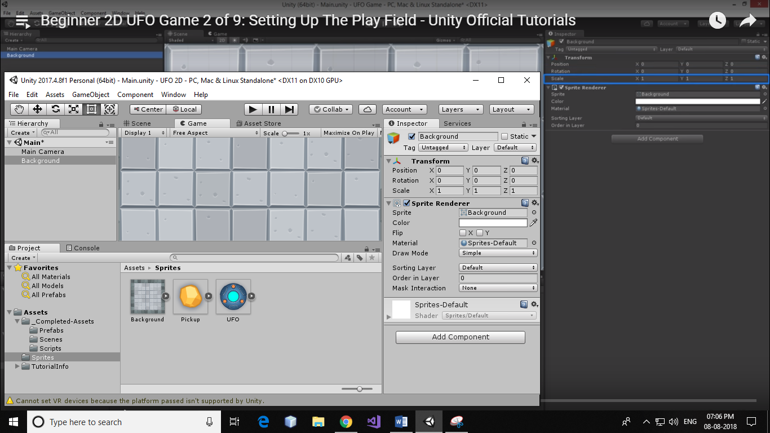

Go to scene then click on background sprite and hit F on keyboard for complete view of background.

Select Gizmos menu (on Scene tab) and uncheck “show grid”.

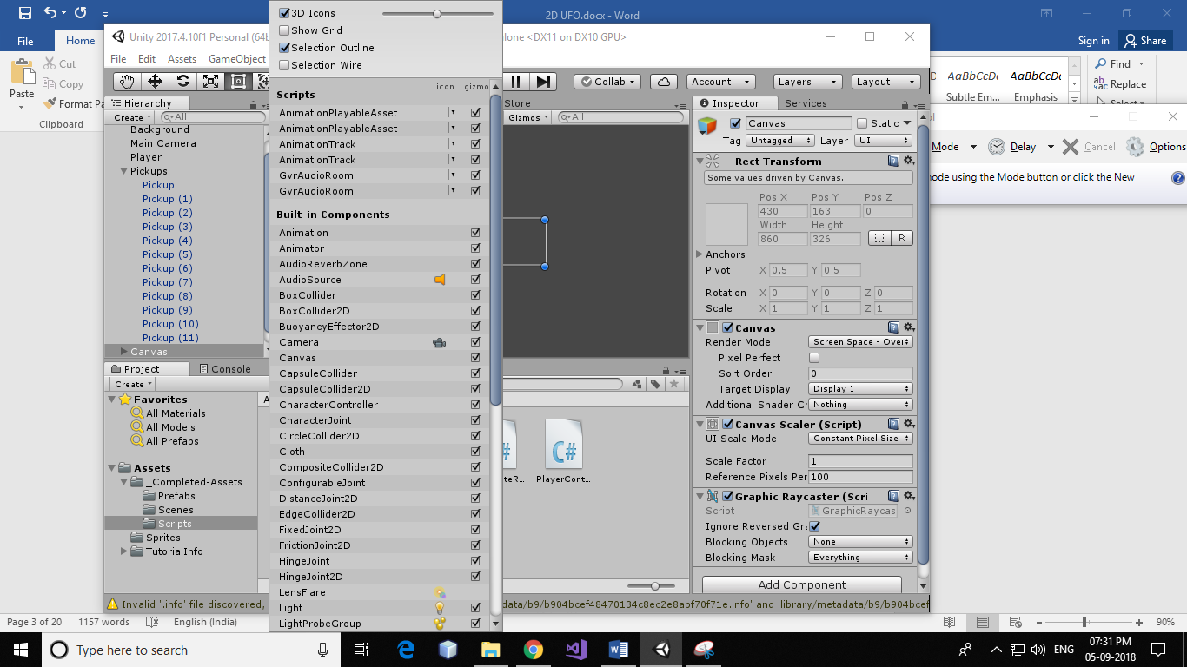

Create your player object by dropping UFO sprite in the Hierarchy.

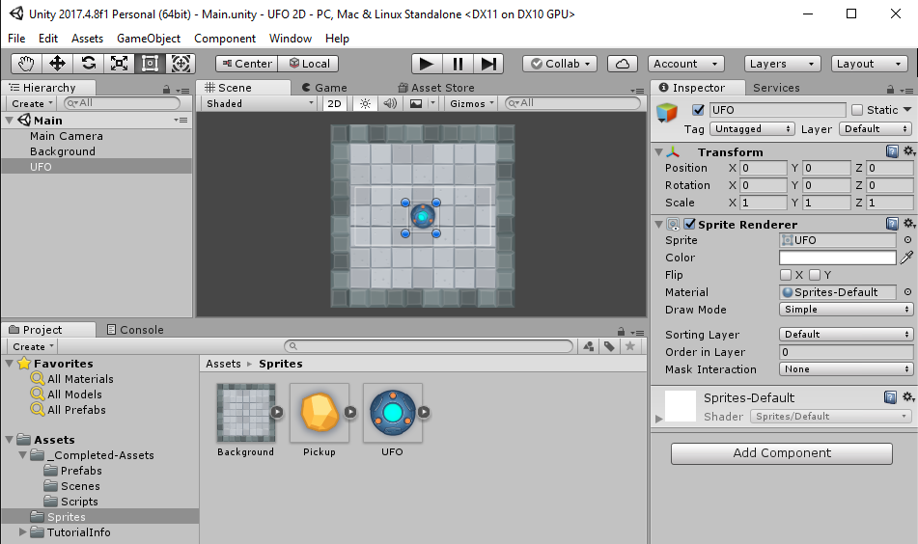

Rename the newly created object by selecting the object. With the object highlighted go to inspector, click on the text box and enter the name.

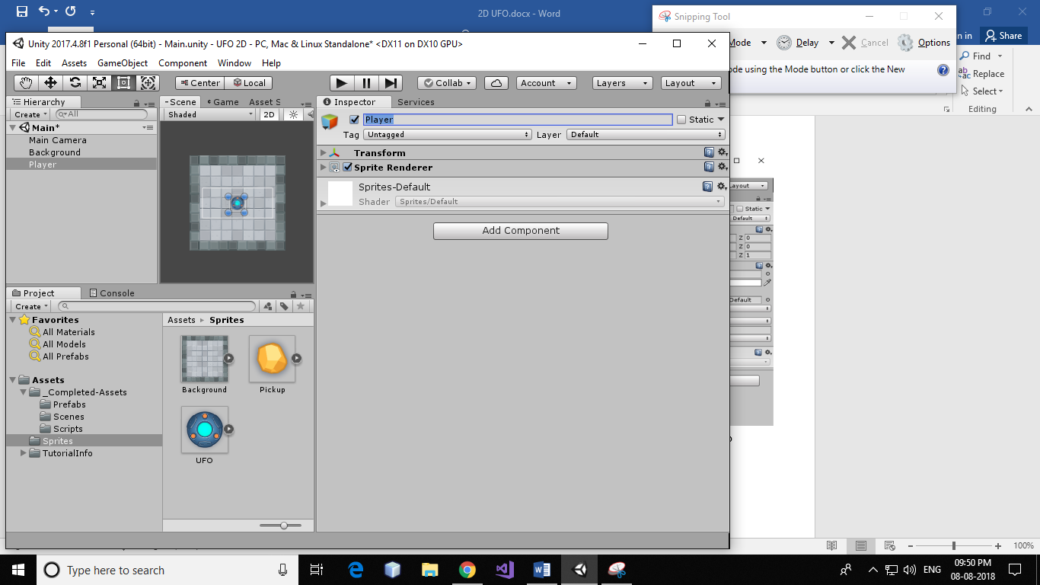

Set sorting layer (in Sprite Renderer) of Background sprite to background and Player (UFO) sprite to player

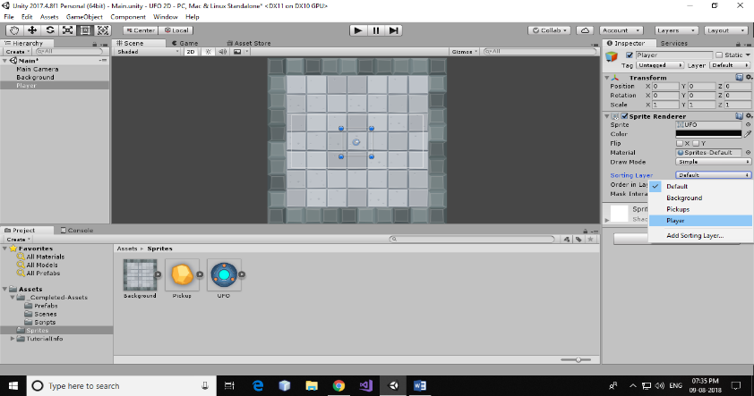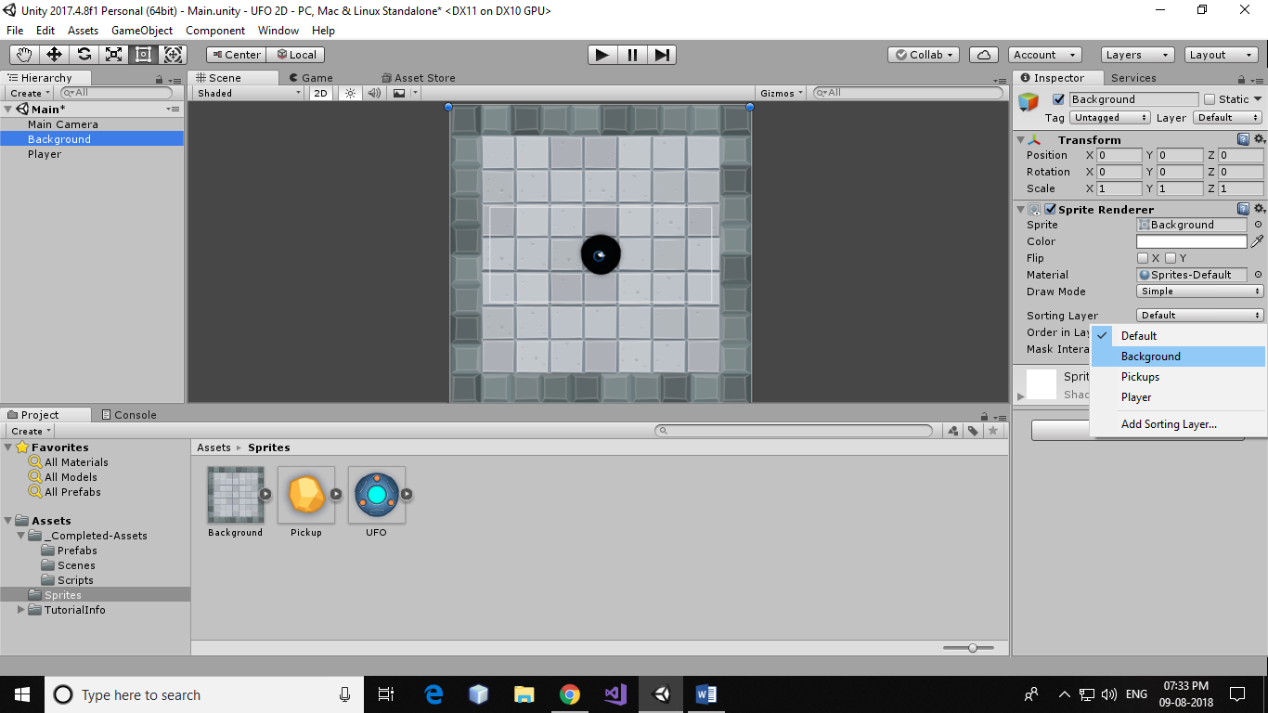

Now set the scale of player.

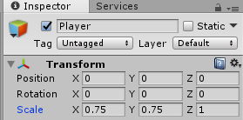

Adjust the view of the main camera so that full background will visible in the game view. You can do this by changing size in Camera component of Main Camera.

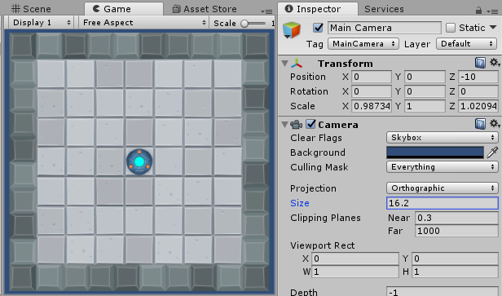

You will see, player lies on board and board lies on blue background. You can change background colour by changing background property of camera component of Main Camera.

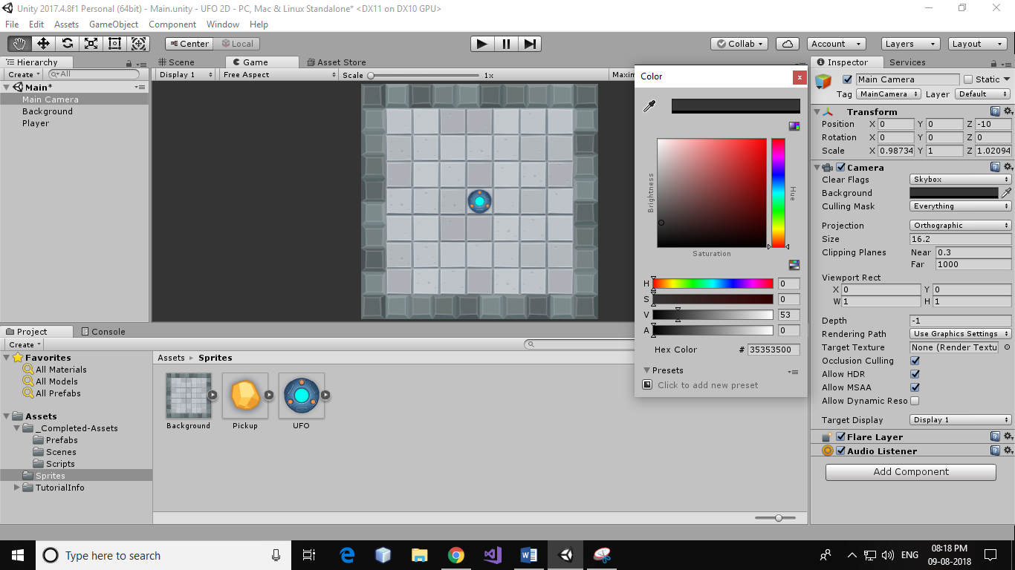

Select Player sprite and click on Add Component button in Inspector search for Rigidbody 2D (or go to Physics 2D-> Rigidbody 2D) and hit enter.

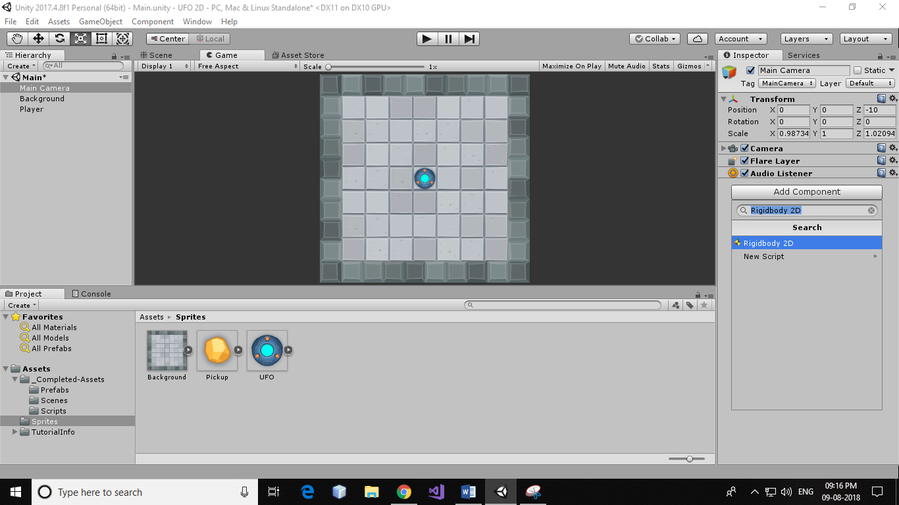

Create a new C# script to move player (take input from keyboard) on the board. Select Player sprite from the hierarchy and then click on Add Component in Inspector. Select New Script and hit enter.

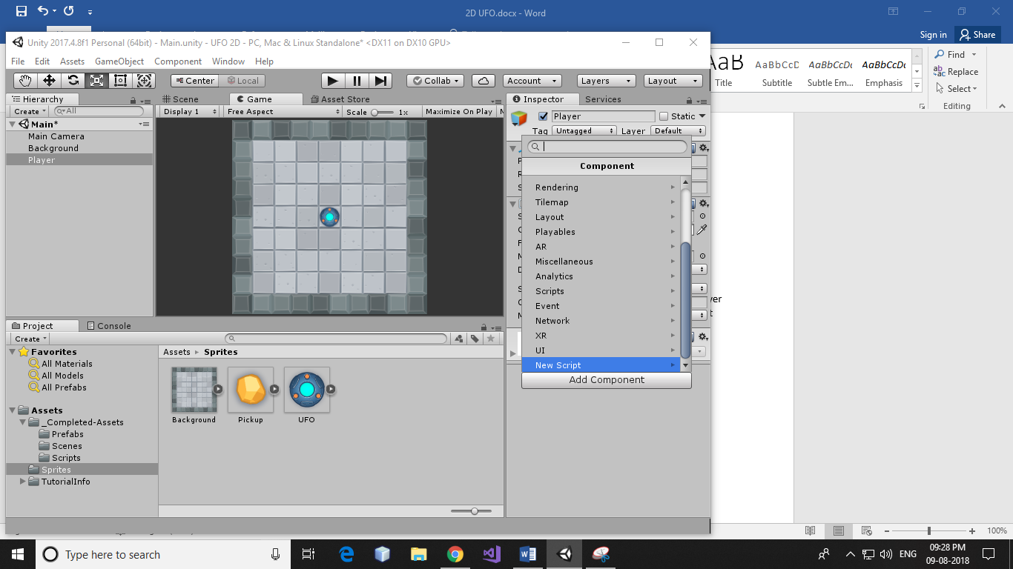

Rename the newly created script. And click on Create and Add button

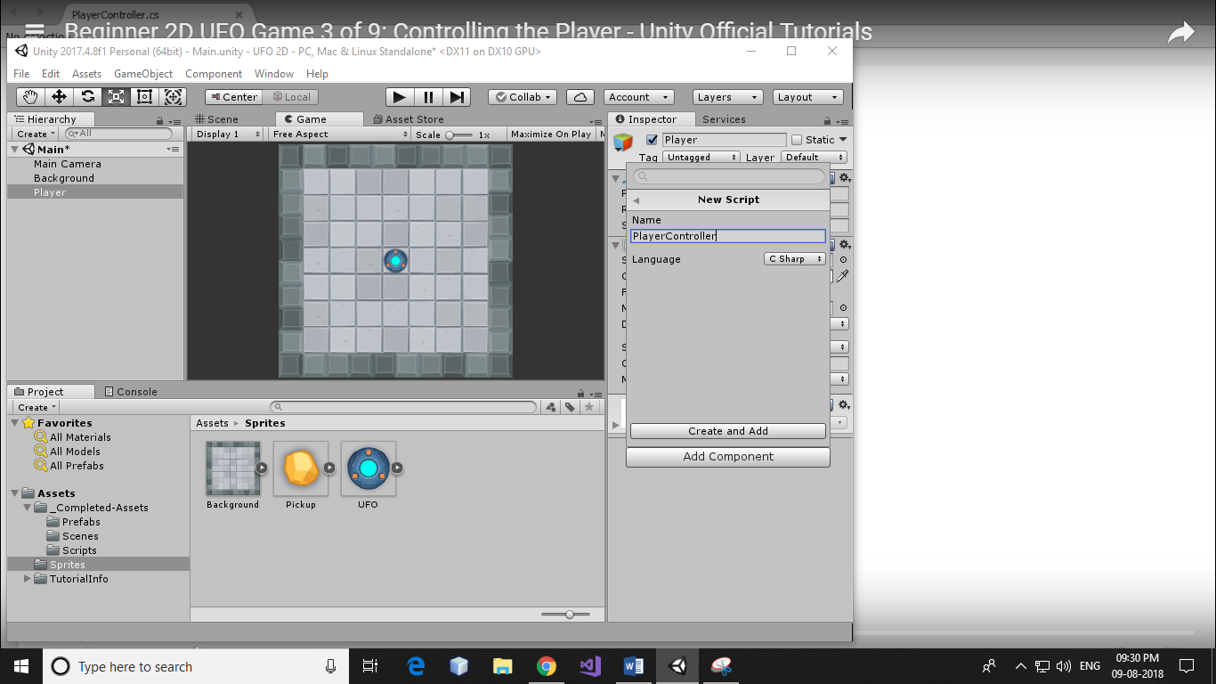

Move this script to the Script folder of _Completed-Assets from Assets folder.

Double click on the script for editing. And add the below code in the script.

using System.Collections;

using System.Collections.Generic;

using UnityEngine;

public class PlayerController : MonoBehaviour {

public float speed;

private Rigidbody2D rb2d;

void Start () {

rb2d = GetComponent<Rigidbody2D>();

}

void FixedUpdate () {

float moveHorizontal = Input.GetAxis("Horizontal");

float moveVertical = Input.GetAxis("Vertical");

Vector2 movement = new Vector2(moveHorizontal, moveVertical);

rb2d.AddForce(movement * speed);

}}

Select Player sprite from hierarchy and set Gravity Scale of Rigidbody component to 0 and set some value of speed. 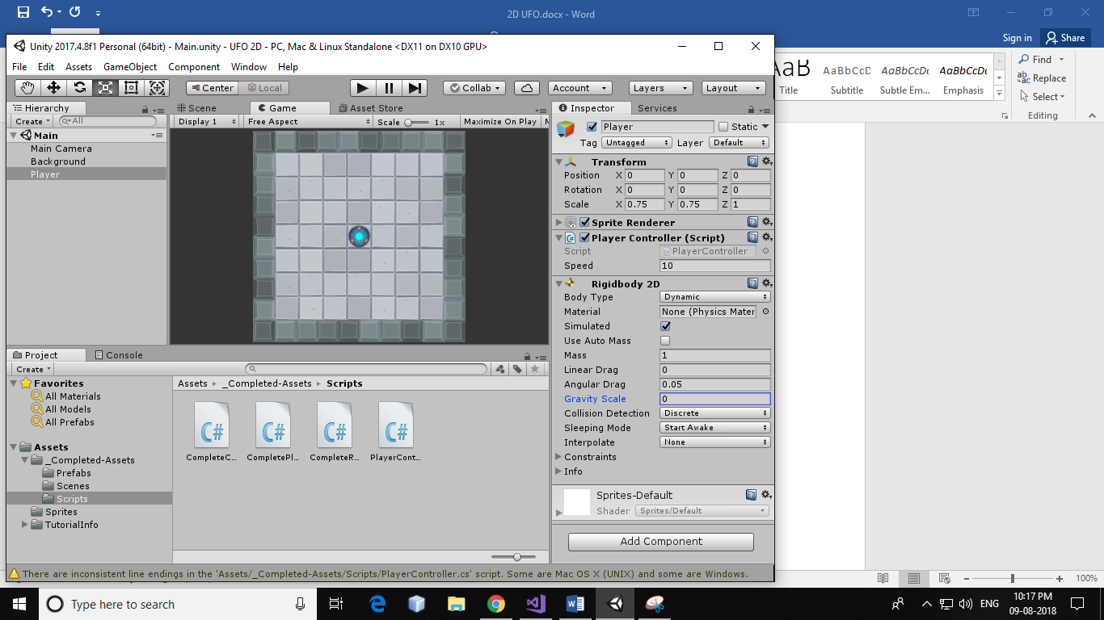

Run the project, you will find that the player object is moving but not only on the board.

Now add circle collider to the player. Highlight player object and then click on add component, search for circle collider 2D and hit enter. Adjust radius of circle collider 2D according to the size of player object.

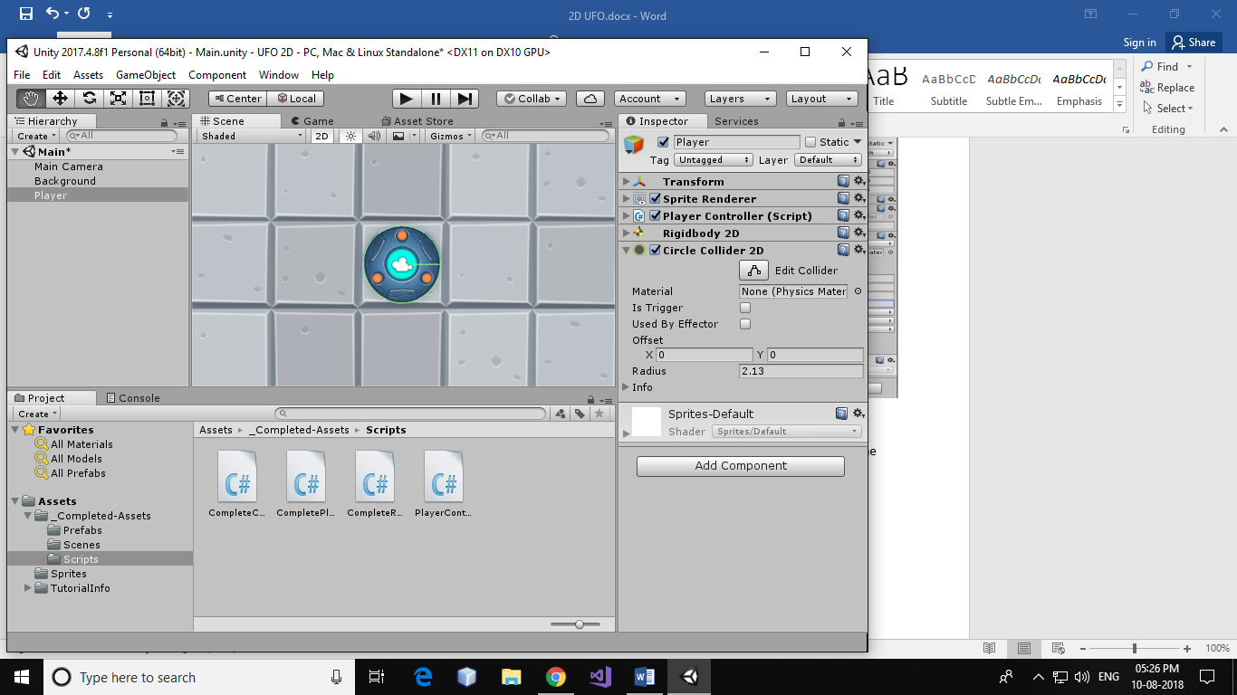

Now we must add box collider to walls. Click on background in the scene and press F on the keyboard to select the frame. Now click on add component and search for Box Collider 2D. Set box collider on the wall by changing the values of X and Y axis of Size and offset of Box Collider 2D.

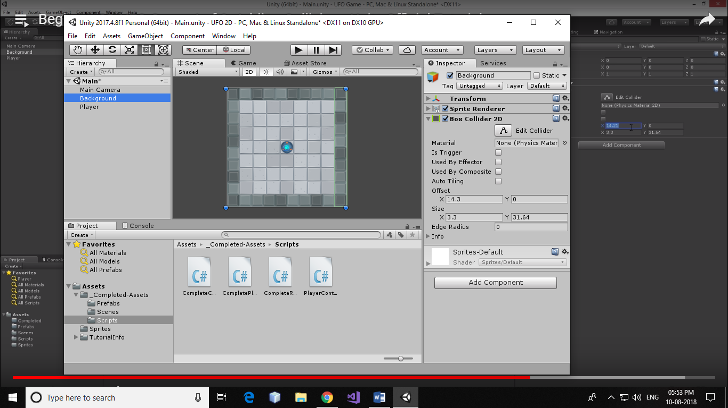

Repeat the above step to add box collider on remaining three walls.

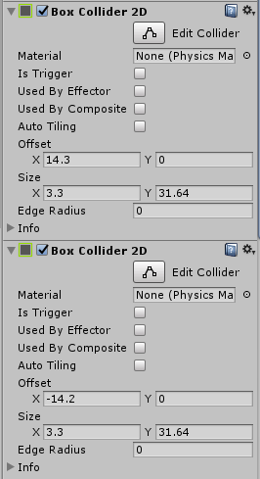

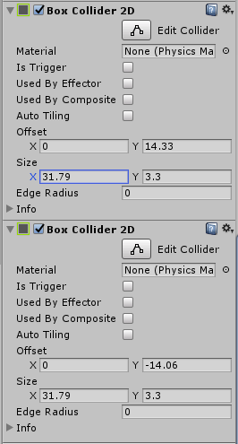

If you run this project you will find that the player object collides with the wall and stay in the play field.

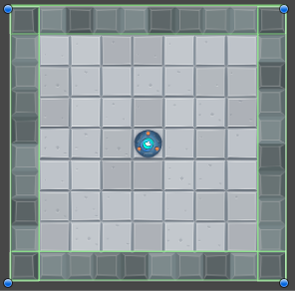

Set main camera above the Player game object in the hierarchy.

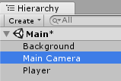

With Main Camera highlighted click on add component and add new script name it CameraController. And add the below code in it.

Using UnityEngine;

using System.Collections;

public class CameraController : MonoBehaviour {

public GameObject player;

private Vector3 offset;

void Start ()

{

offset = transform.position – player.transform.position;

}

void LateUpdate ()

{

transform.position = player.transform.position + offset;

}

}

With Main Camera selected drag and drop player object from hierarchy to Player object of camera controller script.

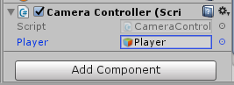

Now drag and drop pickup from sprite folder in the hierarchy.

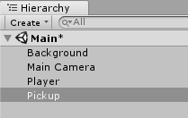

Set sorting layer of Pickup to pickups from sprite renderer.

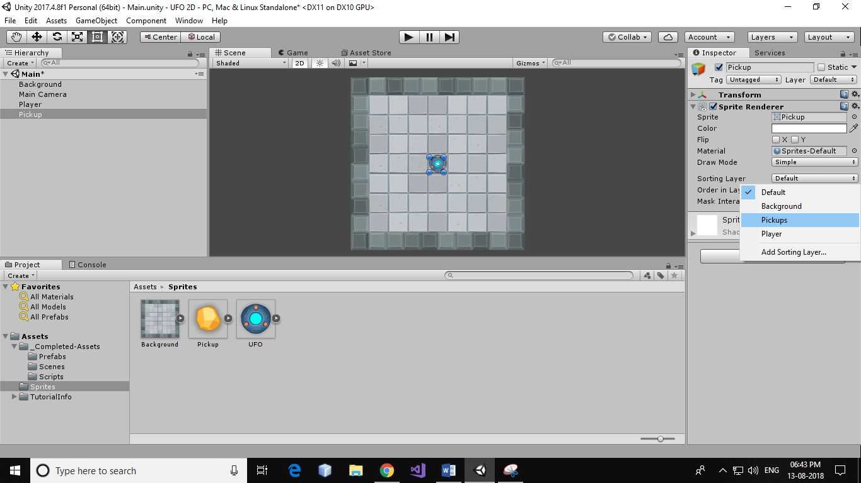

Now temporarily disable player object by selecting Player from hierarchy and unchecking the checkbox to make pickup visible.

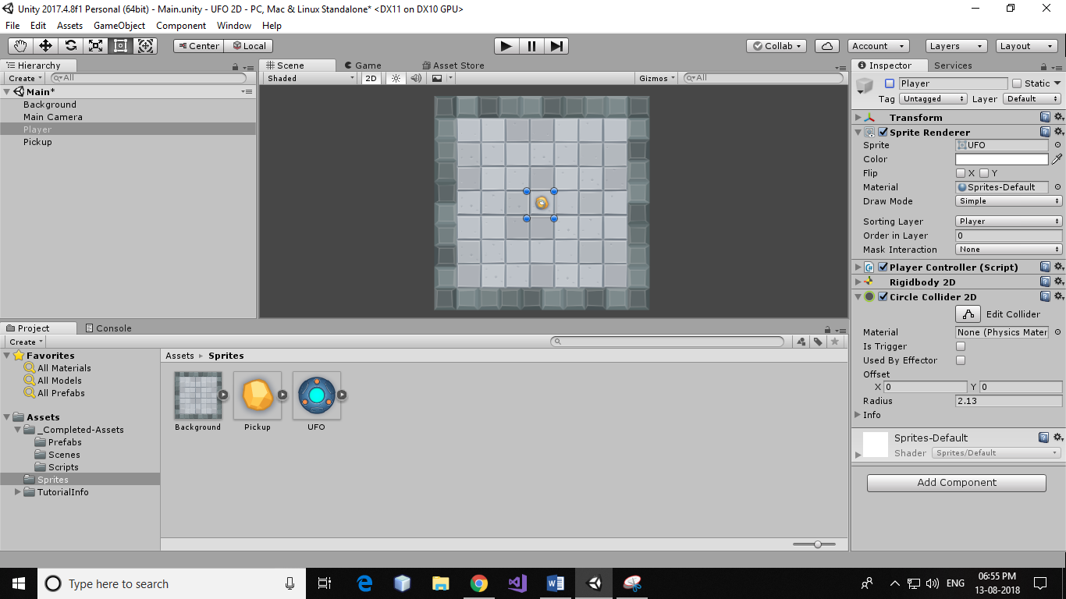

You will find pickup object is now visible on the board, select pickup object in the scene view and press ‘F’ on the keyboard to focus camera on pickup object.

Add circle collider to the pickup object and adjust its radius so that it fits pickup arc visually.

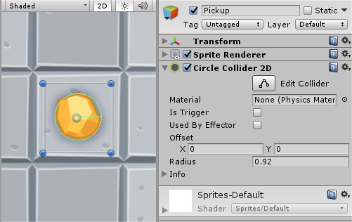

Create a new script (Rotator) for pickup object to rotate it over z-axis. Add below code in the script.

using UnityEngine;

using System.Collections;

public class CompleteRotator : MonoBehaviour {

void Update ()

{

transform.Rotate (new Vector3 (0, 0, 45) * Time.deltaTime);}}

Add pickup object in Prefabs from hierarchy(drag and drop)

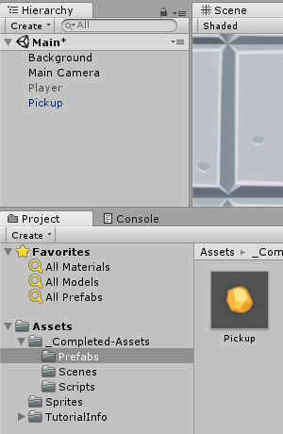

Create new game object to hold our pickups. Click on GameObject and select create empty or pressCtrl+Shift+N. And name it as Pickups.

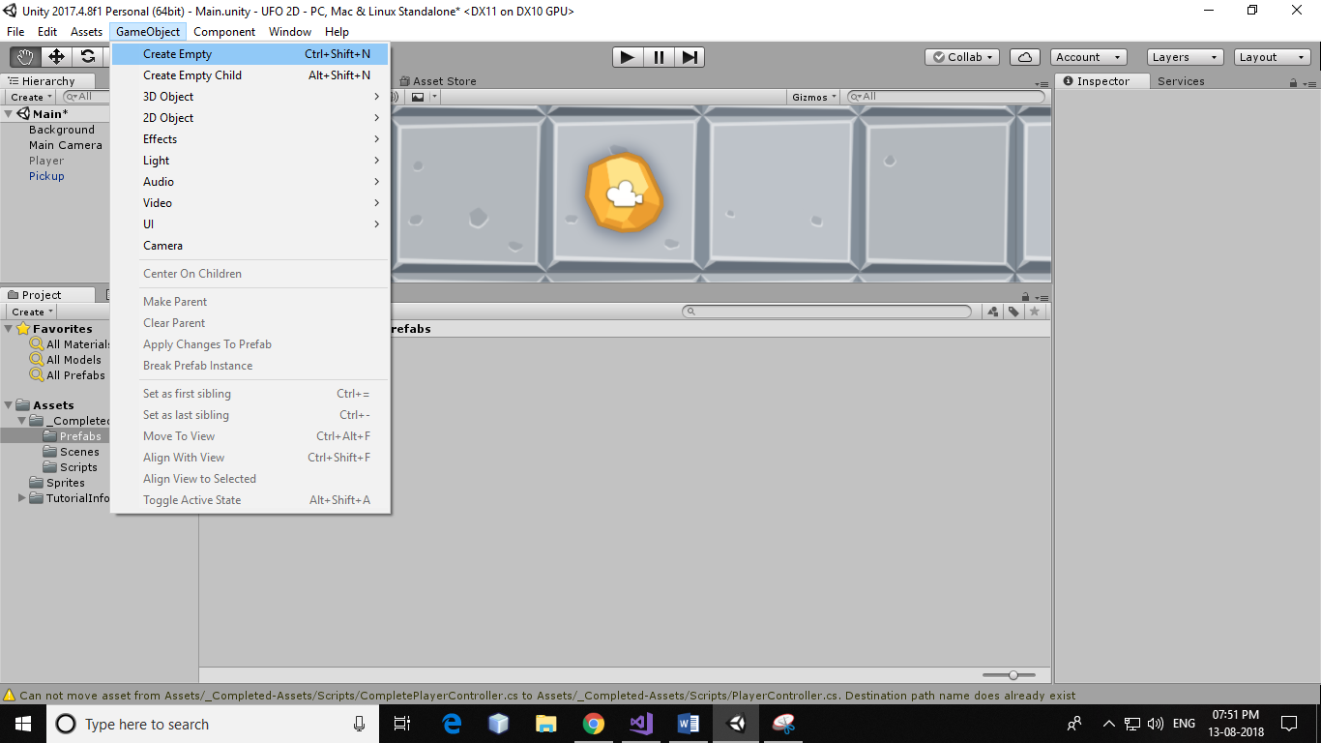 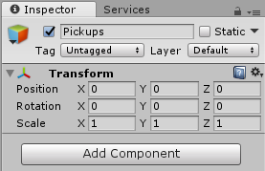

Add pickup object to newly created GameObject(Pickups).

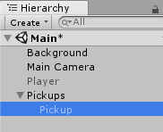 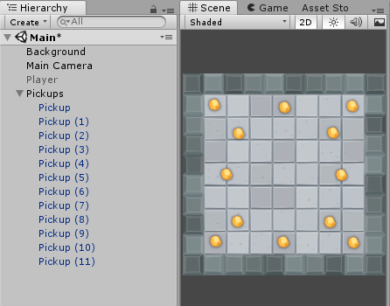

Create duplicate of pickup object either by using hotkey combination Ctrl+D (go to Edit and click on Duplicate) and position it on the board.

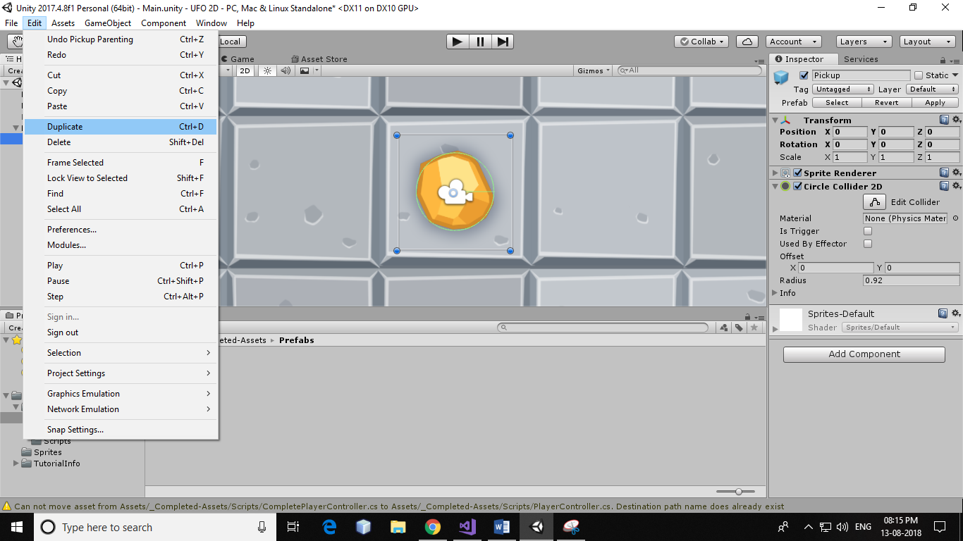

Reactivate the player Object.

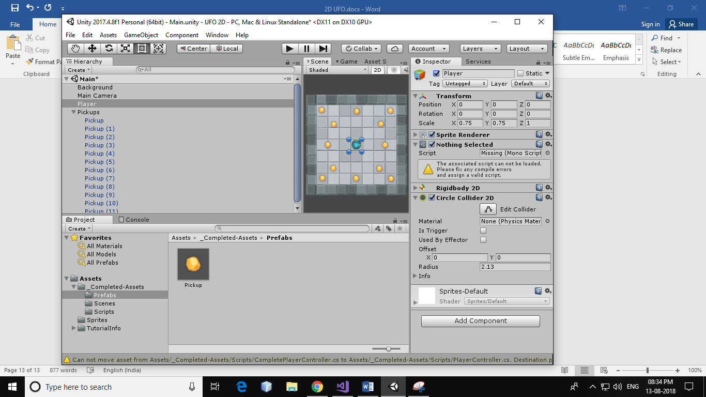  
To detect collision and deactivate pickup objects write the below method in the PlayerController script.

void OnTriggerEnter2D(Collider2D other) {

if (other.gameObject.CompareTag ("PickUp"))

other.gameObject.SetActive(false);

}

Set tag value for our pickup prefab to do this navigate to prefab folder and highlight pickup prefab, with pickup prefab highlighted click on Tag list at the top of the inspector. Select pickup from the list.

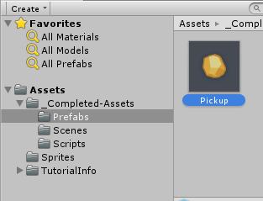 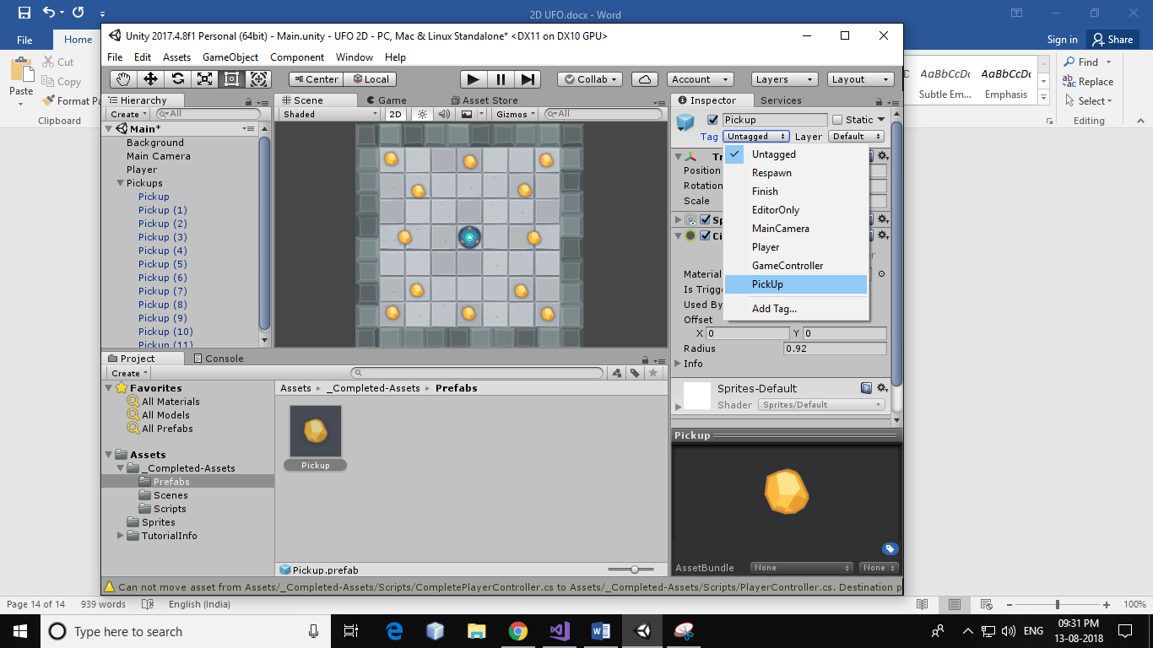

With pickup prefab enable Is Trigger property of Circle Collider 2D to true.

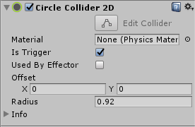

Add Rigid Body 2D to Pickup prefab and set Body Type to Kinematic.

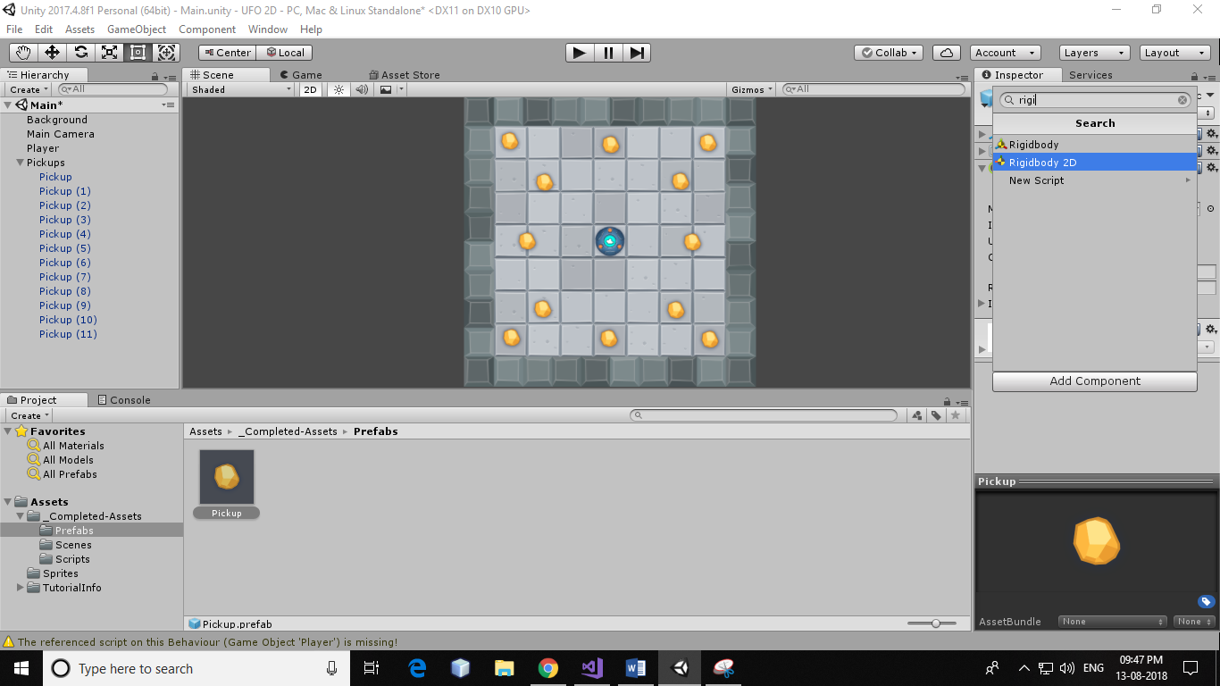 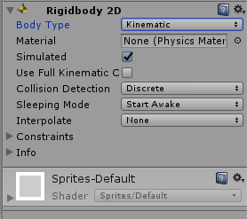

Create new UI element from Create(in hierarchy menu).

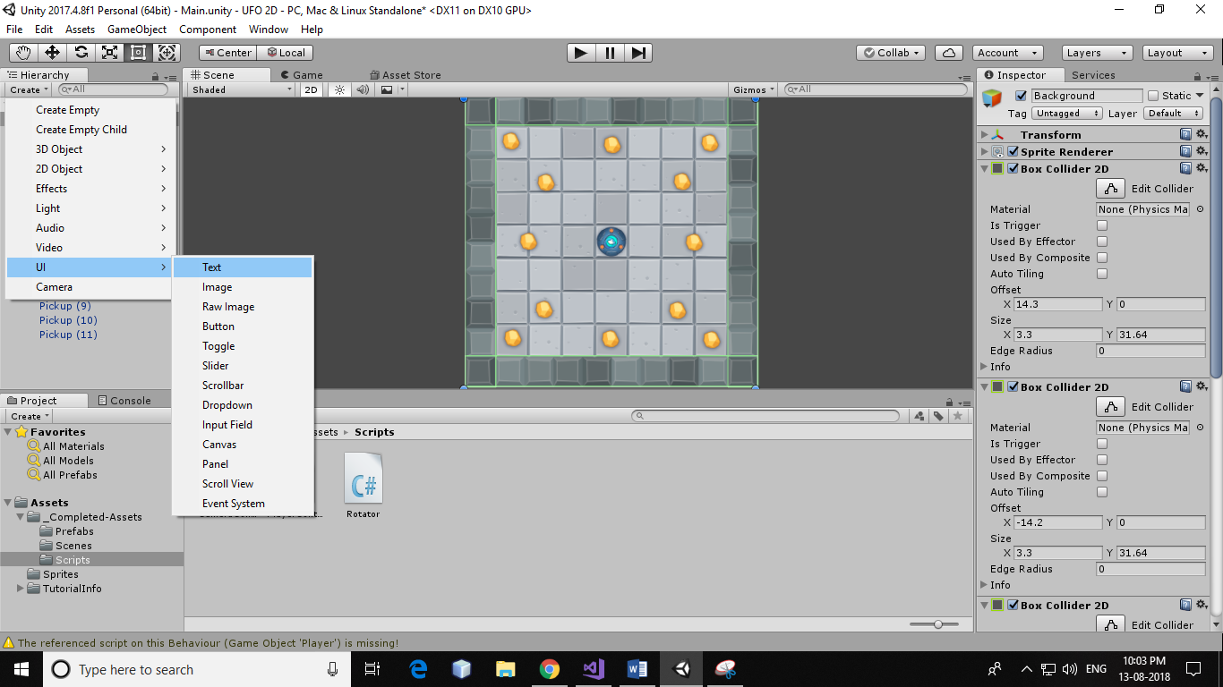 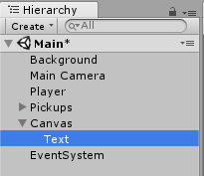

Rename the UI text to ‘CountText’ and change text, text colour, text size etc. With the CountText highlighted press ‘F’ key on the scene to position it on the UI.

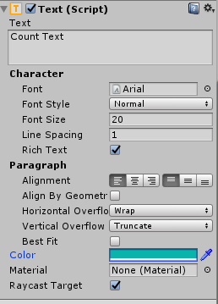

Click on Anchor Preset property of Rect Transform. Hold Ctrl + Alt and select a frame(in our case left top).

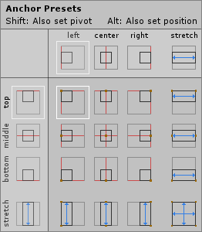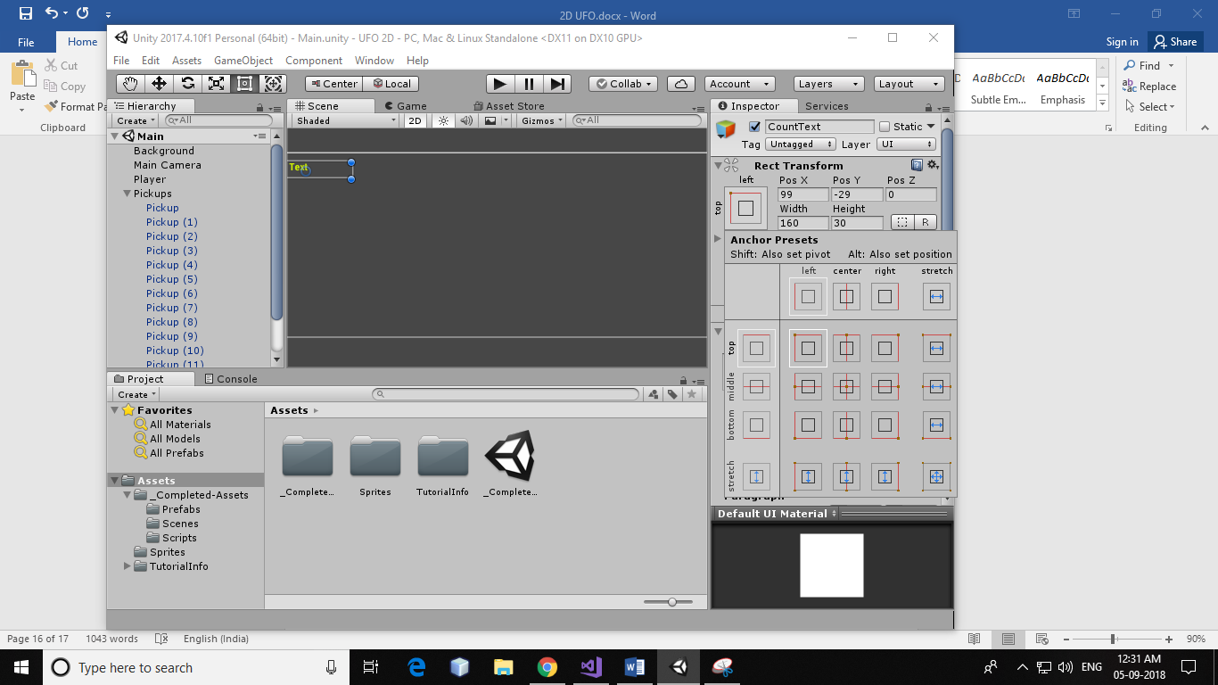

Keep some space between the text and the edge.

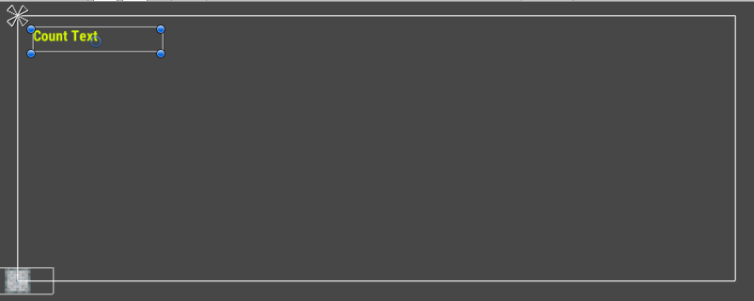

Create new UI text element(Win Text) for displaying result.

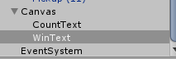

The below code to PlayerContoller script.

using UnityEngine.UI;

public class CompletePlayerController : MonoBehaviour {

public Text countText;

public Text winText;

private int count;

void Start()

{

count = 0;

winText.text = "";

SetCountText ();

}

void OnTriggerEnter2D(Collider2D other)

{

count = count + 1;

SetCountText ();

}

void SetCountText()

{ countText.text = "Count: " + count.ToString ();

if (count >= 12)

winText.text = "You win!";

}

}

With Player object highlighted drag and drop CountText and WinText from Canvas UI to CountText and WinText property of PlayerController Script.

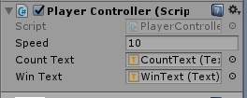

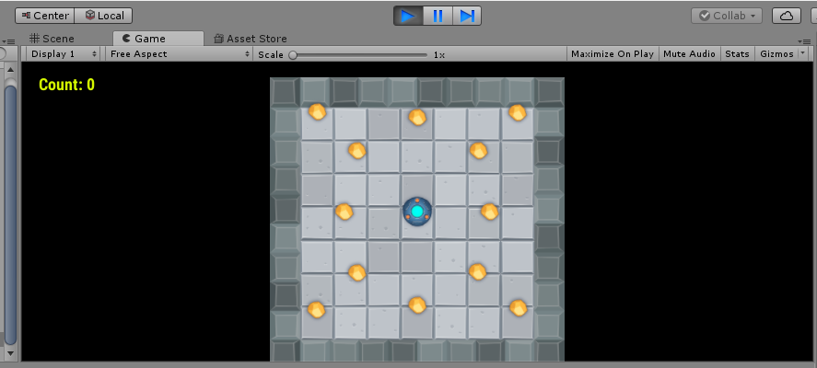All done! Now click on play button.

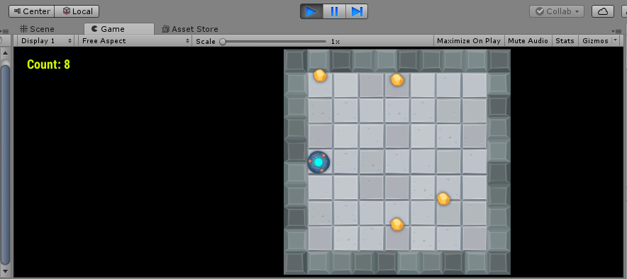

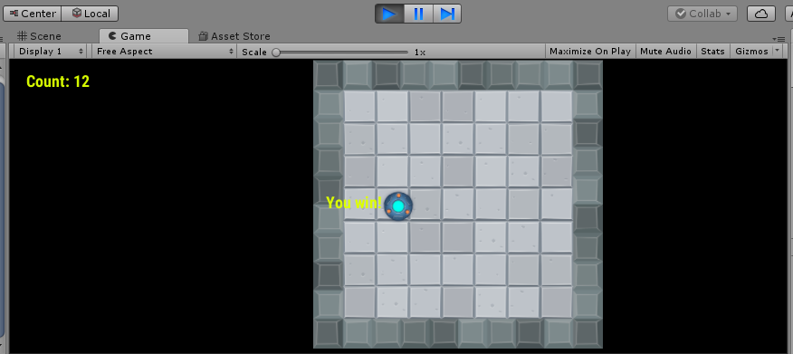

PRACTICAL NO 8

**AIM: https://unity3d.com/learn/tutorials/s/space-shooter-tutorial**

**1. Open Unity and create a new project. Name it as Space Shooter.**

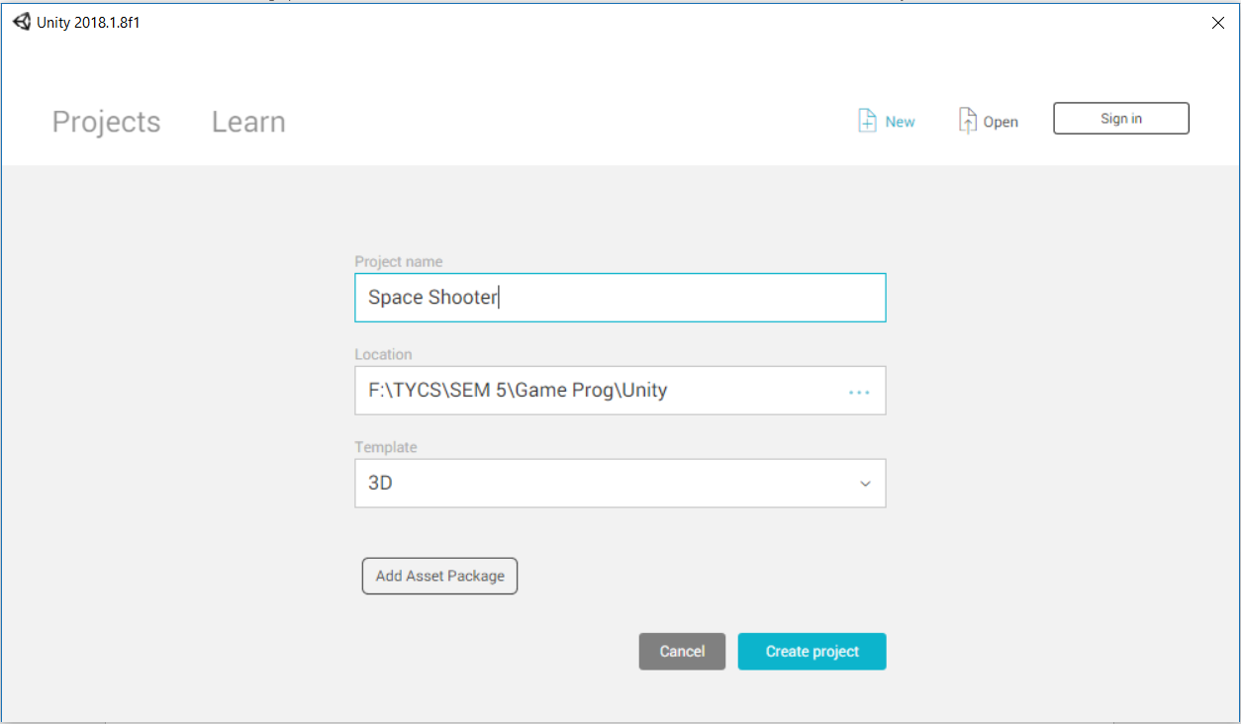

**2. Go to the Asset Store to download the Space Shooter asset.**

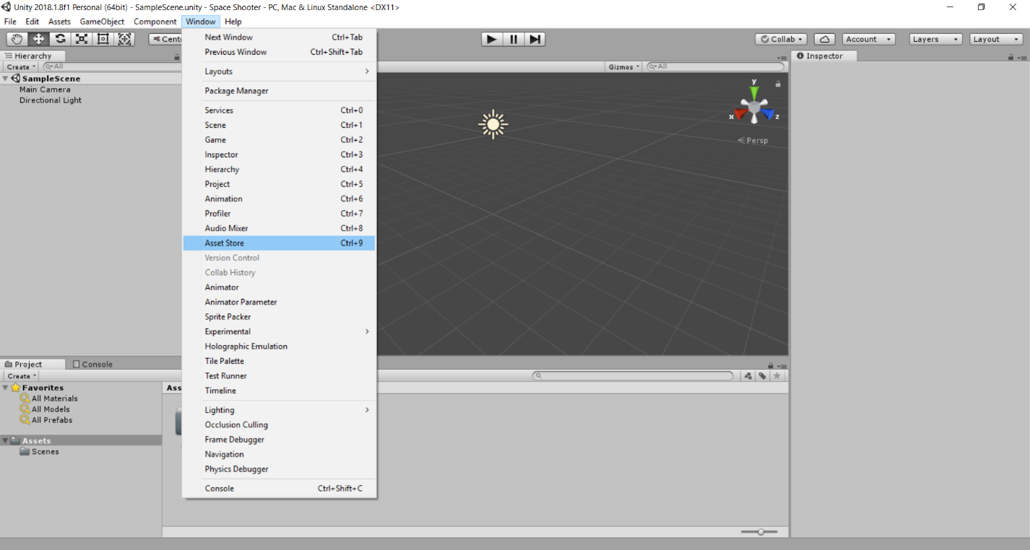

**3. In the Asset Store go to Unity Essentials>Sample Projects and then in the search bar type “space”. Click on the “Space Shooter” in the search results.**

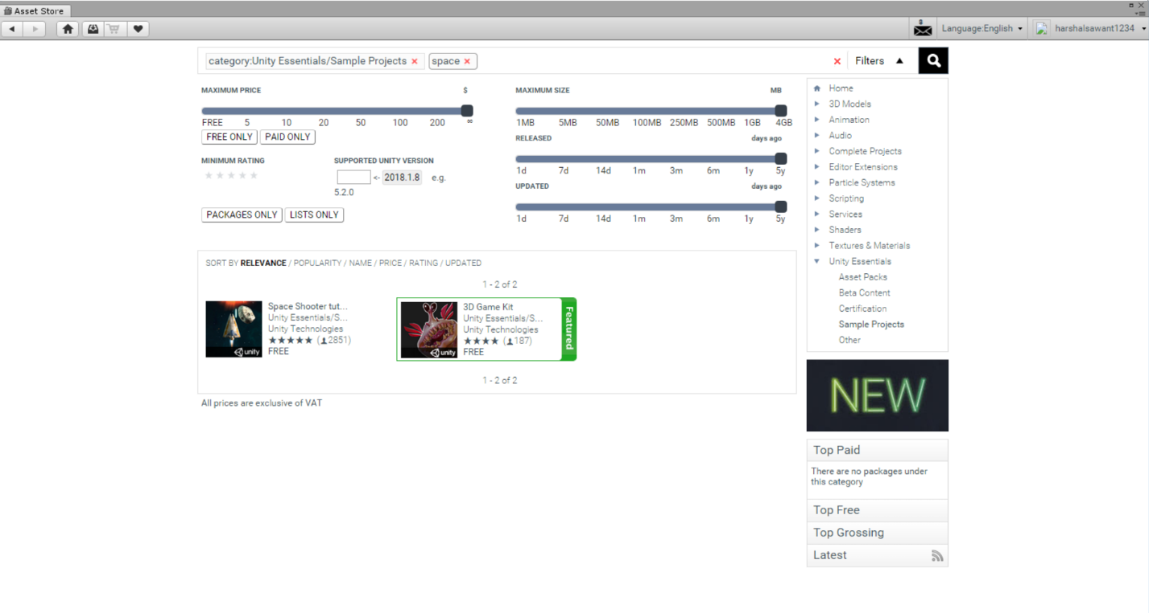

**4. Download the “Space Shooter” asset and import it to our project. Click on import and select “All” to import everything.**

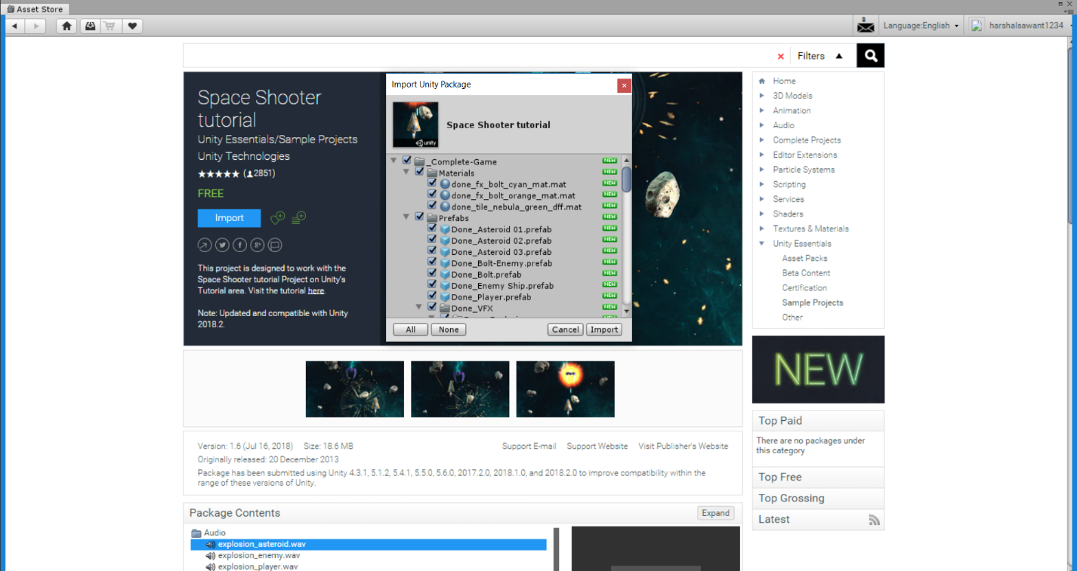

**5. After importing all the Assets come back to Scene View. You will see a sample scene containing a Main Camera and a Directional Light game object.**

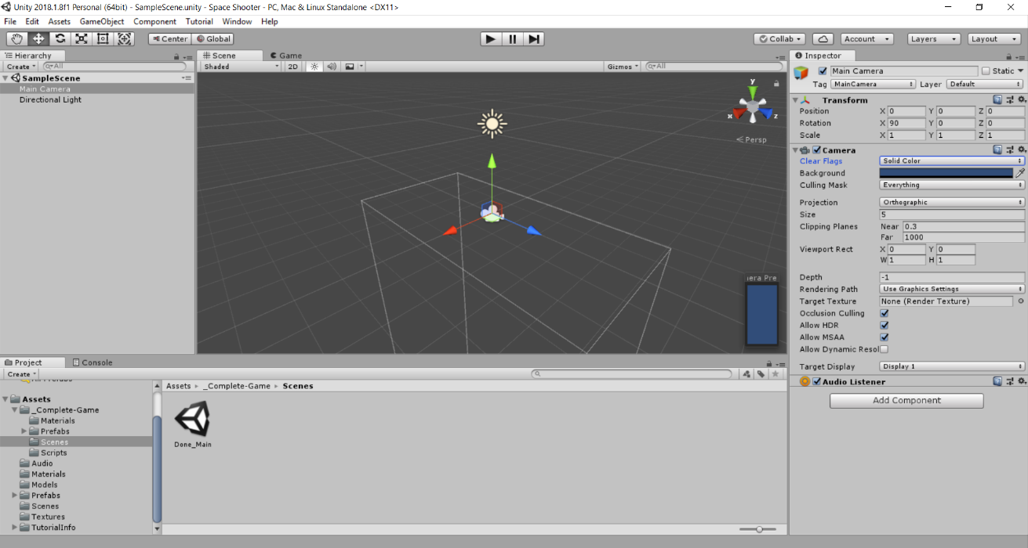

**Main Camera** – describes the viewing angle for the game. As our game is an arcade style game the user will view the game from top. Reset the transform of the Main Camera and then set the rotation of the Main Camera to 90 $°$ along the X-axis, set Clear Flags to Solid Color and the projection of the camera to Orthogonal.

**Directional Light** – specifies a direction for the projection of light. Light is projected on a game object. Here our object is our Space Ship.

**6. To add the Space Ship.**

Go to Assets>Models and drag the vehicle_playerShip to Sample Scene.

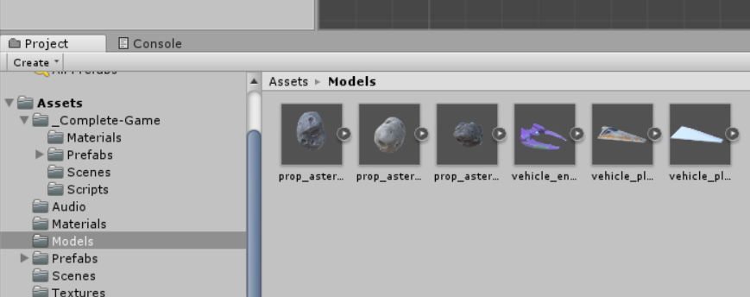

After adding the Space Ship select the vehicle_playerShip Game Object; rename it to Player and reset its transforms.

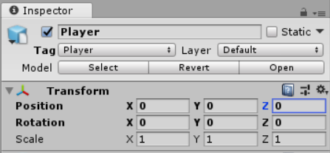

**To add engines to Player:**

Go to Assets>Prefabs>VFX>Engines and add the engines_player to Player. To add drag the engines_player and drop it over the Player object. You can see the engine flares in the Scene.

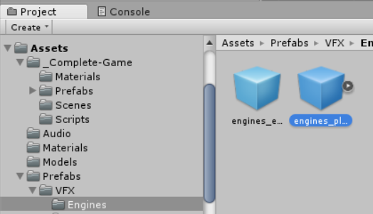 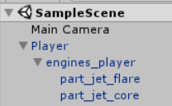 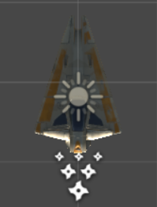

Select Main Camera and set the position of the Main Camera along the Y-axis to some positive value let’s say 5. We are doing this because our Player should be positioned below the Main Camera so that we can see the Player in the Game.

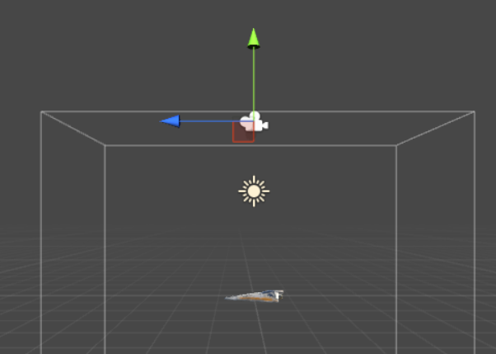 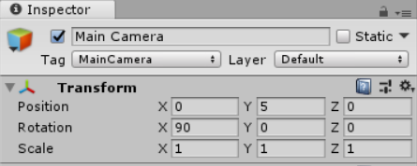

Click Add Component and search for Rigid Body and click on it. We are adding this to make our Player a physical object which will obey physics rules. Uncheck the Use Gravity as ship is in space.

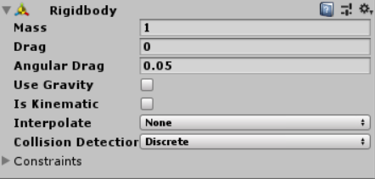

We will add a collider to our Player. Collider components define the shape of an object for the purposes of physical collisions. For our Player we will add a Mesh Collider. The Mesh Collider takes a Mesh Asset and builds its Collider based on that Mesh.

Go to Add Component search for Mesh Collider and click on it. Now go to Assets>Models and drag the player_ship_collider to the Mesh filed in the Mesh Collider.

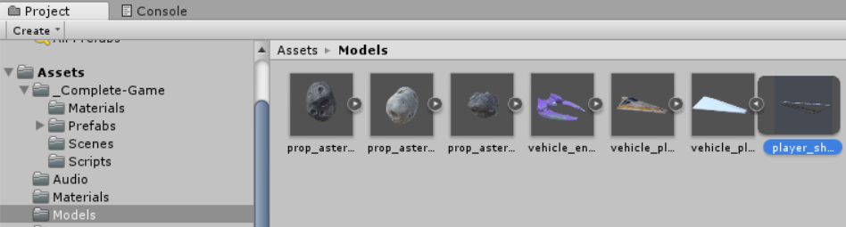

Disable the Mesh Renderer and to see the Mesh Collider.

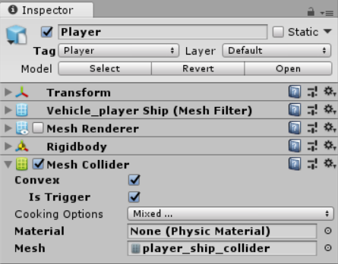 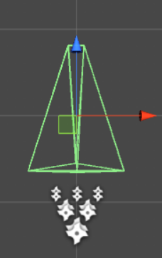

**7. To set lights on Player:**

Select Directional Light game object and reset its Transform. Duplicate the Directional Light to make 2 clones.

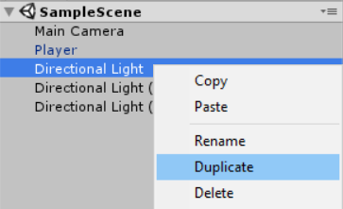

Rename the first Directional Light to Fill Light, second to Main Light and the third to Rim Light. Now create an empty Game Object and rename it to Lighting and move all the three Directional Lights into the Lighting game object.

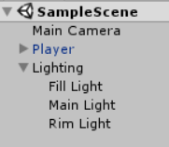

**7.1 To set Fill Light:**

Reset the transform of the Fill Light object and come to Game view to see the effect of lights. As we have not set any values we will see that our Player is in dark.

Set the rotation of the Fill Light along the X-axis and Y-axis to set light focus on the Player. Now set the color of light using the color pallet.

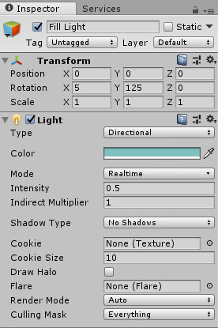

**7.2 To set Main Light:**

Set the rotation of the Main Light along the X-axis and Y-axis to set light focus on the Player. Now we will set the color of light using the color pallet. As this is our Main Light its intensity will be more than the Fill Light.

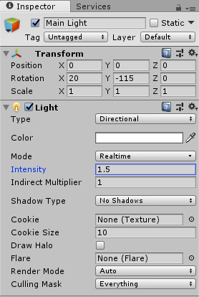

**7.3 To set Rim Light:**

Set the rotation of the Rim Light along the X-axis and Y-axis to set light focus on the Player. Set the color of light using the color pallet. As this is our Rim Light its intensity will be less than the other two lights.

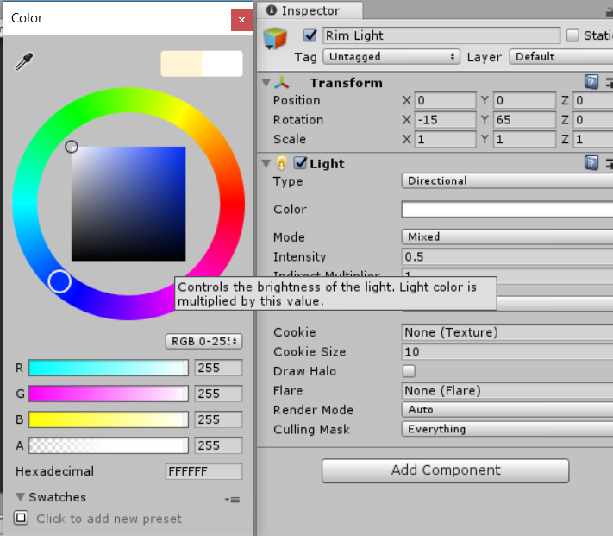

After setting all the lights we can see our

Player has lit-up in the game view.

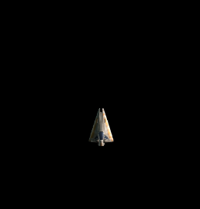

**8. To add a background to game.**

First create a Quad object by 3d Object-> Quad which will hold our background image. Reset the transform of the Quad object and rename it to Background. Now go to Assets>Textures and select the “tile_nebula_green_dff”. Drag this image and drop it over the Background object. Now set the Shader property of the image to Unlit/Texture.

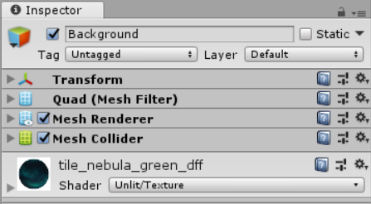

Set the position of the background along negative Y-axis as the Background will be below our Player, rotation of 90 $°$ along the X-axis and scale the image to fit our game screen. Here we have scaled the background image keeping an aspect ratio of 1:2 as our background image has aspect ratio of 1024*2048.

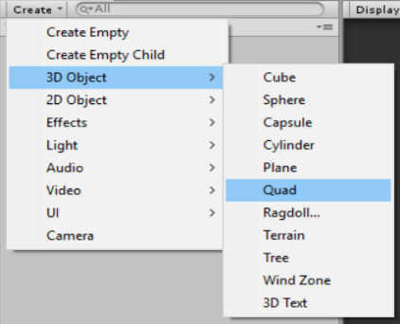 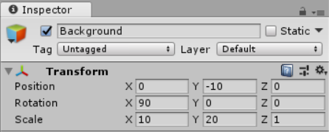

**9. To add obstacles for the Player in the game.**

Create an empty Game Object rename it to Asteroid and reset the transform.

Now go to Assets>Models and select the prop_asteroid_01 drag it and drop on the Asteroid object.

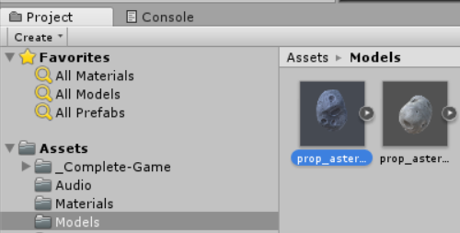

Now in the Asteroid object click on Add Component and search for Rigid Body and add it to our Asteroid object.

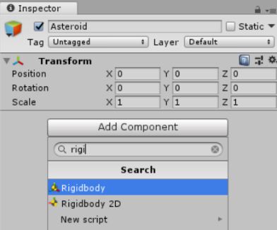

Uncheck the Use Gravity because we are in space and there is no gravity here. Also set the Angular Drag to 0.

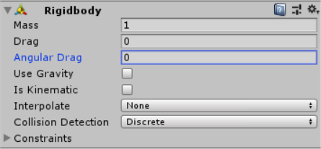

Now search for Capsule Collider in the Add Component and add it to the Asteroid object

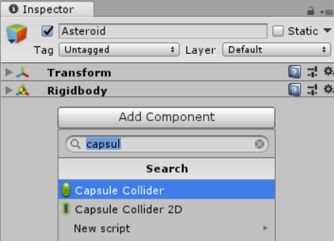

Set the radius and height of the Capsule Collider so that it will cover our Asteroid.

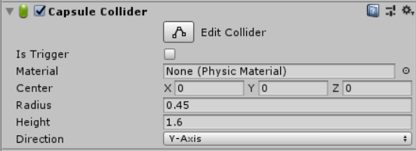 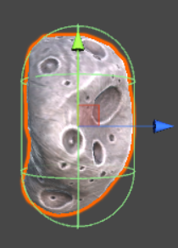

To give our Asteroid tumble effect we must add script for it. In the Add Component search for new script and set the name of the script as RandomRotator and click on “Create and Add”.

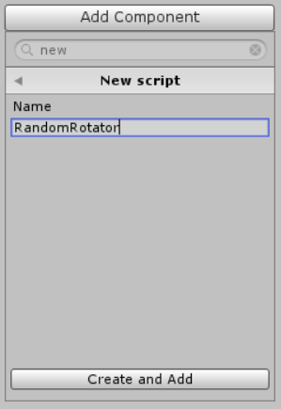

Now paste the below code in the RandomRotator file.

using UnityEngine;

using System.Collections;

public class RandomRotator : MonoBehaviour

{

public float tumble;

void Start()

{

GetComponent<Rigidbody>().angularVelocity = Random.insideUnitSphere * tumble;

}

}

This code will create a Tumble field in the Asteroid Object where we will set the Tumble value for our Asteroid.

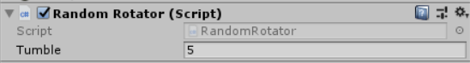

Create a Scripts folder in our Assets and move the RandomRotator script file into that folder. We will use this folder to save all our script files.

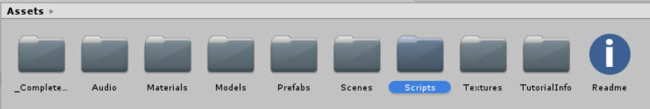

To move Asteroids towards our Player, create another script and name it as Mover and copy the below code into it.

using UnityEngine;

using System.Collections;

public class Mover : MonoBehaviour

{

public float speed;

void Start()

{

GetComponent<Rigidbody>().velocity = transform.forward * speed;

}

}

This code will create a Speed field in the Asteroid Object where we can set the Speed value for our Asteroid. As our Asteroid will move towards our player we have to set its speed with some negative value.

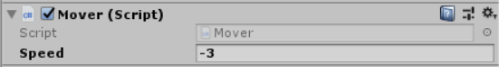

**10. To create Shots that our player will fire to destroy the obstacles.**

Create an empty game object and rename it to Bolt. Reset the transform.

Then create a Quad object and rename it to VFX and move the VFX object to Bolt. Reset the transform of VFX and remove the Mesh Collider from the VFX object.

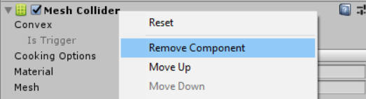

Go to Assets>Materials, drag the fx_bolt_orange and add it to the VFX object.

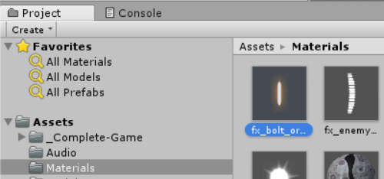

Set the rotation of the VFX object to 90 $°$ along the X-axis.

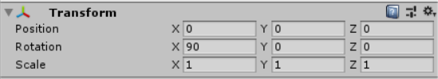

Come to Bolt object and add a Rigid Body and uncheck the Use Gravity field.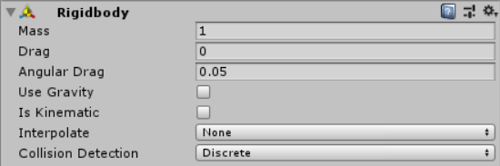

Now add a Capsule Collider to the Bolt object. Check the Is Trigger and set the Radius and Height of the Collider so that it covers our Bolt.

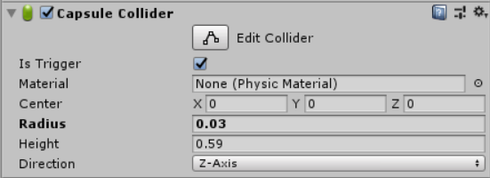 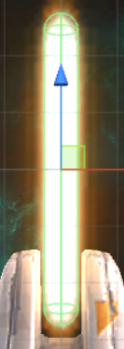

Now we have to move our bolts towards the obstacles so we add the same Mover script file which we created for our Asteroids to the Bolt object and set the Speed of the bolt.

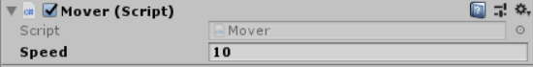

**11. To set controls for our Player.**

First create an empty Game Object and rename it to Shot Spawn. Reset the transform of Shot Spawn and add this object to our Player object.

Now set the transform of the Shot Spawn object with respect to player from where the shots will be fired.

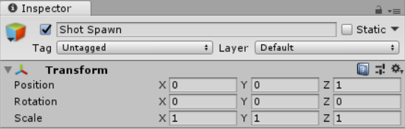

Create a new script and name it as Player Controller. Add the below code to the Player Controller.

using UnityEngine;

using System.Collections;

[System.Serializable]

public class Boundary

{

public float xMin, xMax, zMin, zMax;

}

public class PlayerController : MonoBehaviour

{

public float speed;

public float tilt;

public Boundary boundary;

public GameObject shot;

public Transform shotSpawn;

public float fireRate;

private float nextFire;

void Update()

{

if (Input.GetButton("Fire1") && Time.time > nextFire)

{

nextFire = Time.time + fireRate;

Instantiate(shot, shotSpawn.position, shotSpawn.rotation);

}

}

void FixedUpdate()

{

float moveHorizontal = Input.GetAxis("Horizontal");

float moveVertical = Input.GetAxis("Vertical");

Vector3 movement = new Vector3(moveHorizontal, 0.0f, moveVertical);

GetComponent<Rigidbody>().velocity = movement * speed;

GetComponent<Rigidbody>().position = new Vector3

(

Mathf.Clamp(GetComponent<Rigidbody>().position.x, boundary.xMin, boundary.xMax),

0.0f,

Mathf.Clamp(GetComponent<Rigidbody>().position.z, boundary.zMin, boundary.zMax)

)

GetComponent<Rigidbody>().rotation = Quaternion.Euler(0.0f, 0.0f, GetComponent<Rigidbody>().velocity.x * -tilt);

}

This code will create the following fields:

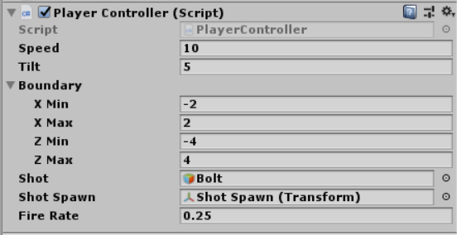

Speed: The speed of bolts.

Tilt: The tilting angle for the Player.

Boundary: The max are where player can move.

X Min: Minimum range along X-axis.

X Max: Maximum range along X-axis.

Z Min: Minimum range along Z-axis.

Z Max: Maximum range along Z-axis.

Shot: Drag the Bolt object into this field.

Shot Spawn: Drag the Shot Spawn object into this field.

Fire Rate: Define the number of shots per second. e.g. here we have set the Fire Rate to 0.25 i.e. 4 shots per second.

**12. To create a Boundary for game.**

When asteroids will go outside the boundary they will automatically get destroyed.

Create an empty Game Object and rename it as Boundary. Reset the transforms.

Create a new tag named Boundary.

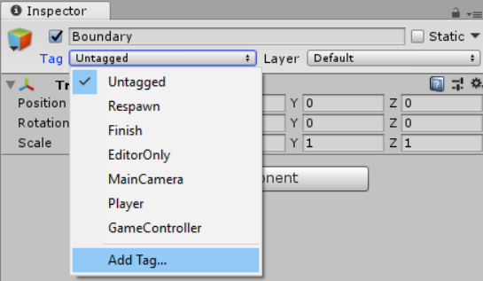

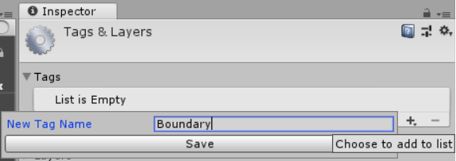

After creating the new tag select it.

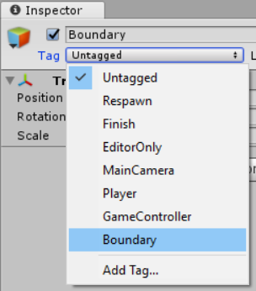

Now we will add a Box Collider to Boundary. Reset transforms.

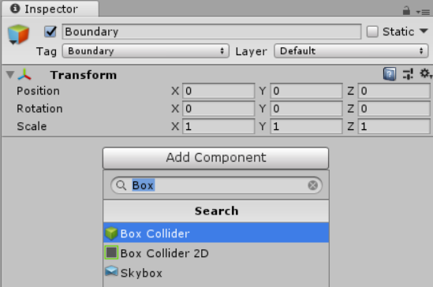

Now scale the Boundary such that it will cover entire game area.

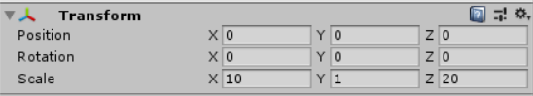 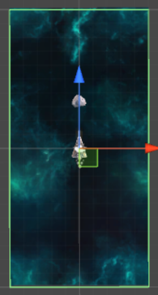

Create a new script and name it as DestroyByBoundary. Add the below code to it.

using UnityEngine;

using System.Collections;

public class DestroyByBoundary : MonoBehaviour

{

void OnTriggerExit(Collider other)

{

Destroy(other.gameObject);

}

}

**13. To set the explosion.**

Go to Asteroid and create a new Script and name it as DestroyByContact. Add the below code to that script.

using UnityEngine;

using System.Collections;

public class DestroyByContact : MonoBehaviour

{

public GameObject explosion;

public GameObject playerExplosion;

public int scoreValue;

private GameController gameController;

void Start()

{

GameObject gameControllerObject = GameObject.FindWithTag("GameController");

if (gameControllerObject != null)

{

gameController = gameControllerObject.GetComponent<GameController>();

}

if (gameController == null)

{

Debug.Log("Cannot find 'GameController' script");

}

}

void OnTriggerEnter(Collider other)

{

if (other.tag == "Boundary")

{

return;

}

Instantiate(explosion, transform.position, transform.rotation);

if (other.tag == "Player")

{

Instantiate(playerExplosion, other.transform.position, other.transform.rotation);

gameController.GameOver();

}

gameController.AddScore(scoreValue);

Destroy(other.gameObject);

Destroy(gameObject);

}

}

This code will create the following fields:

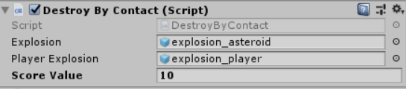

Explosion: Go to Assets>Models>VFX>Explosions and select the explosion_asteroid.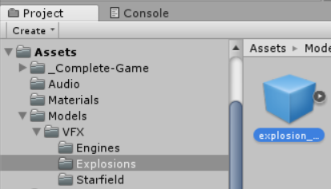

Player Explosion: Go to Assets>Models>VFX>Explosions and select the explosion_player.

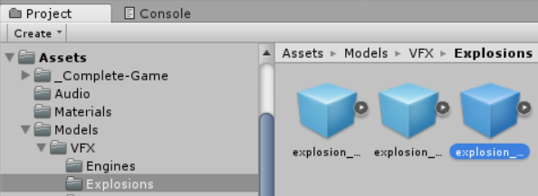

Add a new script and name it as DestroyByTime. Add the below code to that file.

using UnityEngine;

using System.Collections;

public class DestroyByTime : MonoBehaviour

{

public float lifetime;

void Start()

{

Destroy(gameObject, lifetime);

}

}

This code will create a field named lifetime. Here we will set the lifetime of that object.

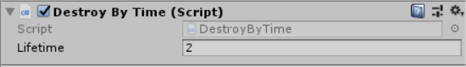

**14. To create a Game Controller using which we will spawn waves of Asteroids.**

Create an empty Game Object and rename it to Game Controller. Reset the transform.

Add a new script file named GameController to Game Controller object. Add the below code in the script file.

using UnityEngine;

using System.Collections;

using UnityEngine.UI;

public class GameController : MonoBehaviour

{

public GameObject hazard;

public Vector3 spawnValues;

public int hazardCount;

public float spawnWait;

public float startWait;

public float waveWait;

public Text scoreText;

public Text restartText;

public Text gameOverText;

private bool gameOver;

private bool restart;

private int score;

void Start()

{

gameOver = false;

restart = false;

restartText.text = "";

gameOverText.text = "";

score = 0;

UpdateScore();

StartCoroutine(SpawnWaves());

}

void Update()

{

if (restart)

{

if (Input.GetKeyDown(KeyCode.R))

{

#pragma warning disable CS0618 // Type or member is obsolete

Application.LoadLevel(Application.loadedLevel);

#pragma warning restore CS0618 // Type or member is obsolete

}

}

}

IEnumerator SpawnWaves()

{

yield return new WaitForSeconds(startWait);

while (true)

{

for (int i = 0; i < hazardCount; i++)

{

Vector3 spawnPosition = new Vector3(Random.Range(-spawnValues.x, spawnValues.x), spawnValues.y, spawnValues.z);

Quaternion spawnRotation = Quaternion.identity;

Instantiate(hazard, spawnPosition, spawnRotation);

yield return new WaitForSeconds(spawnWait);

}

yield return new WaitForSeconds(waveWait);

if (gameOver)

{

restartText.text = "Press 'R' for Restart";

restart = true;

break;

}

} }

public void AddScore(int newScoreValue)

{

score += newScoreValue;

UpdateScore();

}

void UpdateScore()

{

scoreText.text = "Score: " + score;

}

public void GameOver()

{

gameOverText.text = "Game Over!";

gameOver = true;

}}

The above code will generate the following fields:

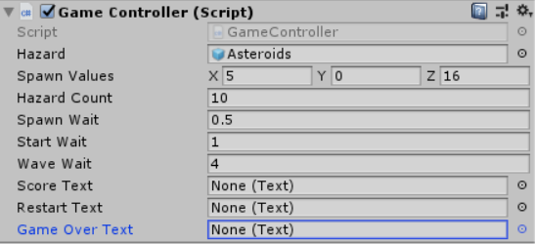

Hazard: Asteroid object.

Spawn Values: Spawn range along the axis.

Hazard Count: Number of Hazards per wave.

Spawn Wait: Wait time between two successive Hazards.

Start Wait: Wait time to create first asteroid.

Wave Wait: Wait time between two successive waves.

Score Text: To display score.

Restart Text: To guide user how to restart the game.

Game Over Text: Text to be displayer when game ends.

**15. To create the Text Objects.**

Create a new UI>Text object and name it as Score Text.

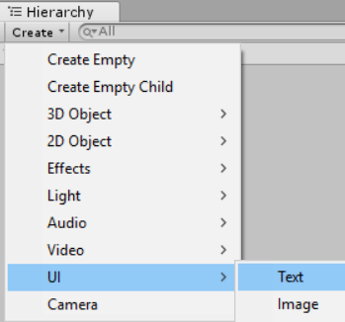

It will by default created as a child object to Canvas Object.

Duplicate the Score Text object and create two copies. Rename them as Game Over Text and Restart Text respectively.

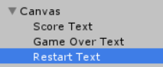

Select Score Text. Set the transform such that the text will appear at the top left corner of game.

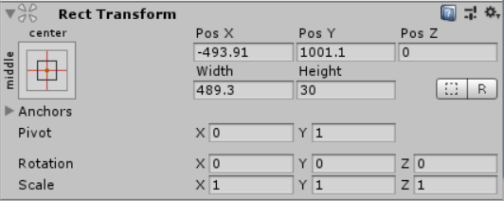 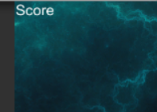

Set the Text, Font and Font Style properties.

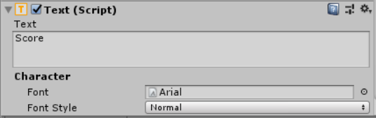

Select Game Over Text. Set the transform such that the text will appear at the center of our game.

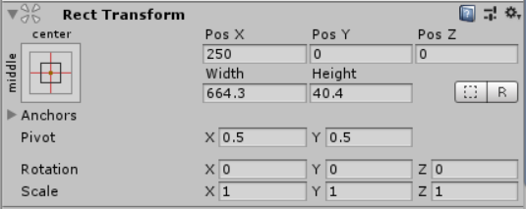 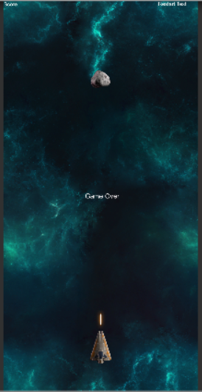

Set the text to display, Font and Font Style.

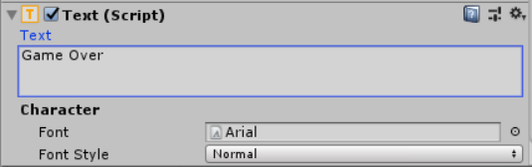

Select Restart Text. Set the transform such that the text will appear at the top right corner of our game.

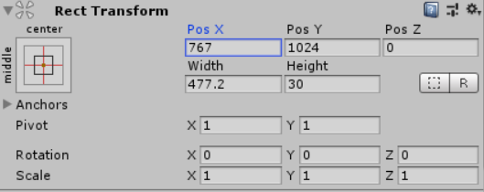 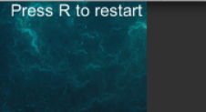

Set the text to display, Font and Font Style.

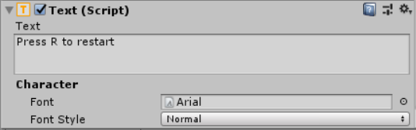

Select Game Controller object and add the Text Objects we created to the fields which we left blank earlier.

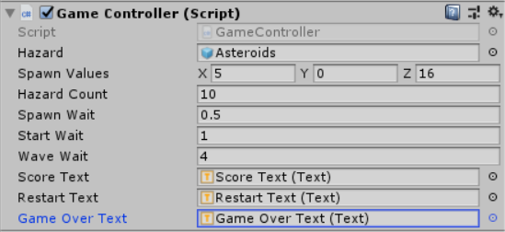

That’s it we have finished making the game. Click on the play button at the top center of the screen to play.

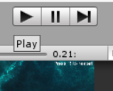

PRACTICAL NO 9

**AIM: https://unity3d.com/learn/tutorials/s/roll-ball-tutorial**

**Open Unity and Create a New Project and give it a proper name**.

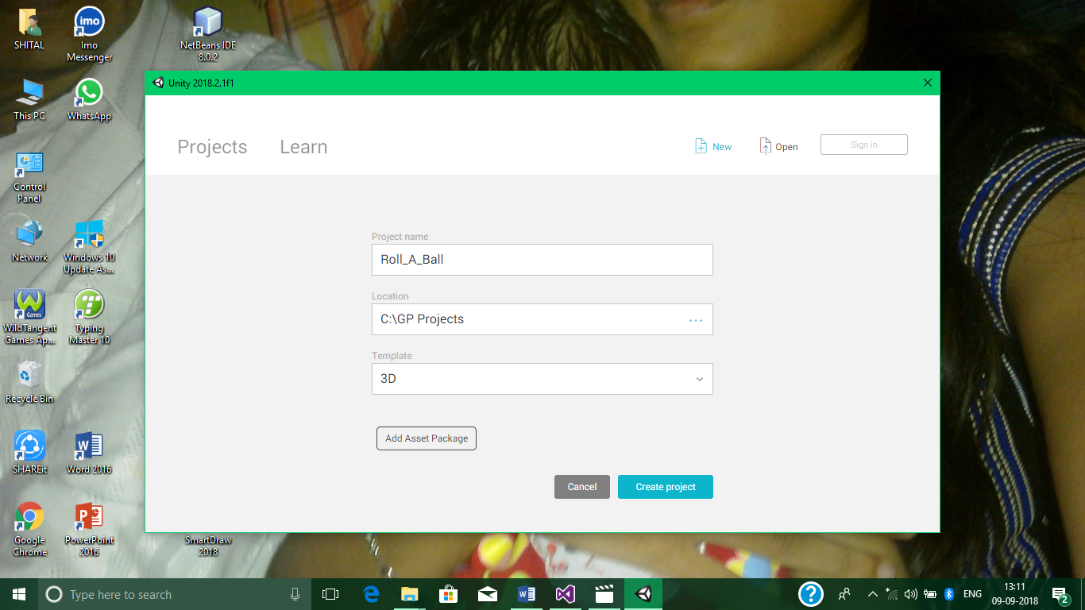

**1. Environment And Player**

Setting Up The Game

First, Save your Scene by giving any name.

Now, to set the Play area, Go to Hierarchy>Create>3D Object>Plane and name it as Ground.

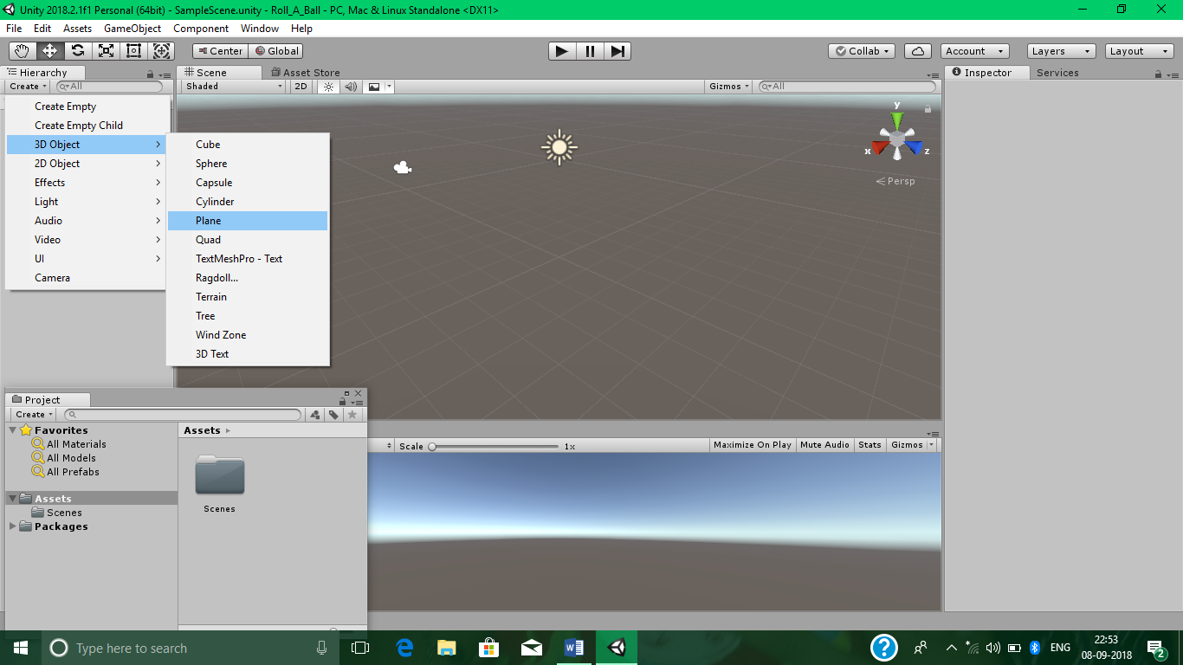

Now, turn the grids off. Go to Gizmos>Show Grid and uncheck the checkbox beside it.

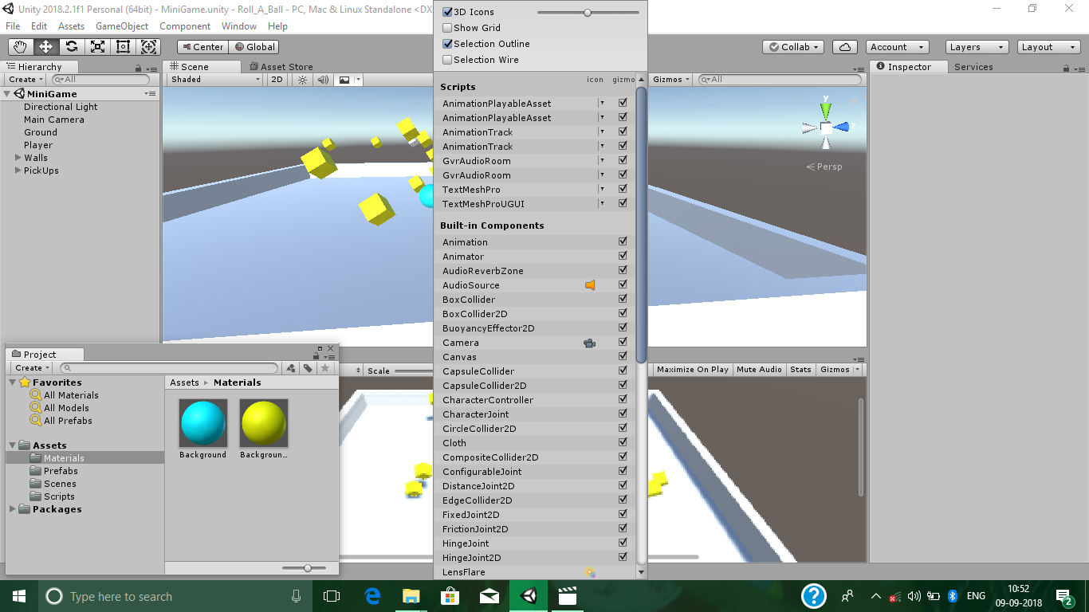

Now, to set the player, Go to Hierarchy>Create>3D Object>Sphere and name it as Player.

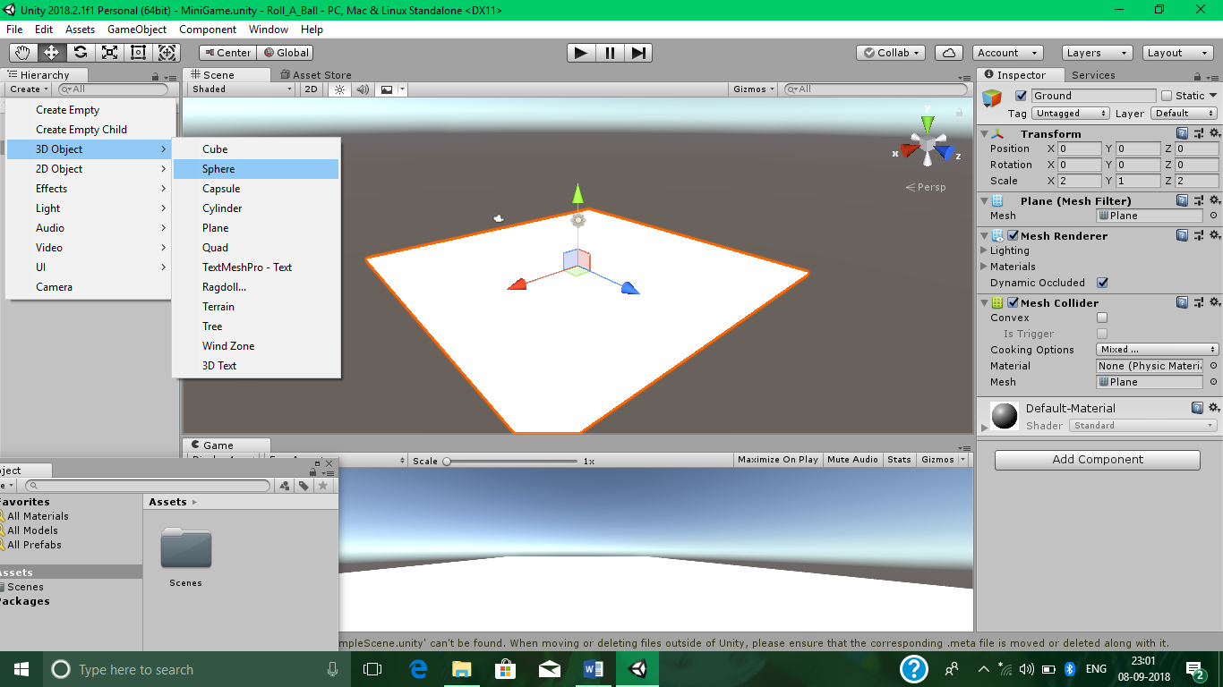

Now, Go to Project>Create>Folder and Name it as Materials.

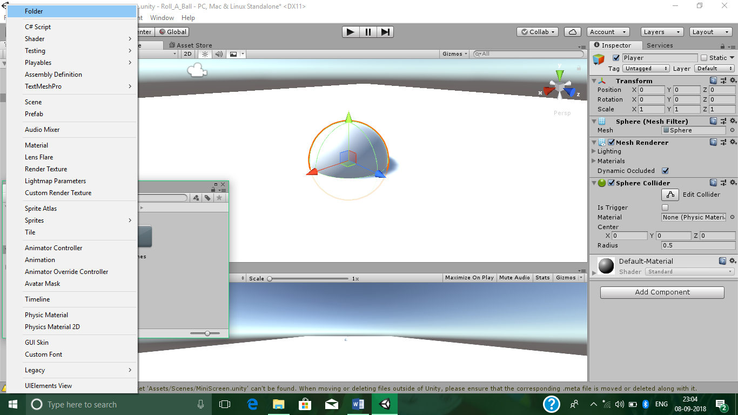

Now, to add some material to Materials folder, Select the Materials folder, Right Click on it, Select Material option and name it as Background.

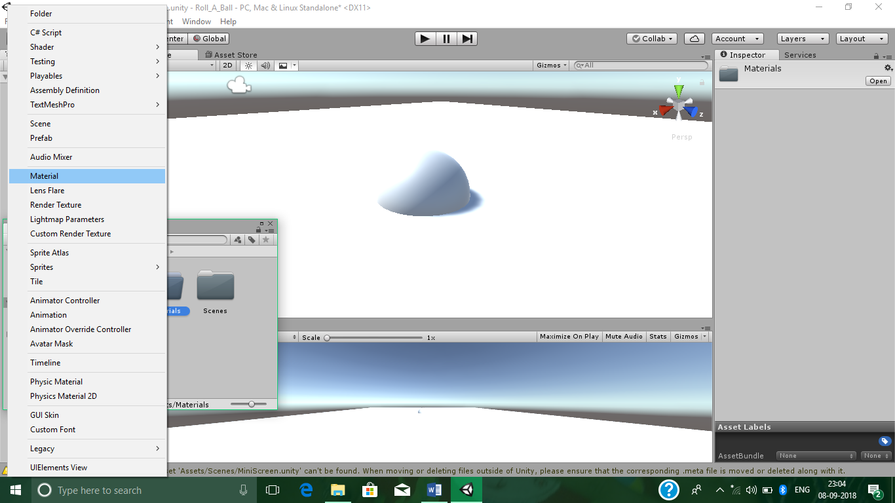

Now, We can choose different Textures and Colors for our background.

For Color, Select the Background>Color picker after Albedo> Choose your Color and see the preview.

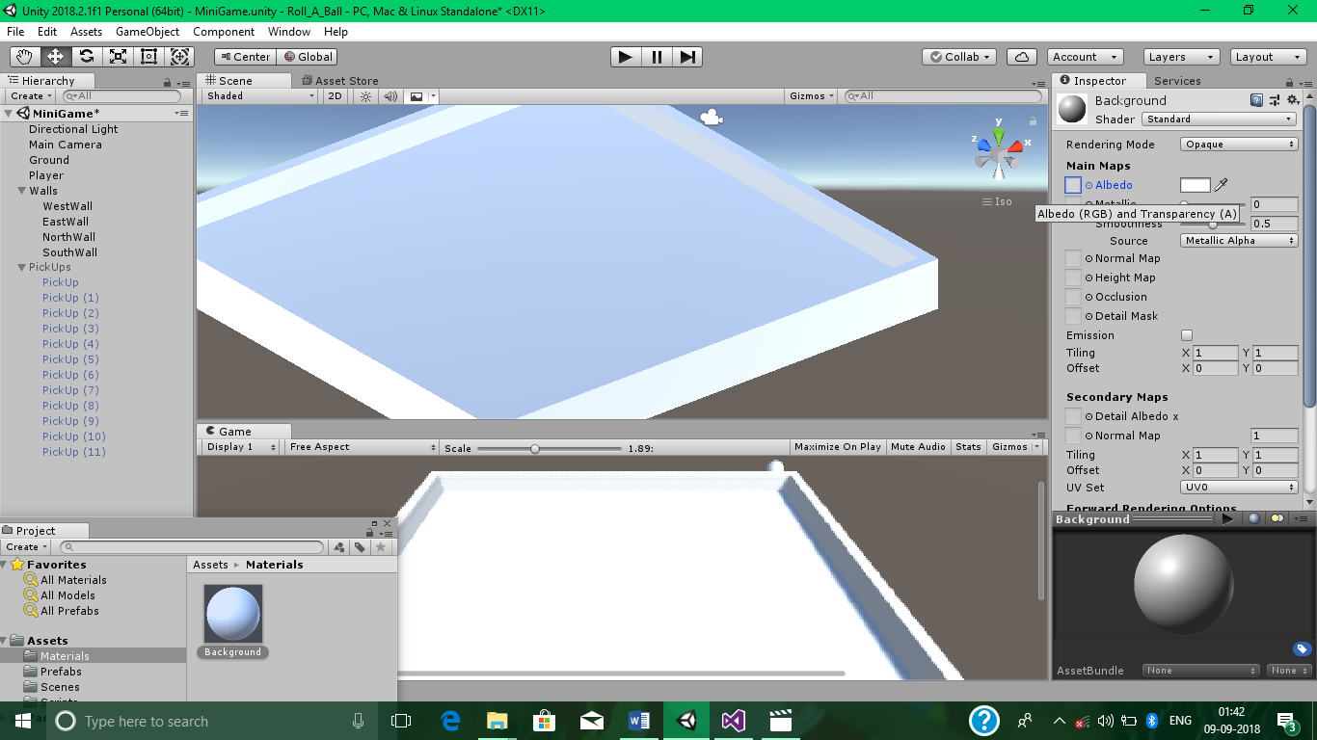

For Texture, Select the Background>Small Circle in front of Albedo>Choose your Texture and see the preview.

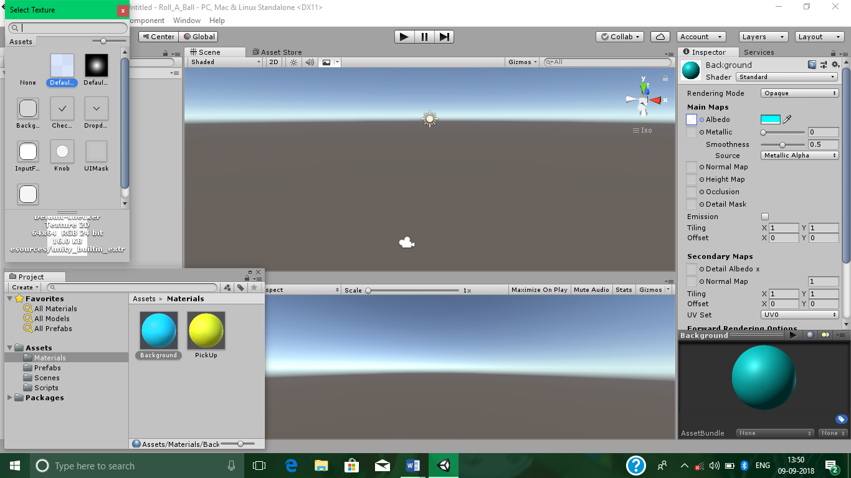

Moving The Player

Now, Go to Player>Add Component(In Rightside Panel)>Physics>Rigidbody.

Now, Create a new Folder and name it as Scripts.

Now, Go to Player>Add Component>New script and name it as PlayerController and move it into our Scripts folder.

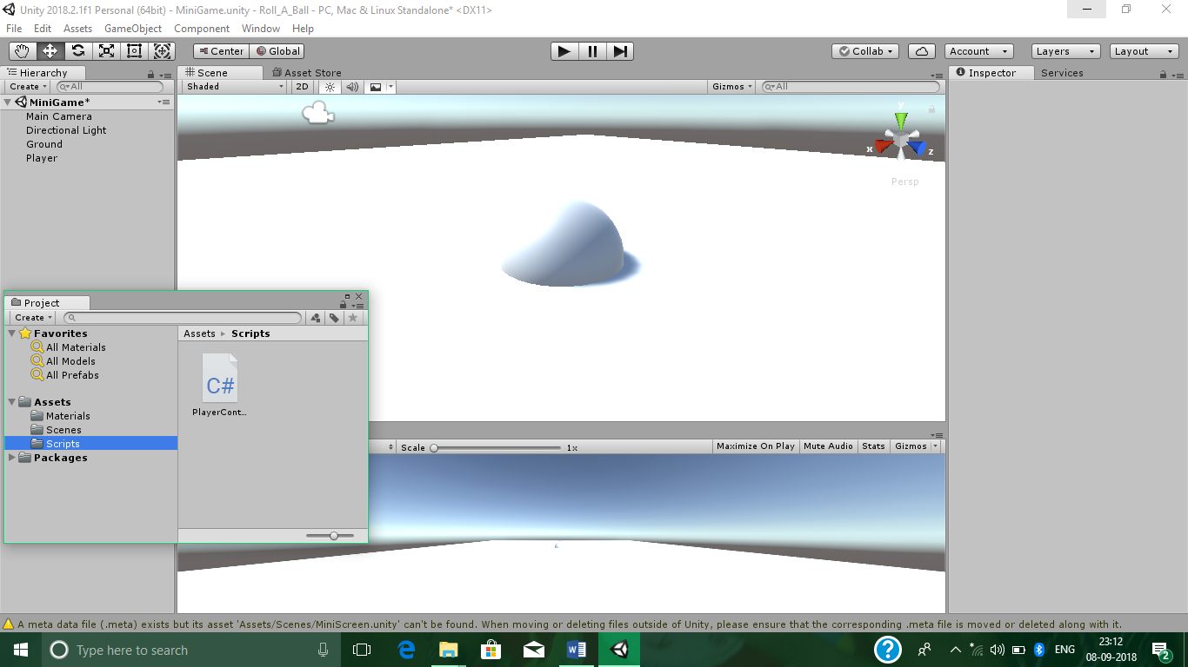

Open PlayerController Script File in Visual Studio and Write the following code.

PlayerController.cs

using System.Collections;

using System.Collections.Generic;

using UnityEngine;

public class PlayerController : MonoBehaviour

{

public float speed;

private Rigidbody rb;

// Use this for initialization

void Start()

{

rb = GetComponent<Rigidbody>();

}

// Update is called once per frame

void FixedUpdate()

{

float moveHorizontal = Input.GetAxis("Horizontal");

float moveVertical = Input.GetAxis("Vertical");

Vector3 movement = new Vector3(moveHorizontal, 0.0f, moveVertical);

rb.AddForce(movement * speed);

}

}

**2. Camera And Play Area**

Moving The Camera

Set the Main Camera with following values.

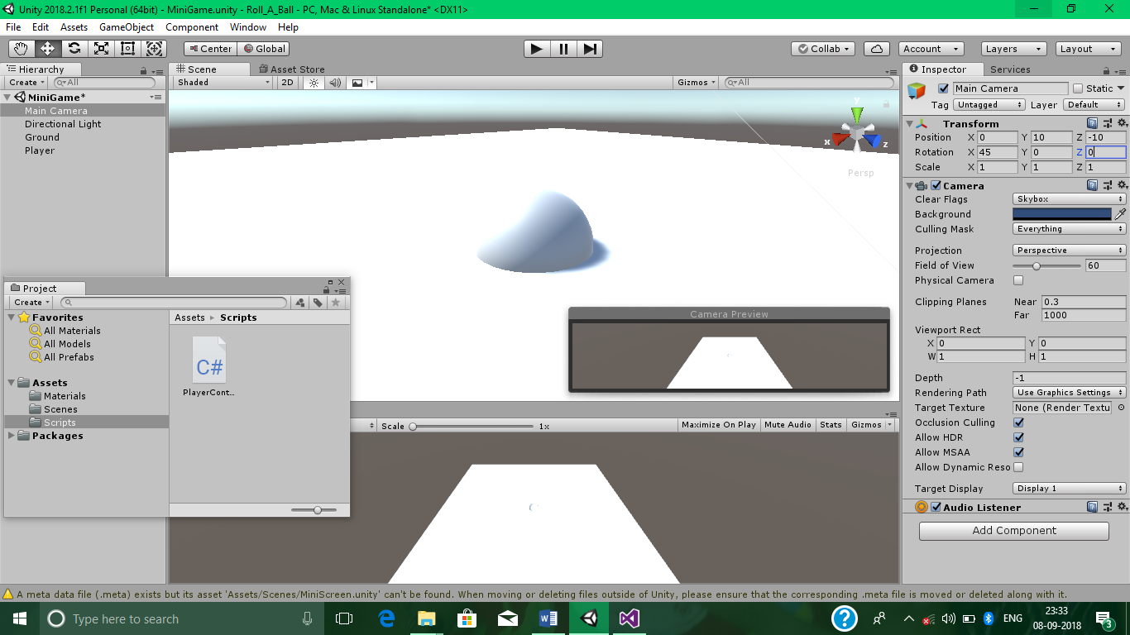

Make the Main Camera child of Player control by dragging it into Player.

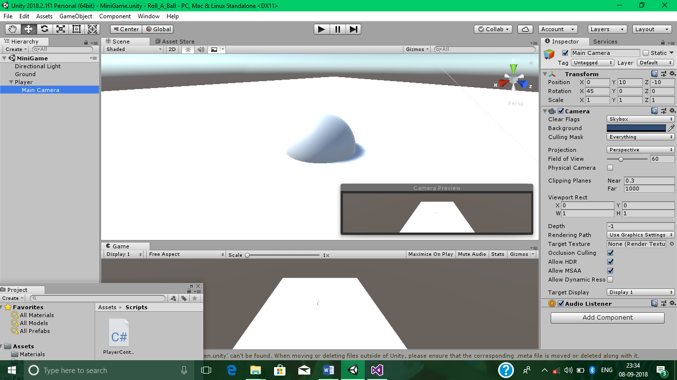

Now, Make a New script in Main Camera control called CameraController and move it into Scripts folder.

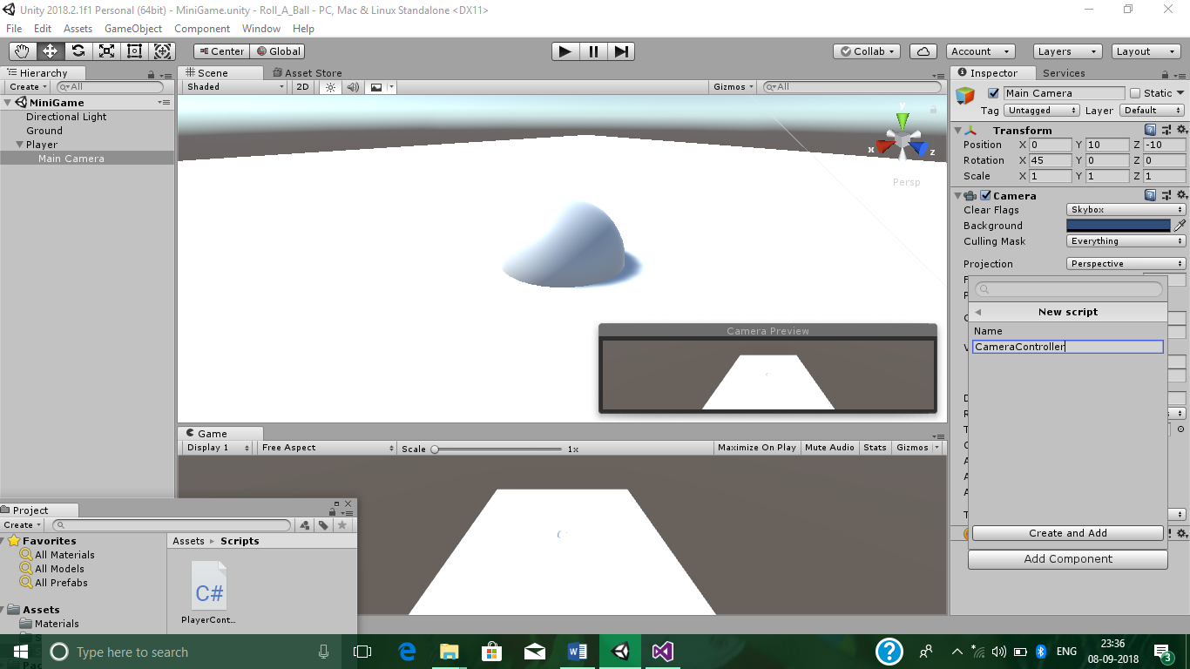

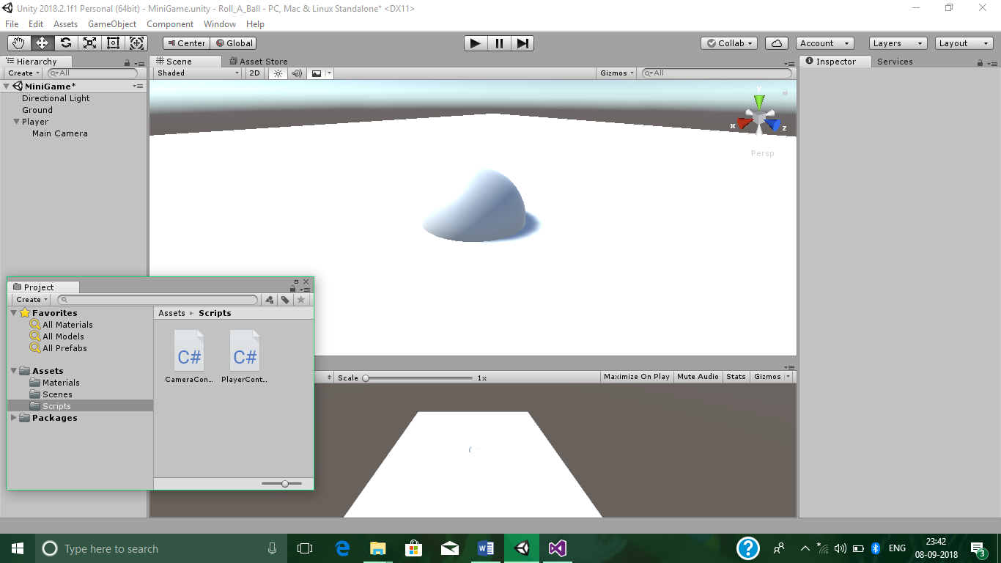

Open CameraController Script File in Visual Studio and Write the following code.

CameraController.cs

using System.Collections;

using System.Collections.Generic;

using UnityEngine;

public class CameraController : MonoBehaviour {

public GameObject player;

private Vector3 offset;

// Use this for initialization

void Start()

{

offset = transform.position - player.transform.position;

}

// Update is called once per frame

void LateUpdate()

{

transform.position = player.transform.position + offset;

}

}

Now, drag the Player control in Main Camera’s>CameraController’s>Player option.

Setting Up The Play Area

Go to Hierarchy>Create>Create Empty and name it as Walls.

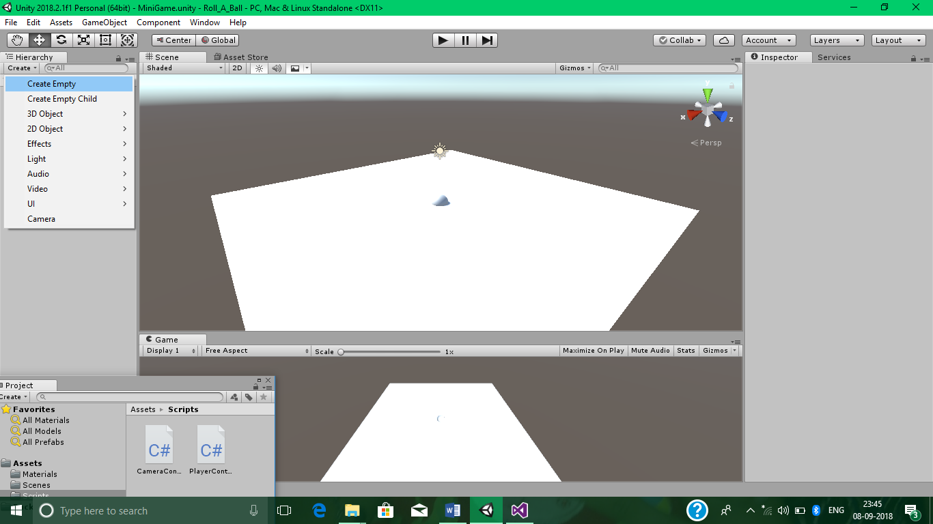

Reset it in Rightside Panel.

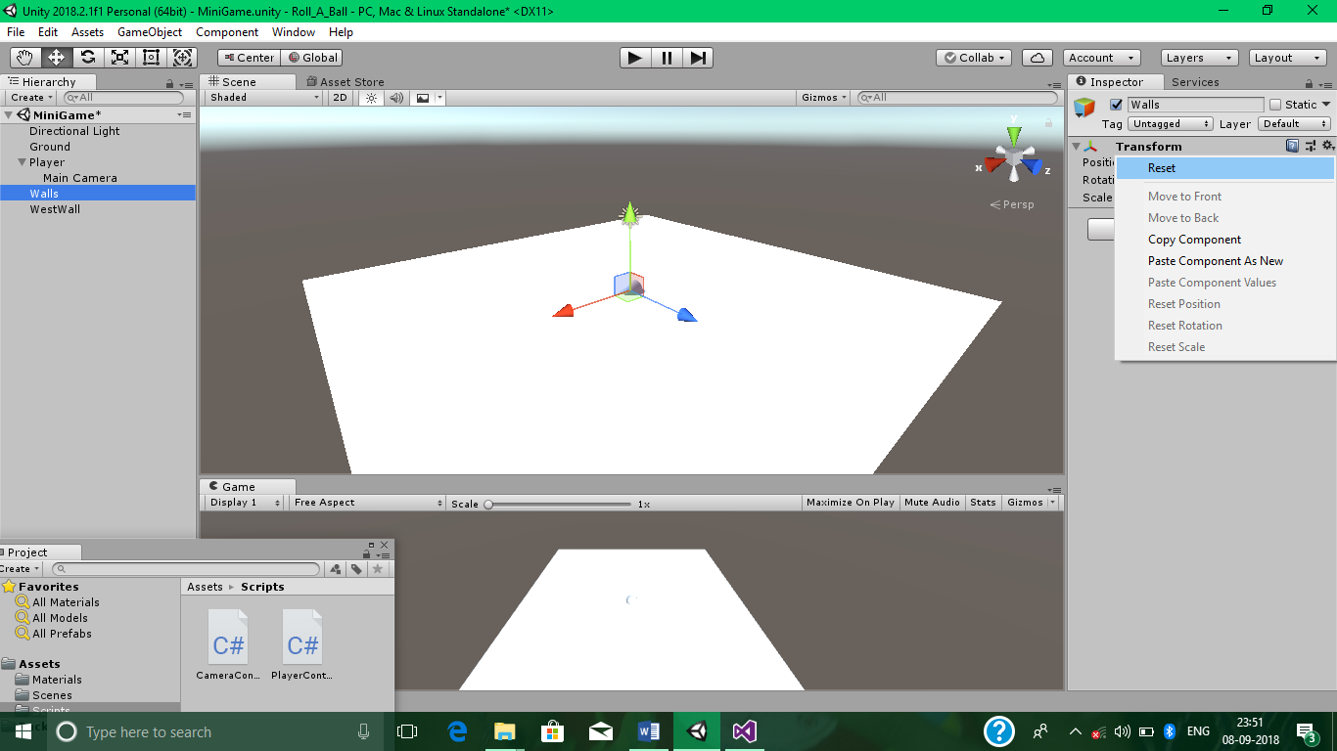

Go to Hierarchy>Create>3D Object>Cube and name it as WestWall and move it into Walls.

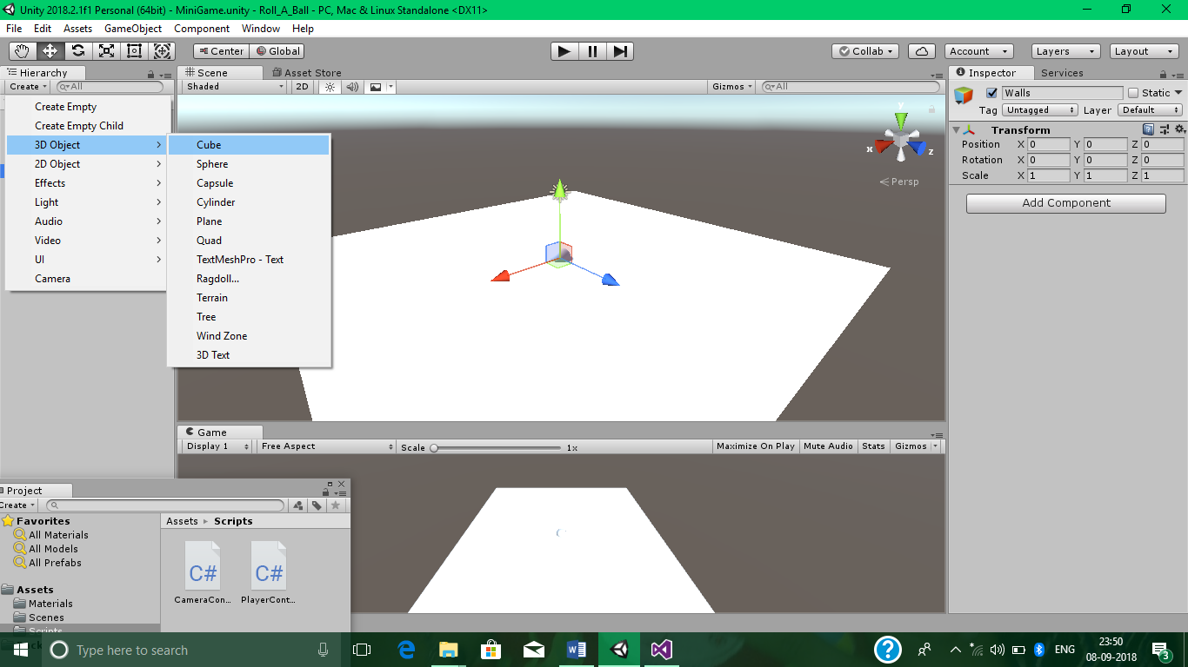 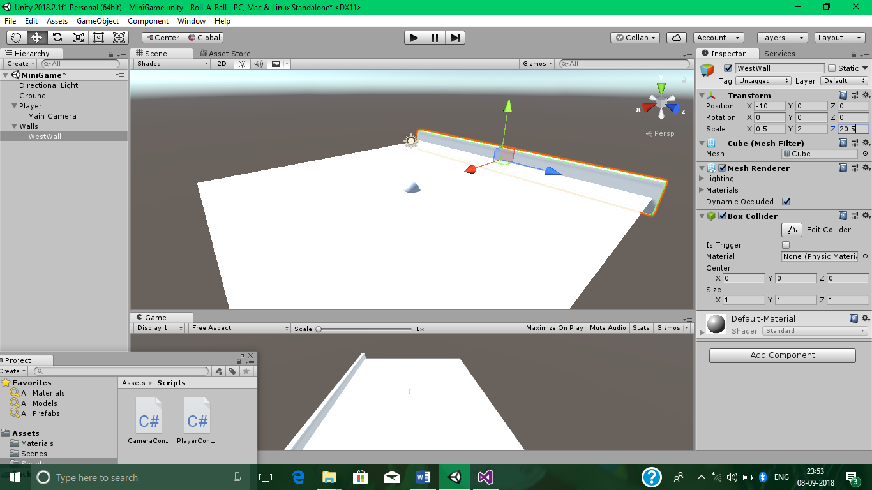

Set its proper Transforms.

Now, duplicate it 3 times and give names as EastWall, NorthWall and SouthWall.

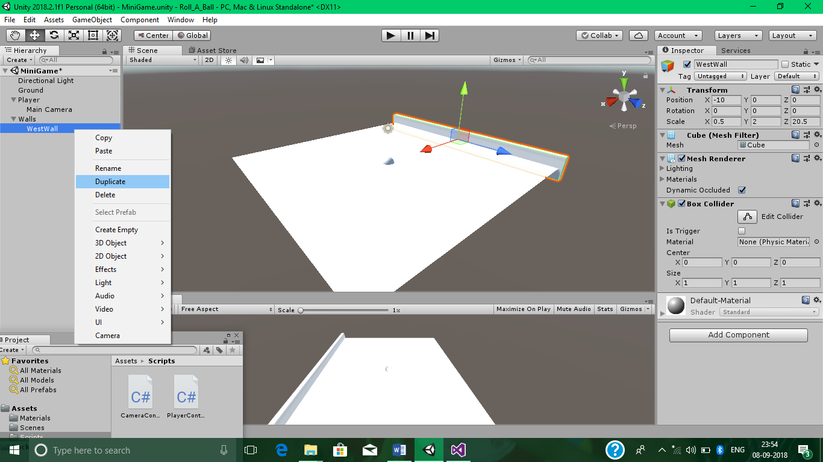 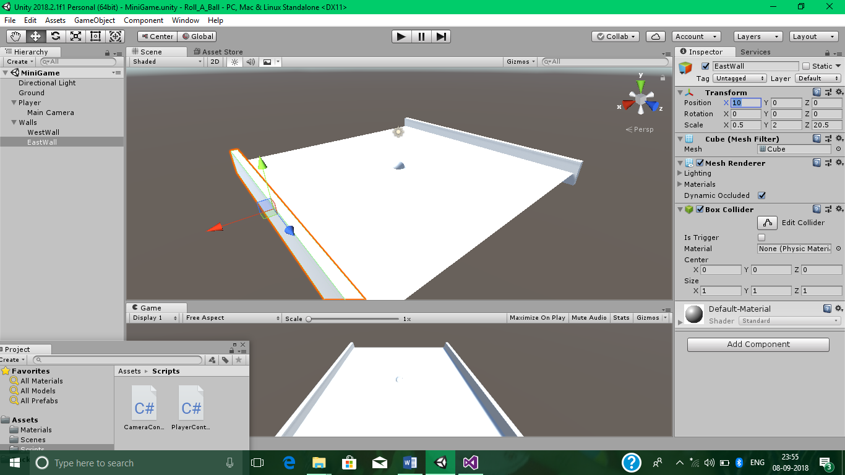

Again set Transforms of each Wall.

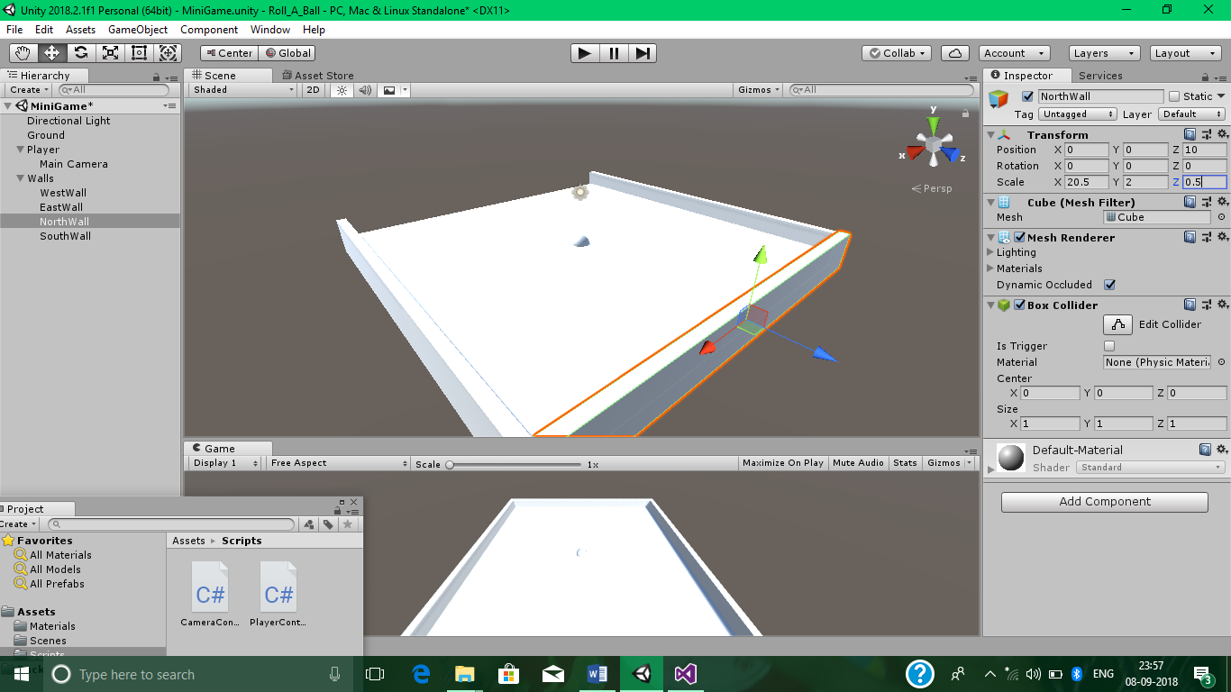 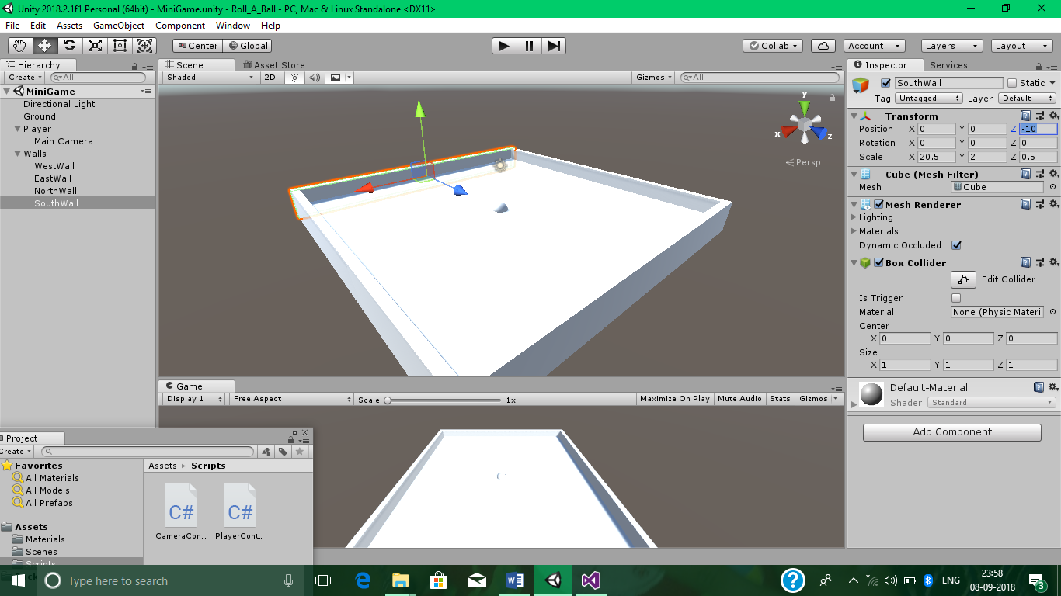

**3. Collecting, Scoring And Building The Game**

Creating Collectable Objects

Go to Hierarchy>Create>3D Object>Cube and name it as PickUp and reset it.



Deactivate the Player control for some time to concerntrate on PickUps.

Uncheck the checkbox beside Player.

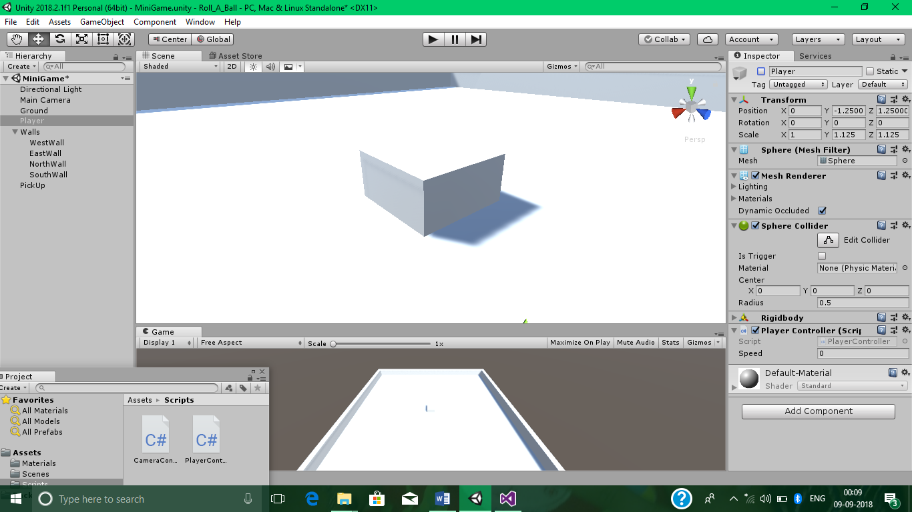

Now, change PickUp’s Transforms according to choice.

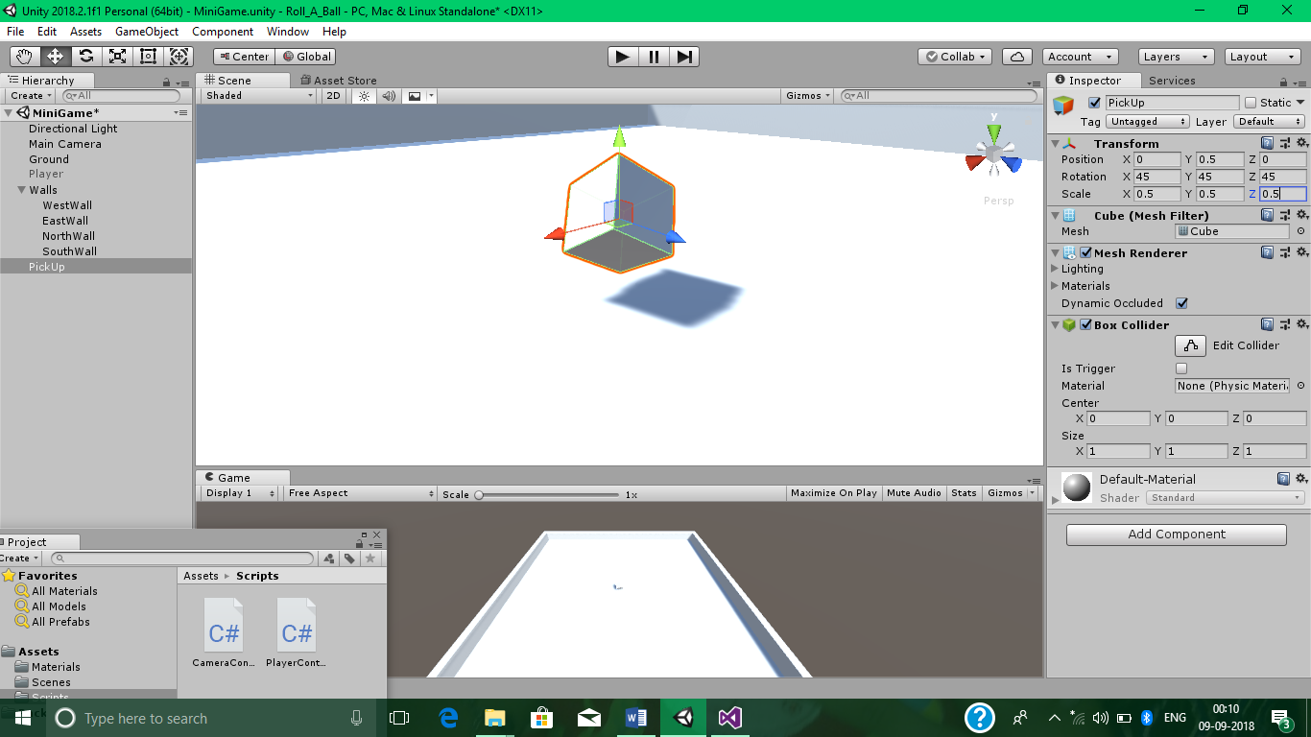

Add a New script in PickUp called Rotator and move it into Scripts folder.

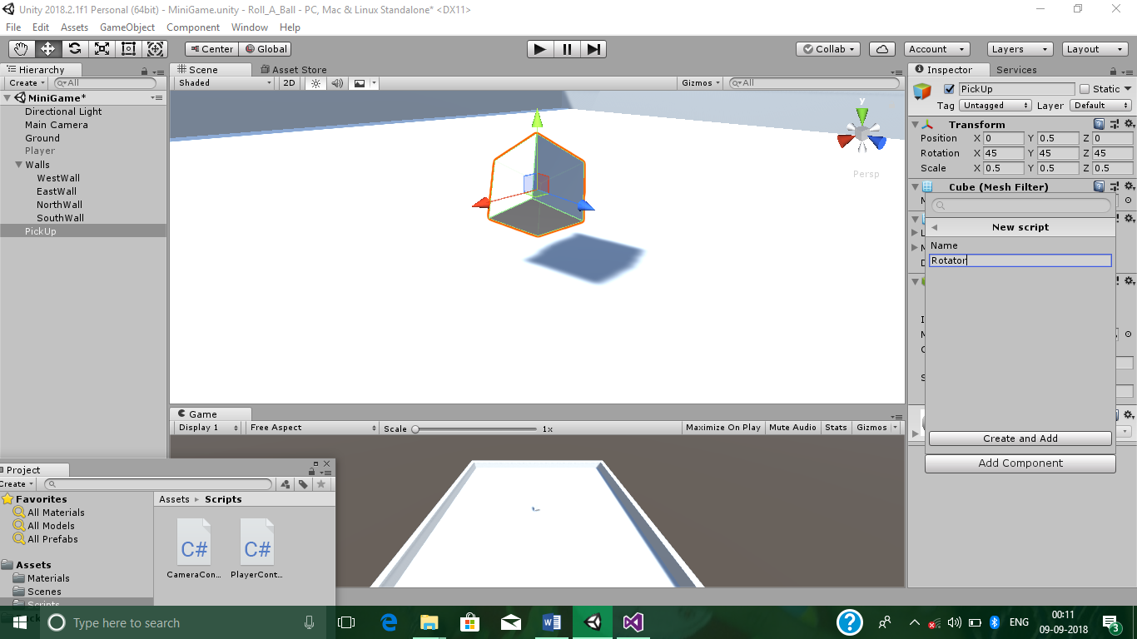

Open Rotator Script File in Visual Studio and Write the following code.

Rotator.cs

using System.Collections;

using System.Collections.Generic;

using UnityEngine;

public class Rotator : MonoBehaviour {

// Update is called once per frame

void Update()

{

transform.Rotate(new Vector3(15, 30, 45) * Time.deltaTime);

}

}

Create a New Folder called Prefabs and place the PickUp into it.

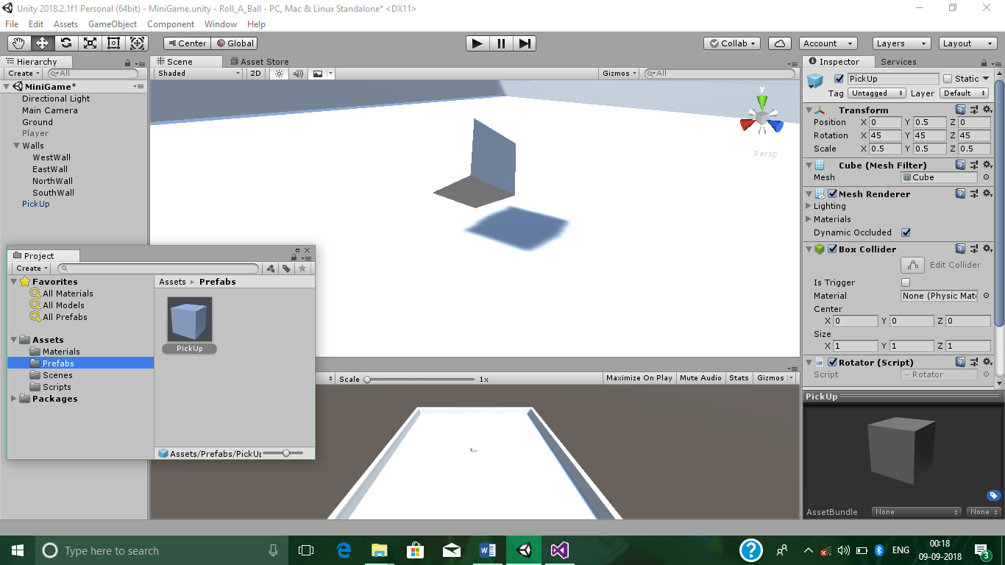

Go to Hierarchy>Create>Create Empty and name it as PickUps.

Move the created single PickUp into it.



Duplicate the PickUp 11 times to create 12 PickUps.

Arrange all of them in a circle.

Bring our Player back by checking the checkbox beside it.

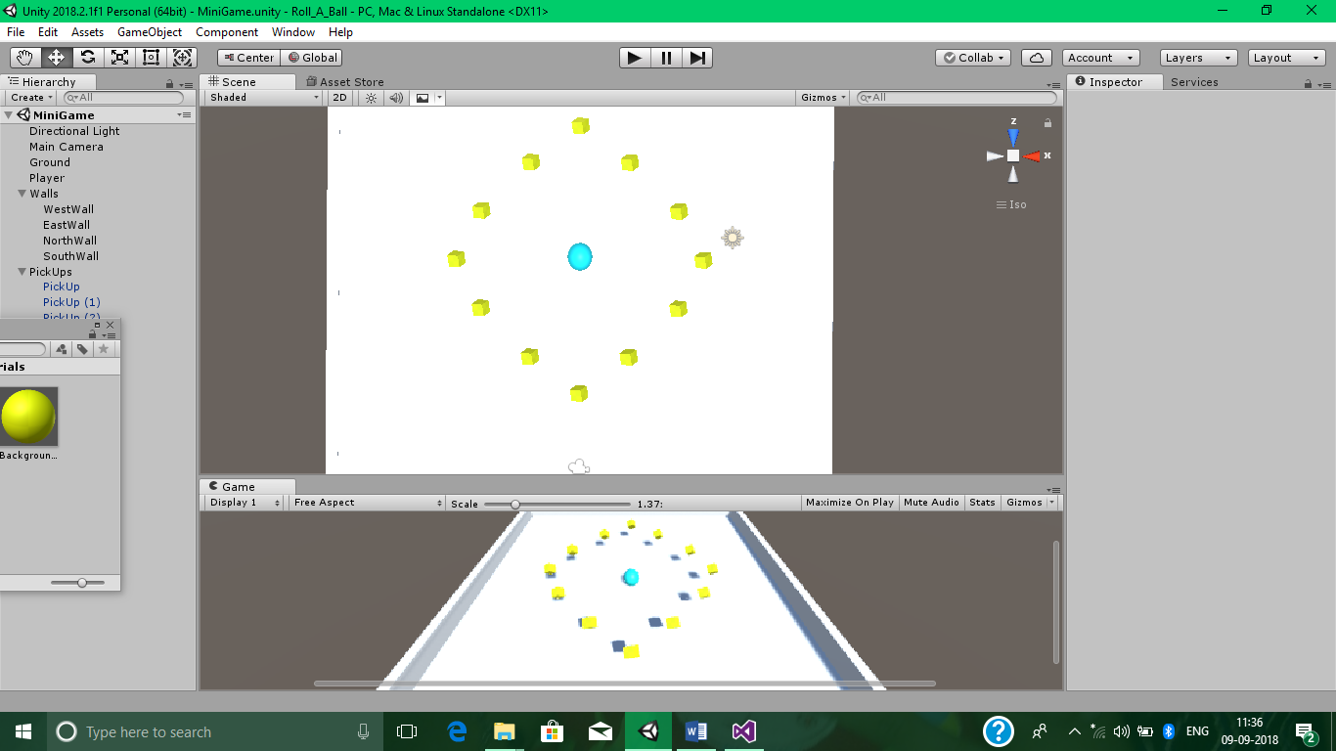

Collecting The PickUp Objects

To turn PickUps False after colliding with it Our Player.

Add the following code in PlayerController Script File.

PlayerController.cs

void OnTriggerEnter(Collider other)

{

if(other.gameObject.CompareTag("PickUp"))

{

other.gameObject.SetActive(false);

}

}

Now We have to Add a PickUp Tag in Prefabs>PickUp.

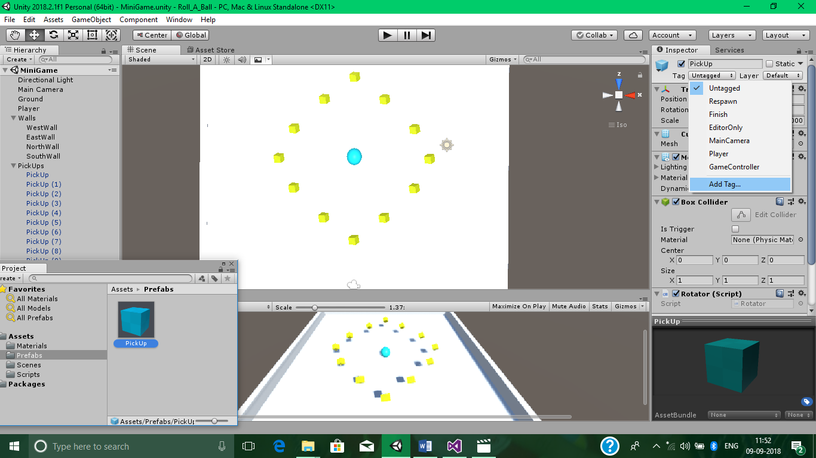

Click on ‘+’ sign.

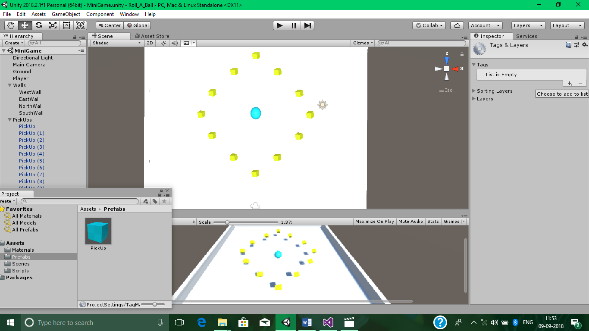

Name it as PickUp.

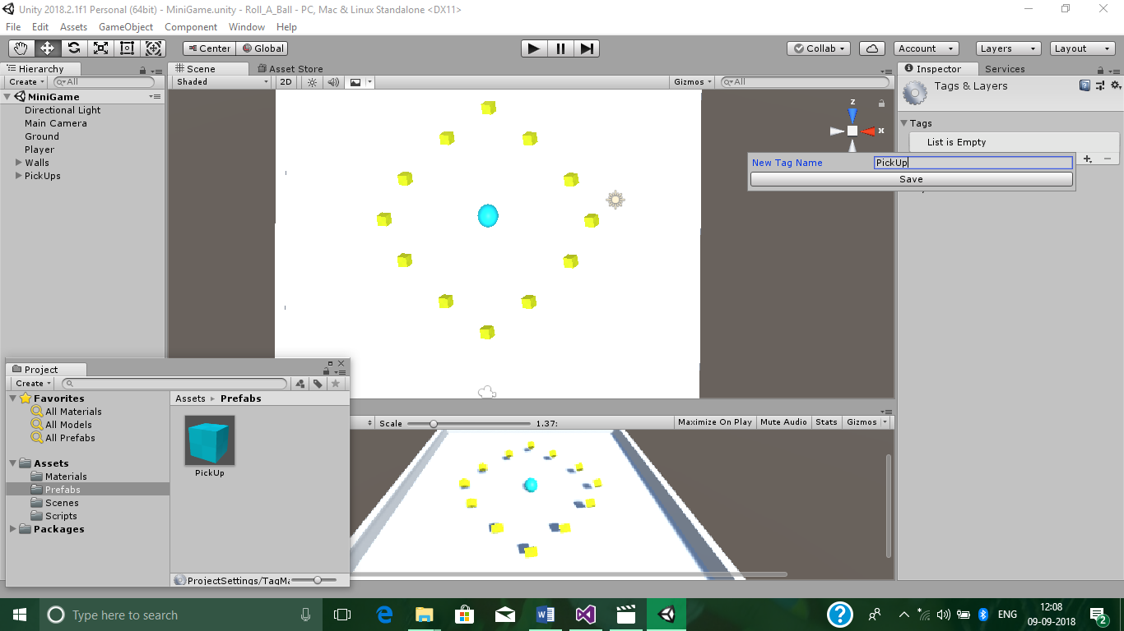

Now, Tag the Prefabs PickUp to our just created PickUp Tag.

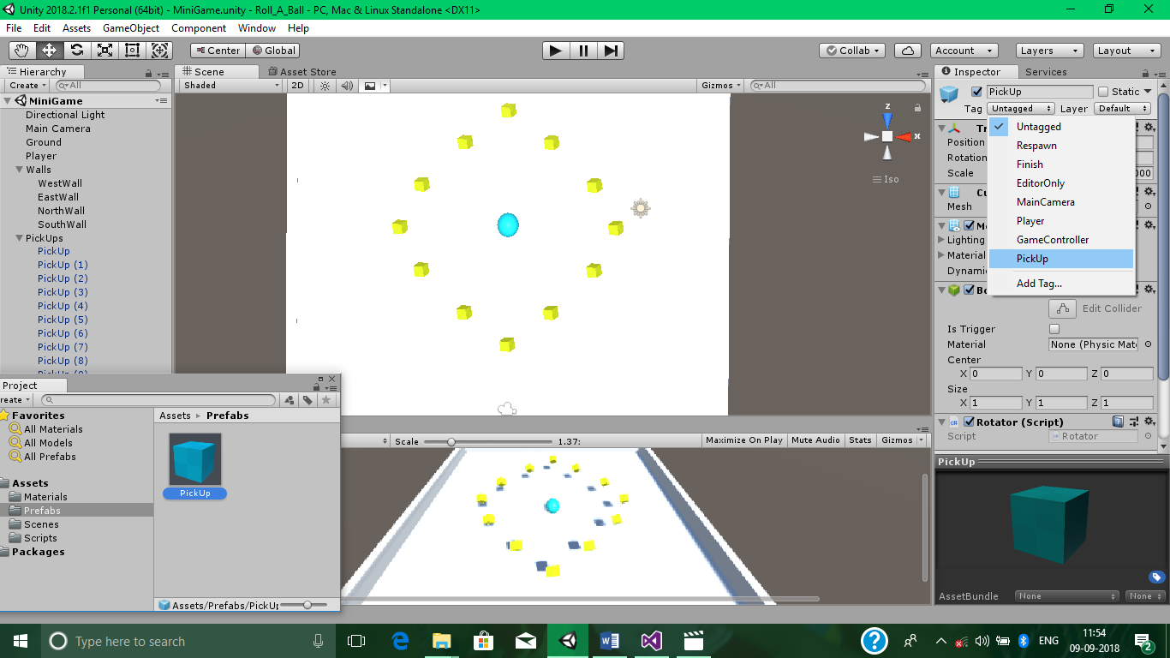

Also, Check the Box Collider’s Is Trigger option.

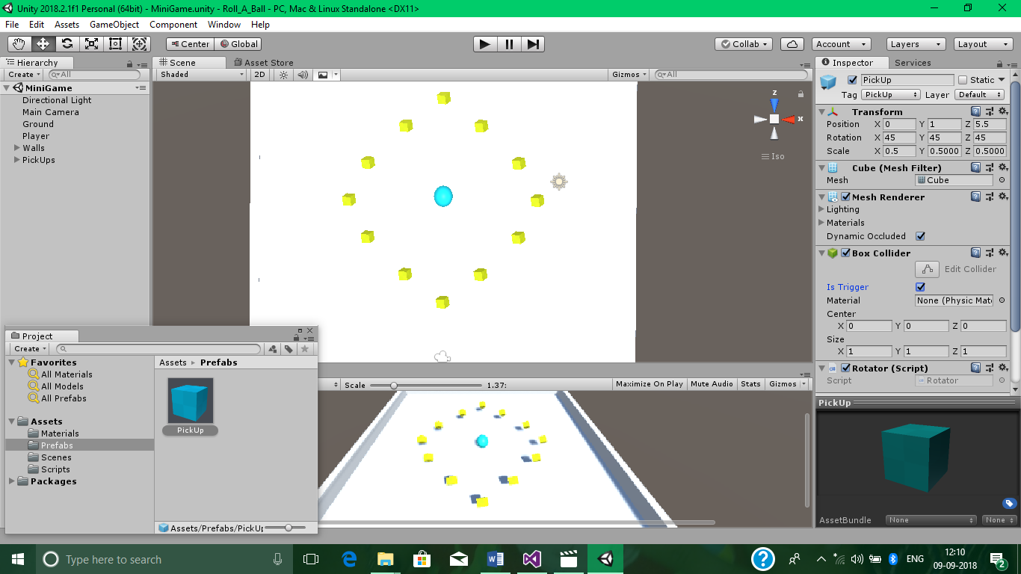

Add a Rigidbody Component in Prefabs>PickUp.

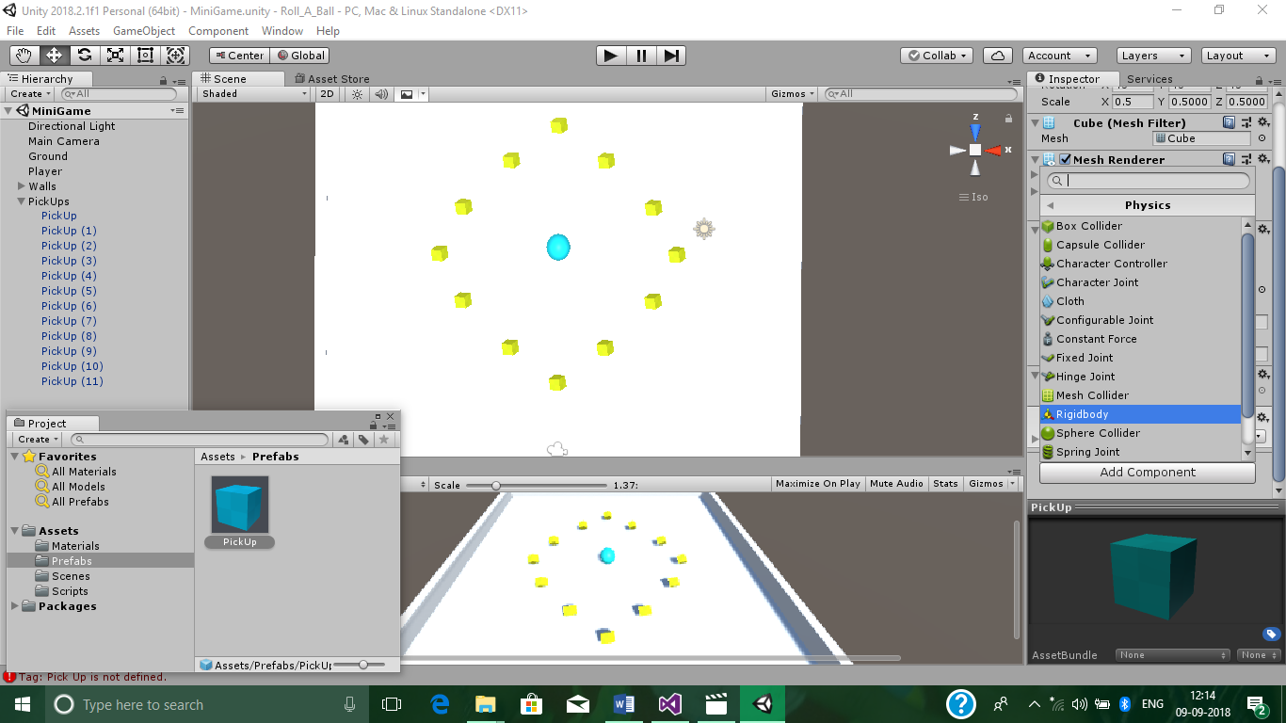Check the Gravity and Is Kinematic options of Rigidbody component.

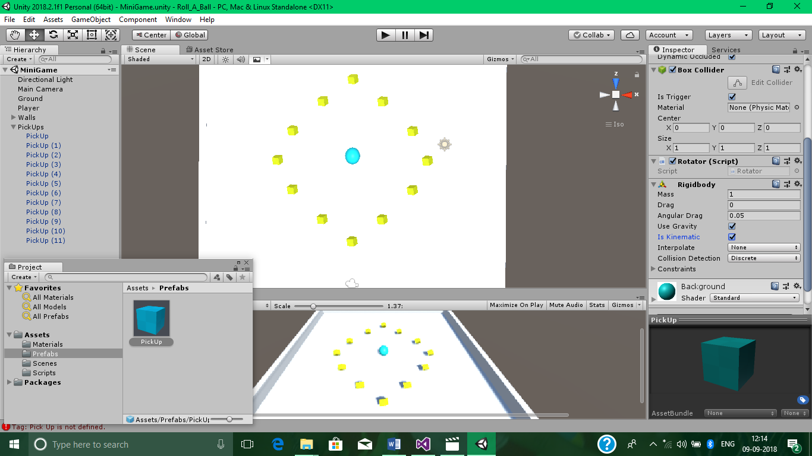

Test it by clicking on the play button in Top Center of the screen.

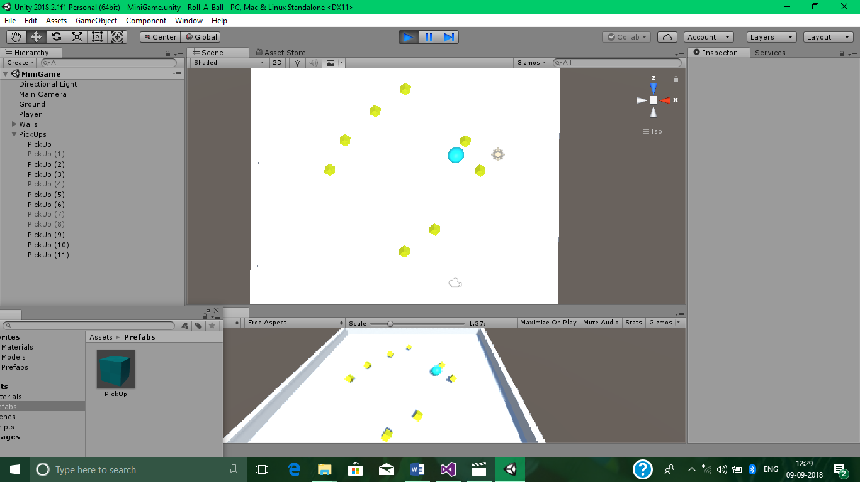

Displaying The Score And Text

To display Count Text, Go to Hierarchy>Create>UI>Text and name it as CountText.

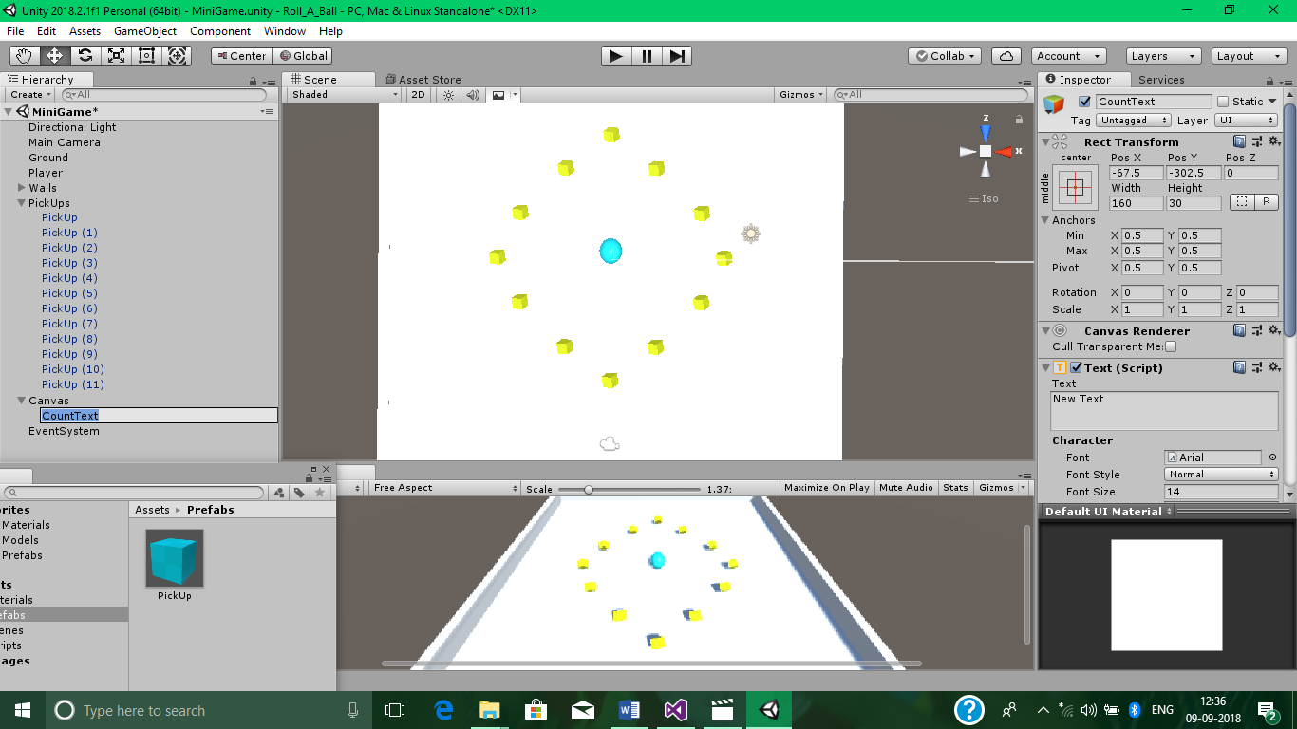

Set its Anchor to Top Left.

Set different properties of it as shown below.

Set the CountText for Player by dragging it into Player’s Count Text option.

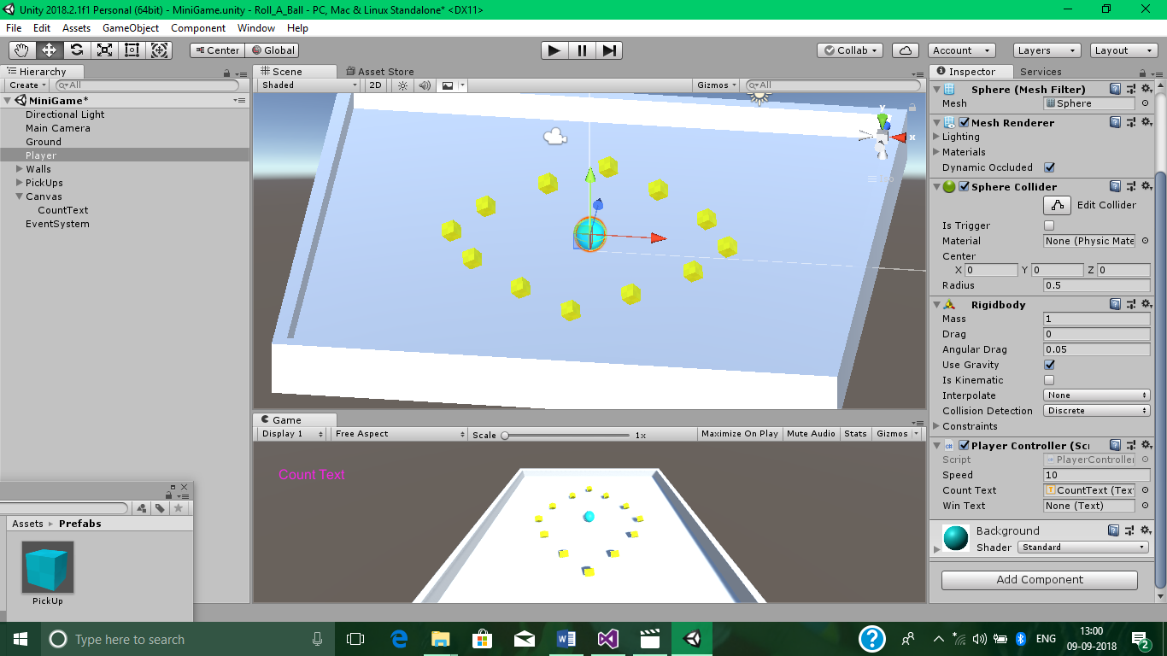

To display Win Text, Go to Hierarchy>Create>UI>Text and name it as WinText.

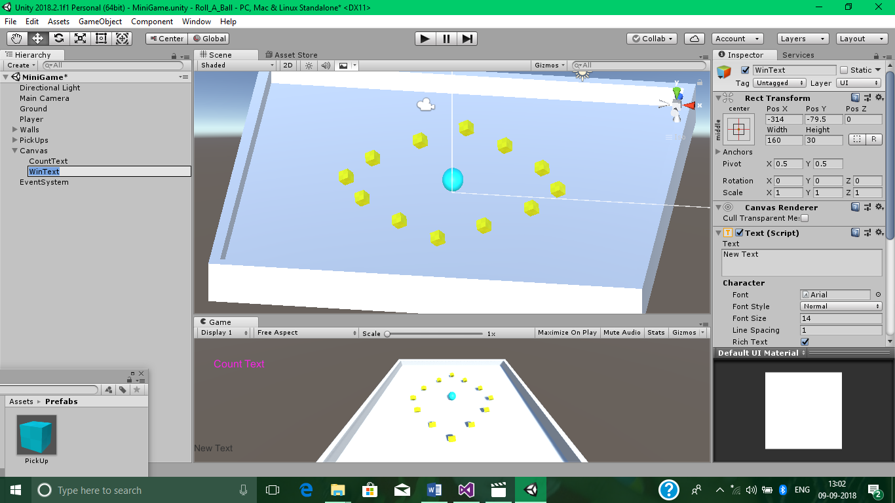

Set its Anchor to Center Middle.

Set different properties of it as shown below.

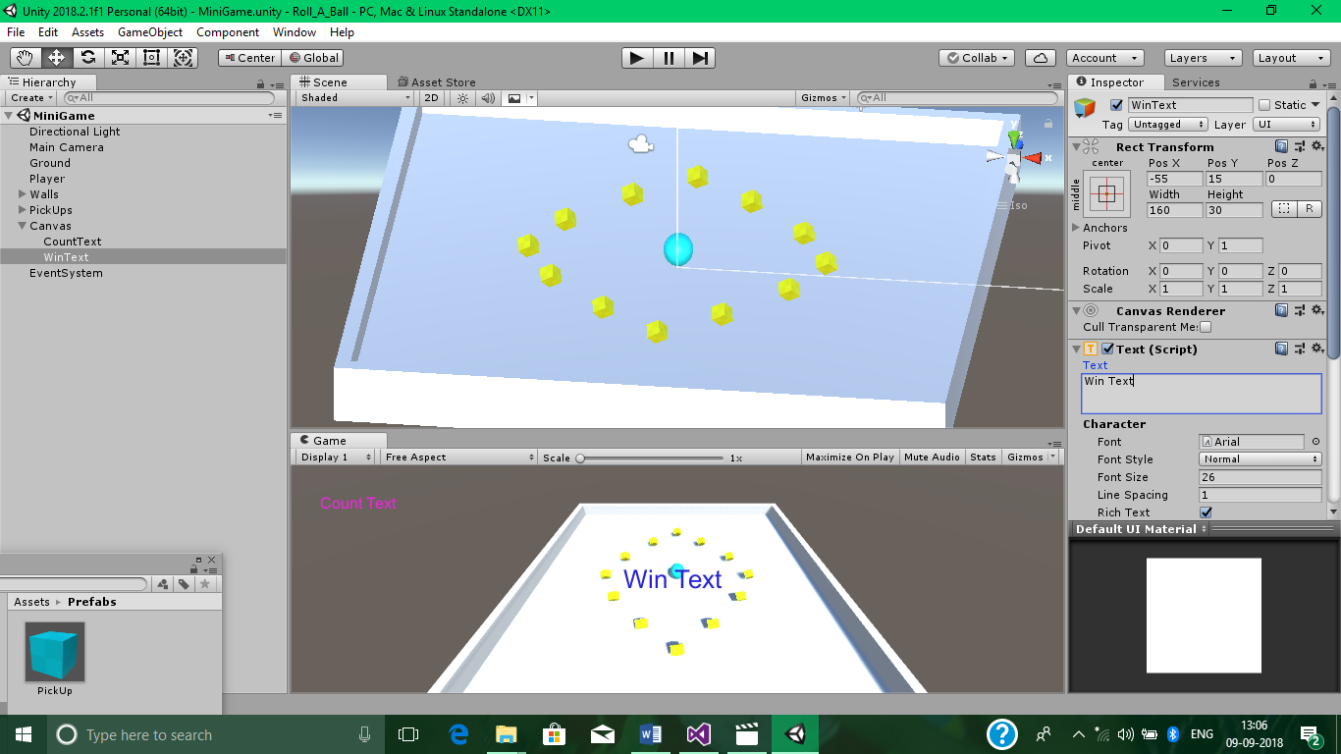

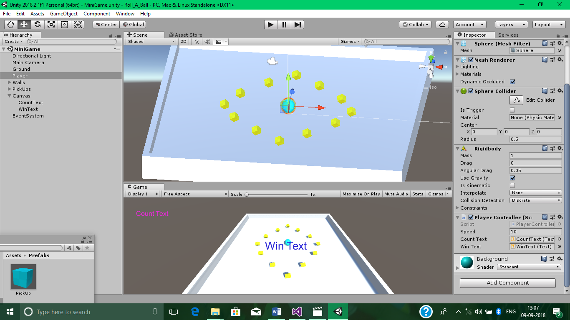

Now for calculating and displaying the Count Text and the Win Text.

Add some code in PlayerController Script File as shown below.

Rest of the code of above will be as it is.

PlayerController.cs

using UnityEngine.UI;

public class PlayerController : MonoBehaviour

{

public Text countText;

public Text winText;

private int count;

// Use this for initialization

void Start()

{

count = 0;

SetCountText();

winText.text = "";

}

void OnTriggerEnter(Collider other)

{

if (other.gameObject.CompareTag("PickUp"))

{

other.gameObject.SetActive(false);

count = count + 1;

SetCountText();

}

}

void SetCountText()

{

countText.text = "Count : " + count.ToString();

if (count >= 12)

{

winText.text = "You Won!";

}

}}

Finally, Play your Roll A Ball Game.

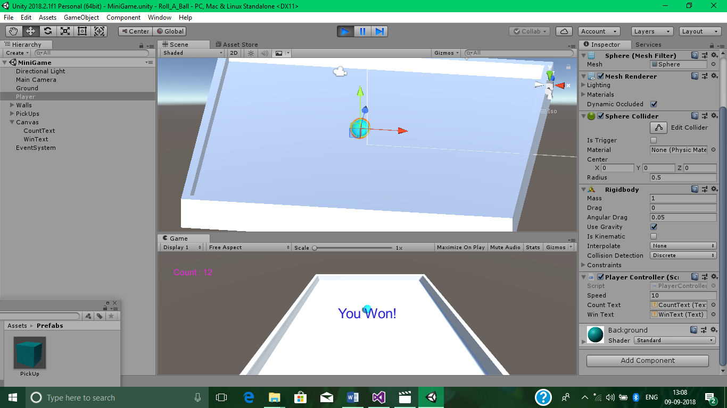

Extra Practical 1

**AIM : Creating a 2d unity game where ball continous bounces with different objects like sticks and bricks.**

**Step 1) Create a new Project and name this mygame1**

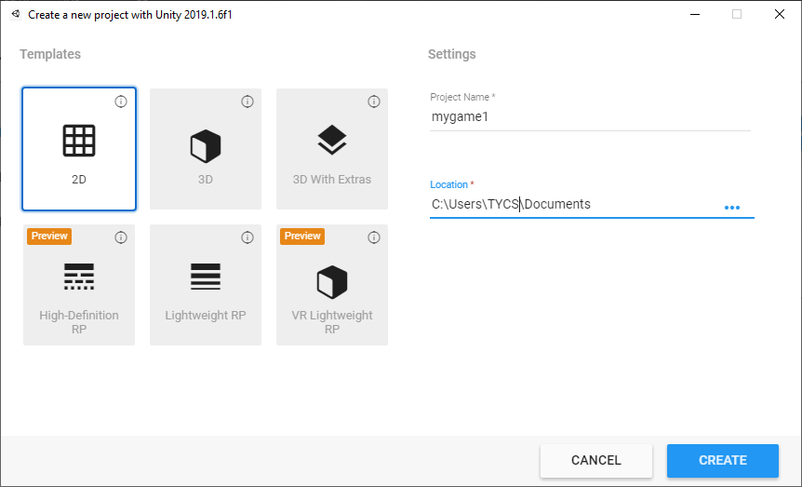

**Step 2) Import the Assets from the folder**

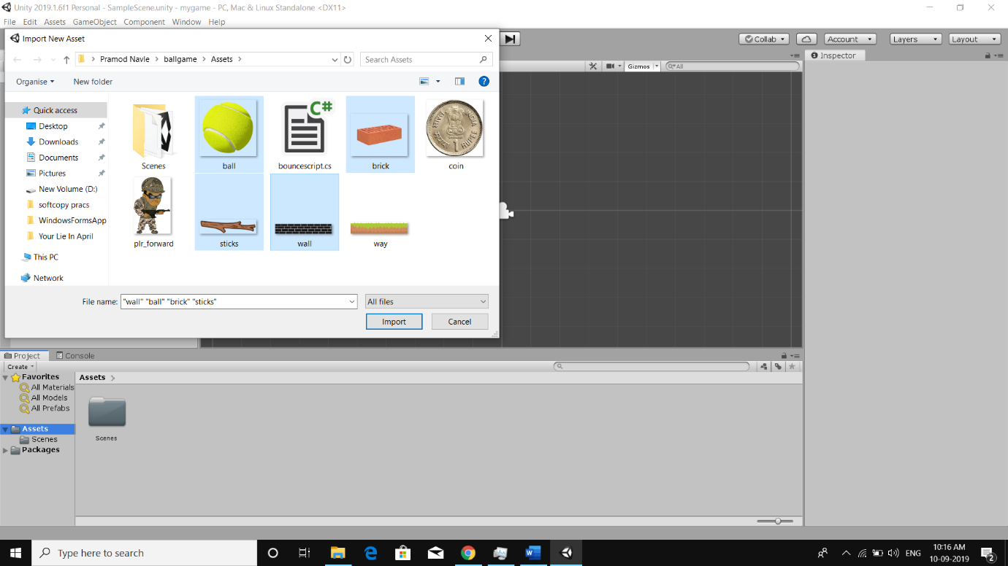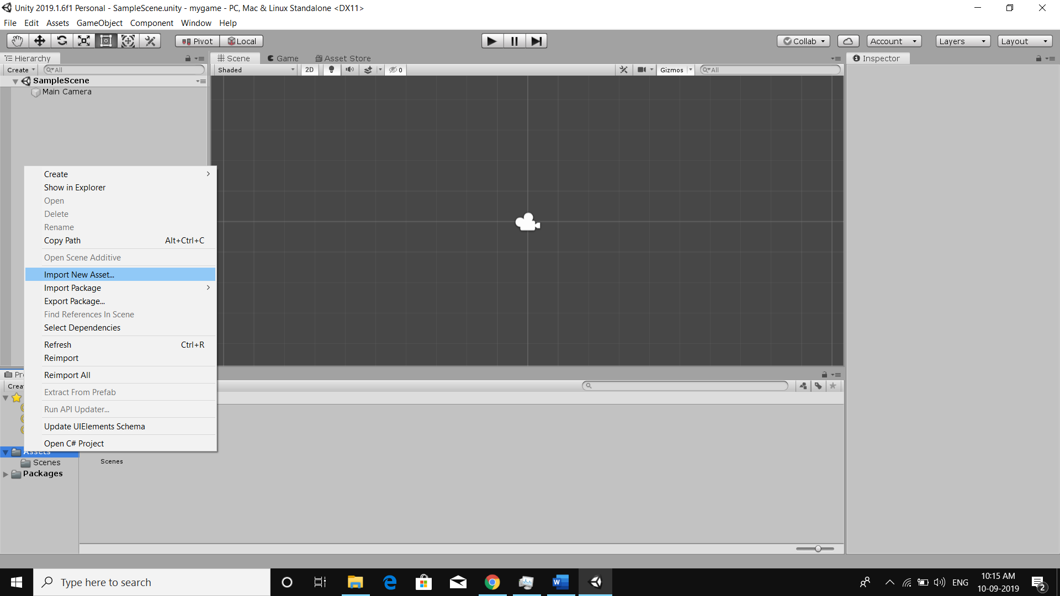

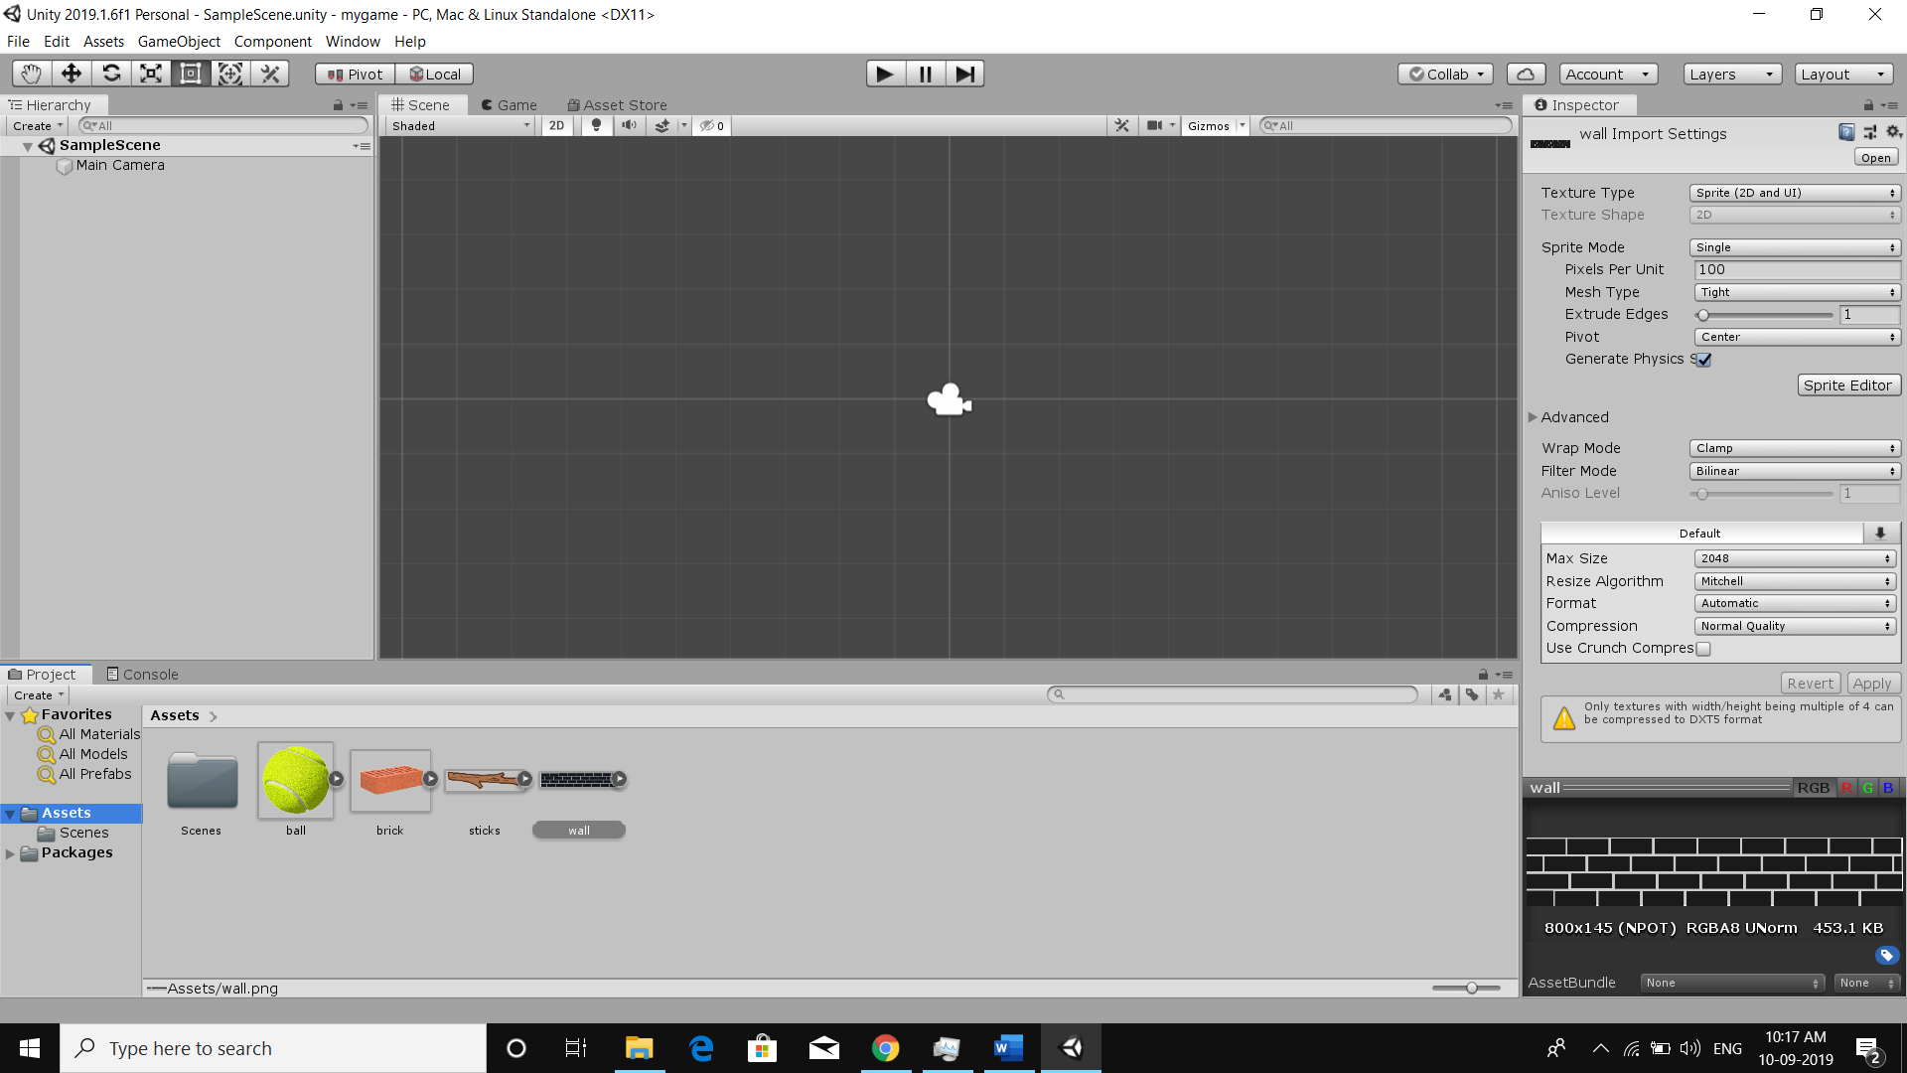

**Step 3) Drag and Drop all the assets into the scene :**

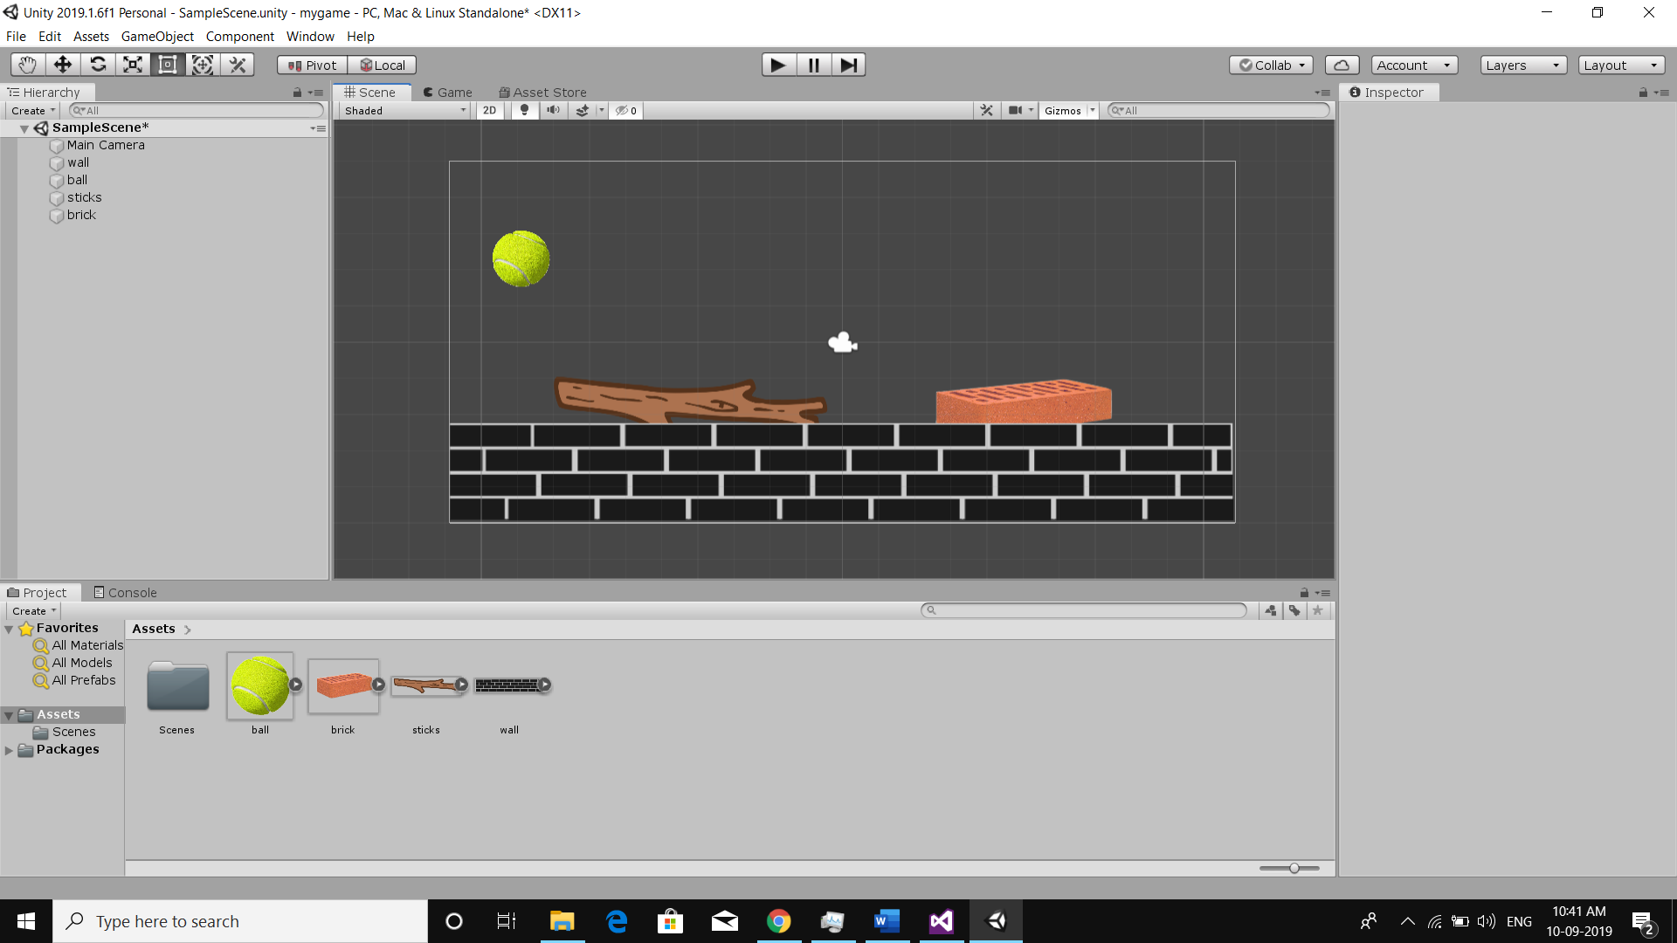

**Step 4) add the colliders circle and box colliders**

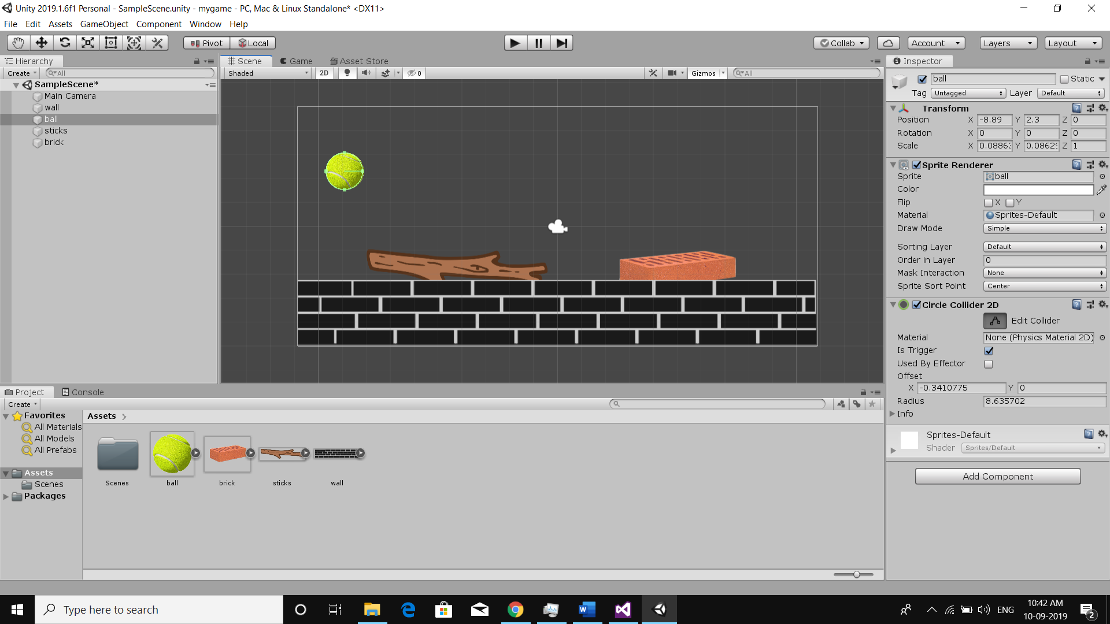

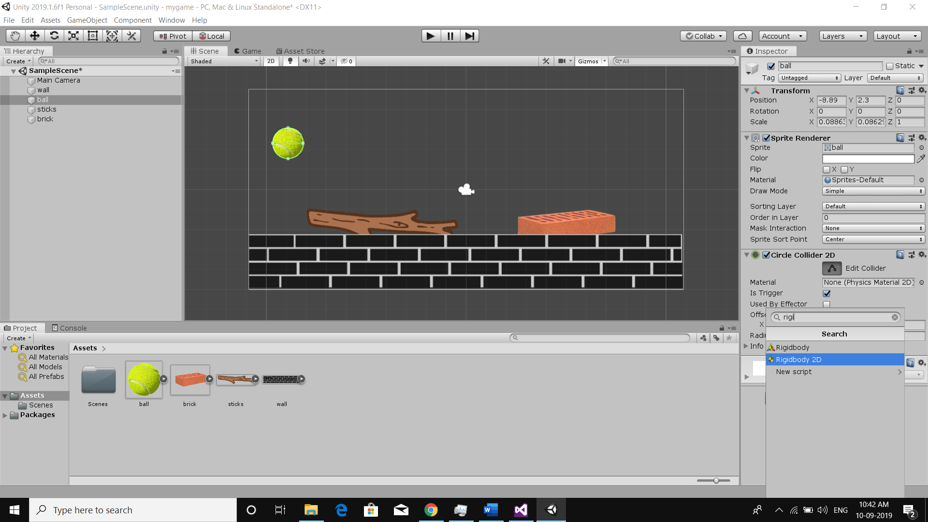

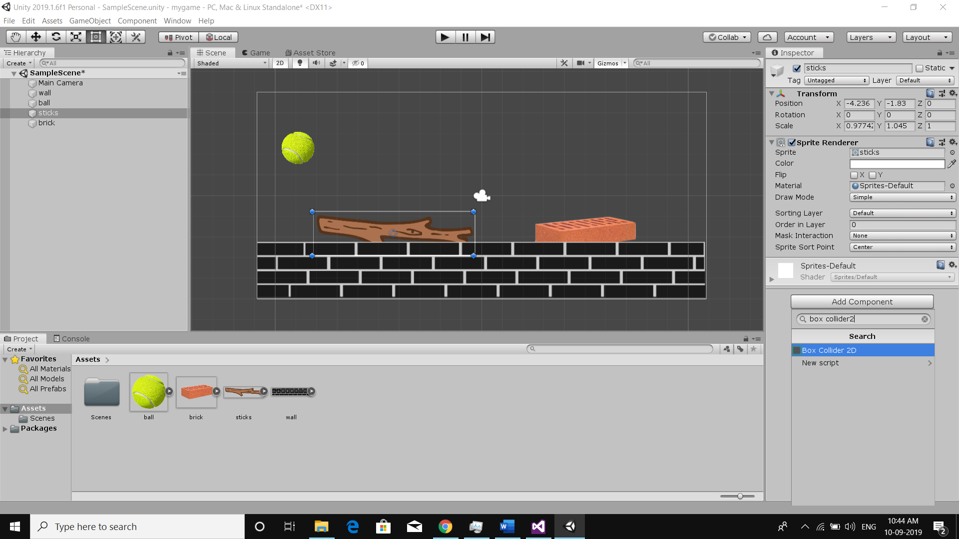

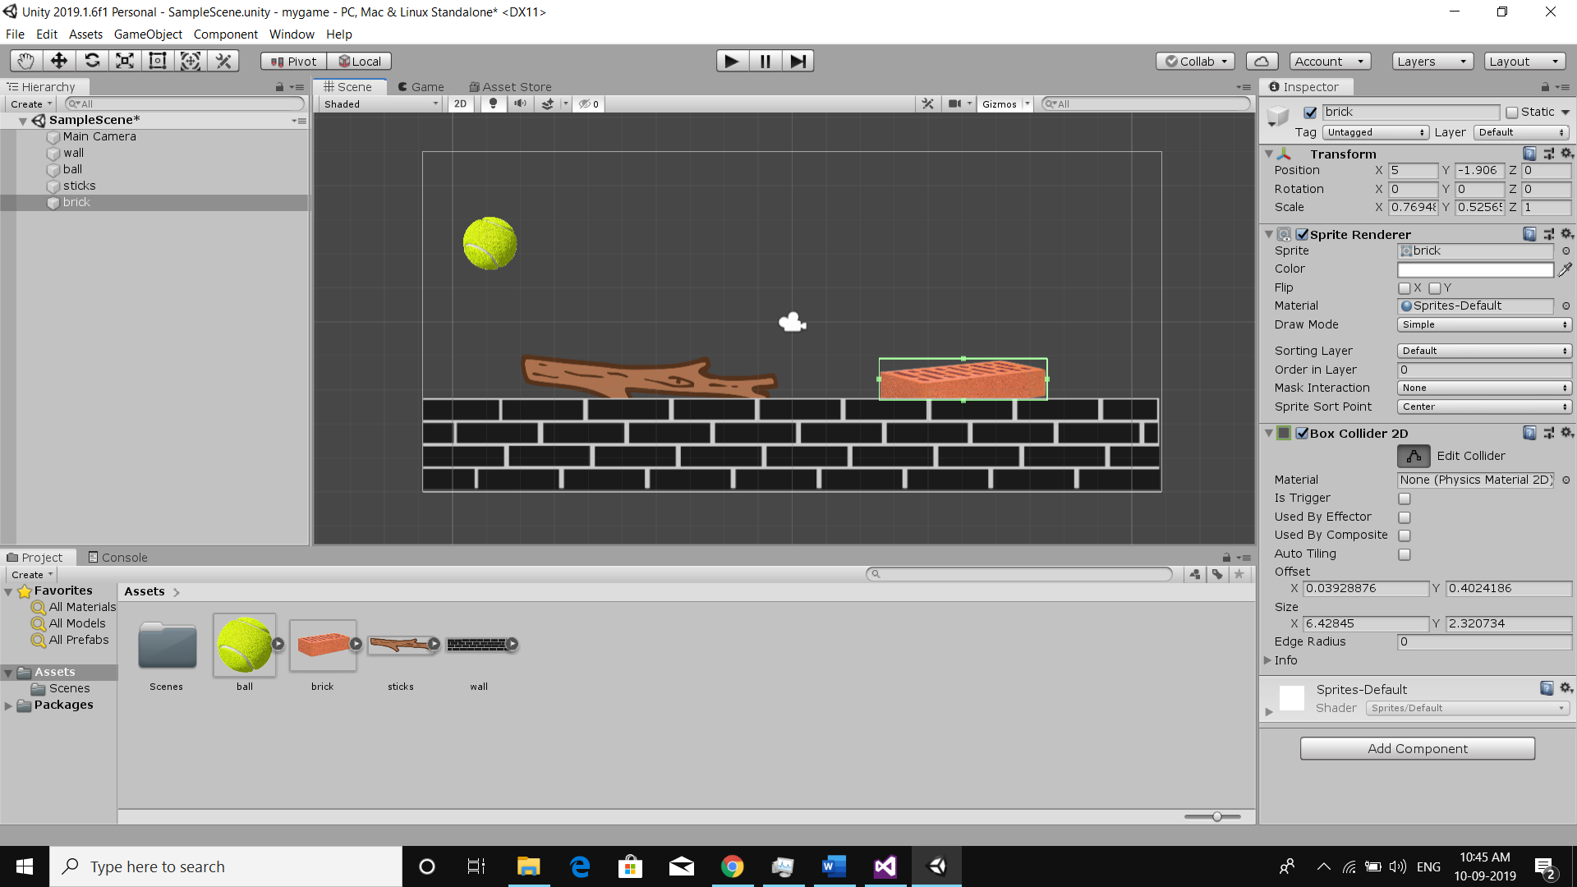

**Step 5) Give proper tag names to the gameobjects.**

Enable is trigger method on every colliders

Add a rigidbody2d to ball.

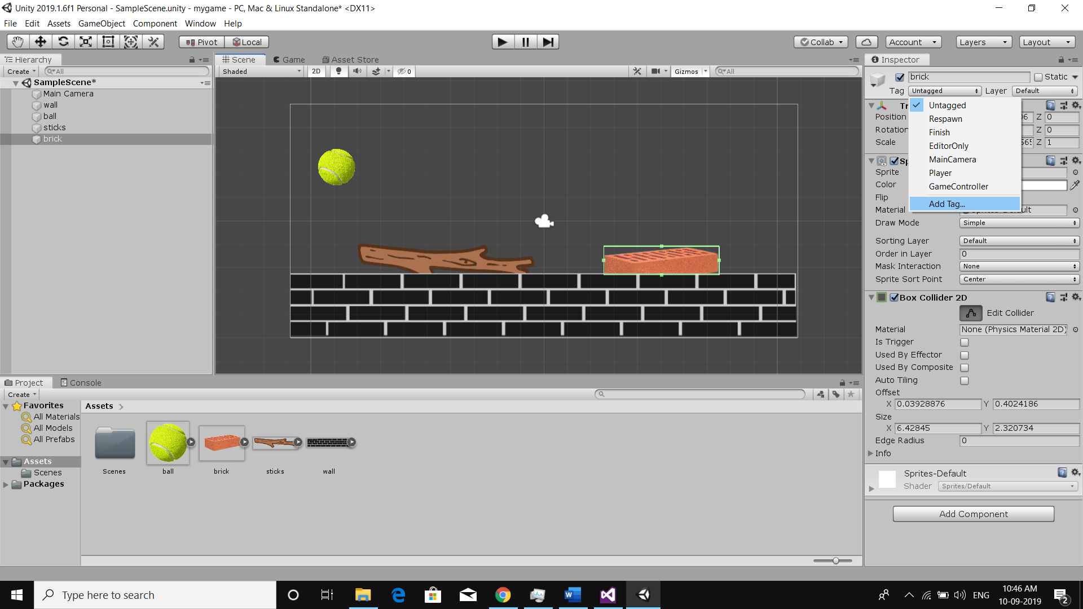 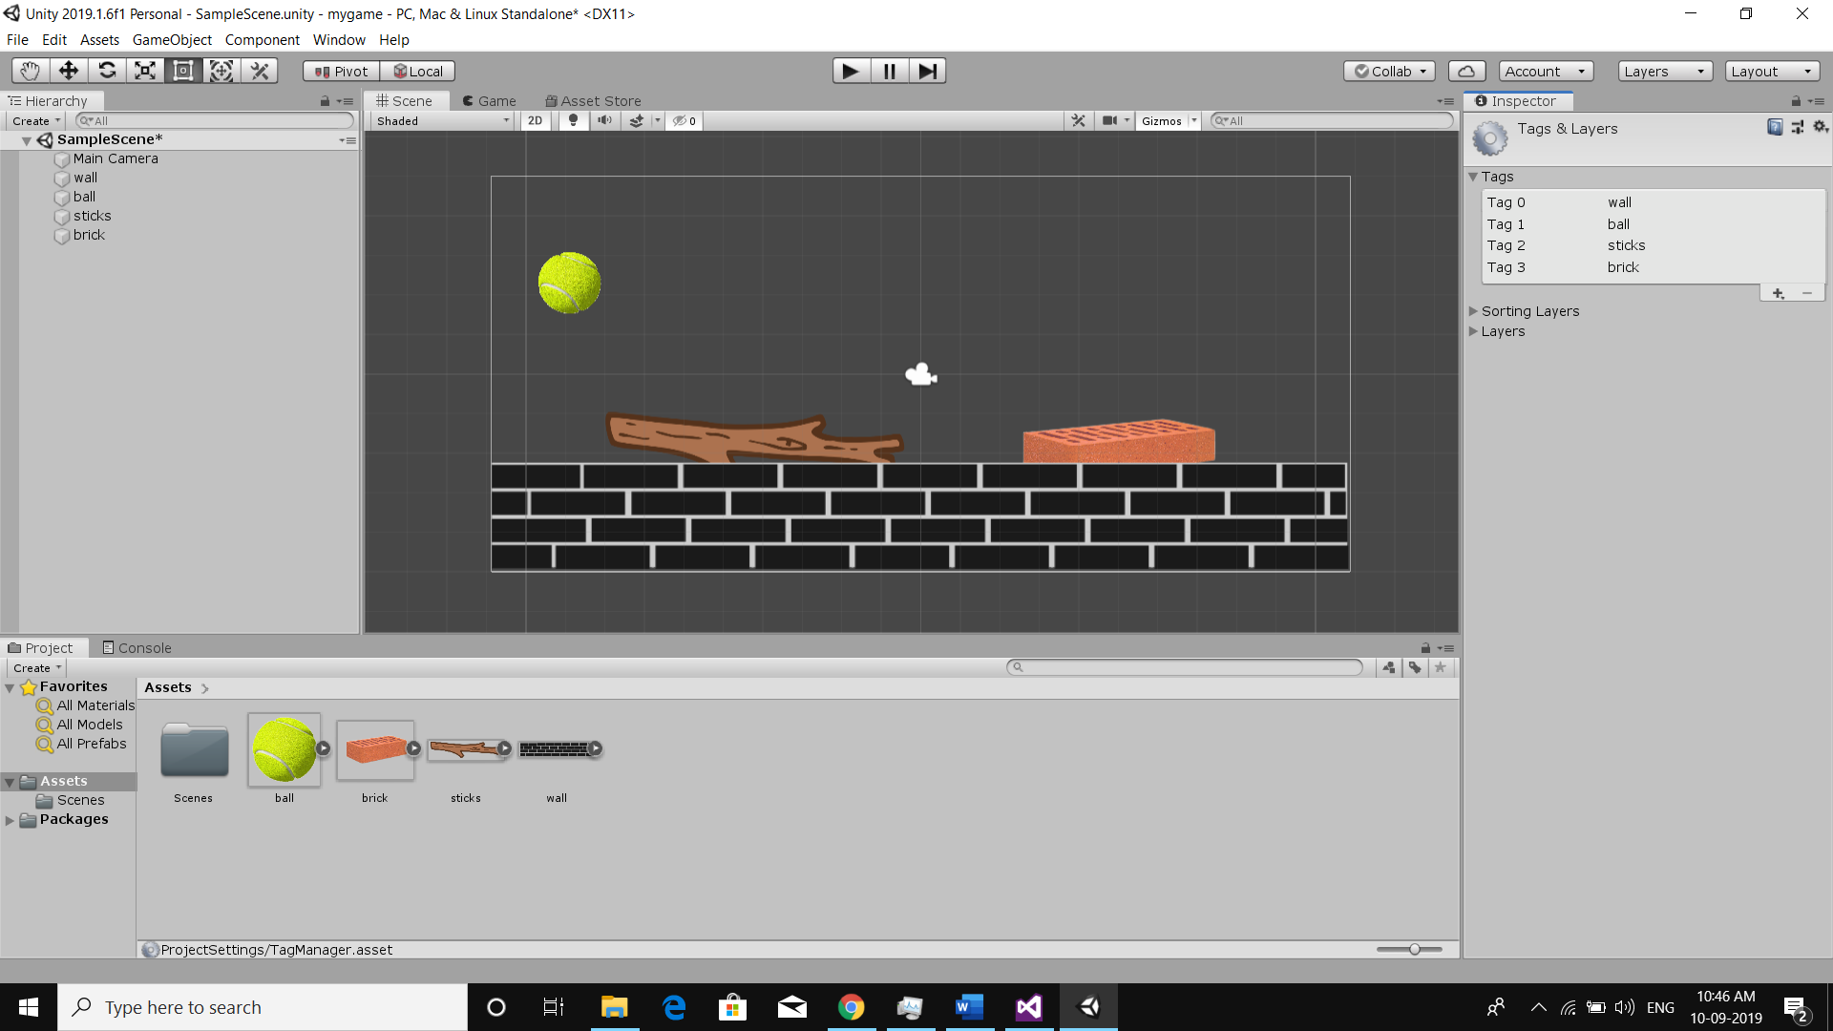

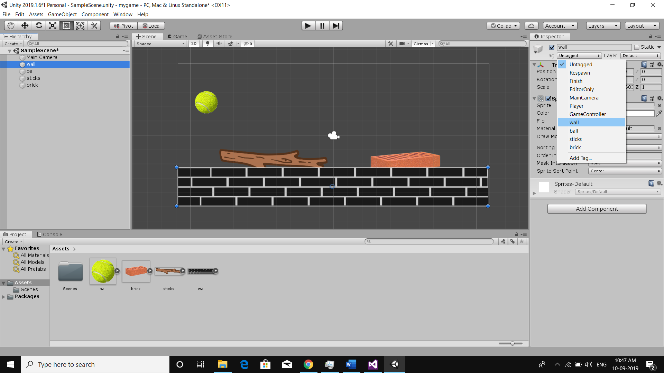

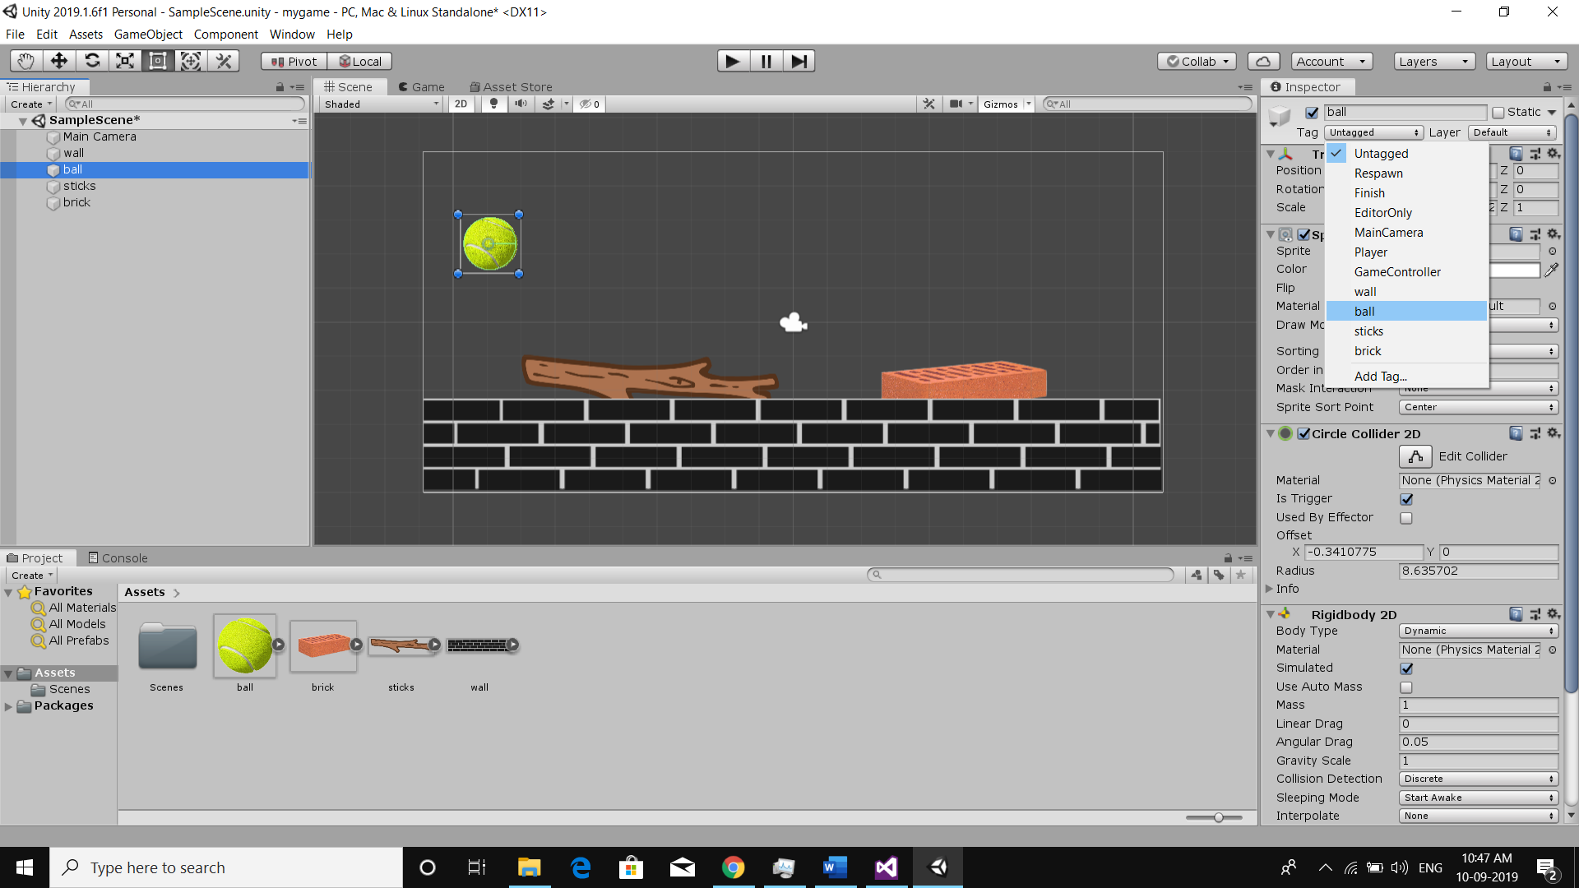

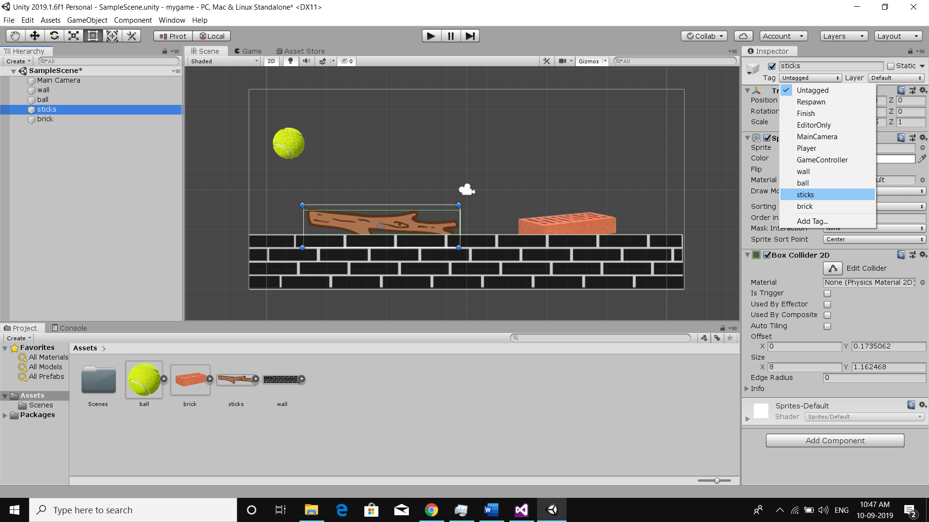

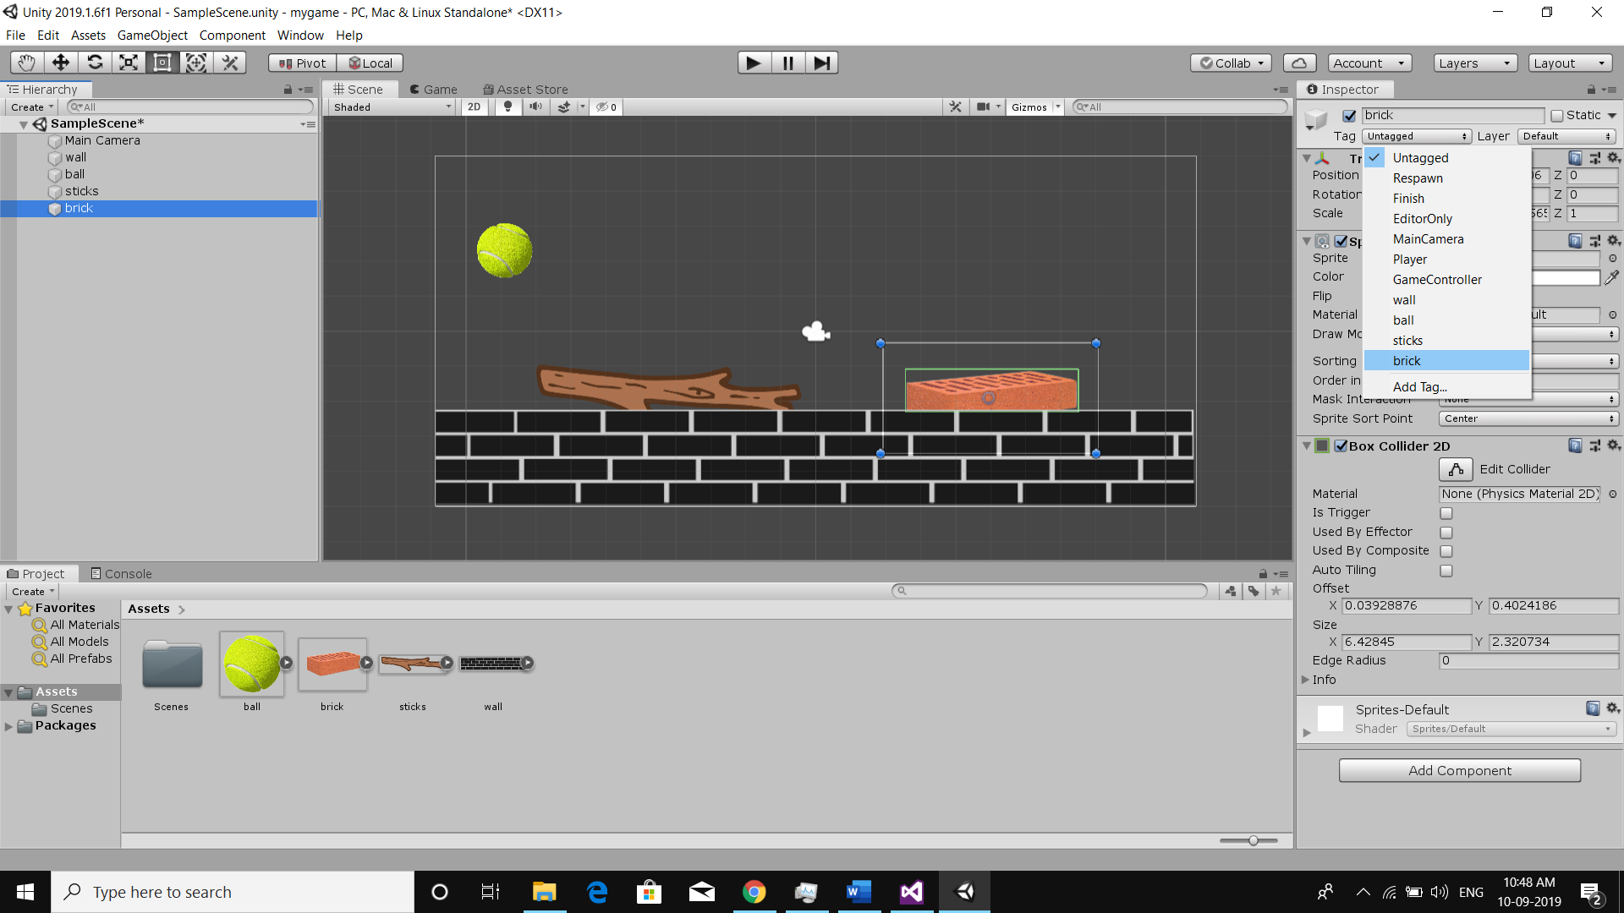

**Step 6) Now create a script named bouncescript and add these lines**

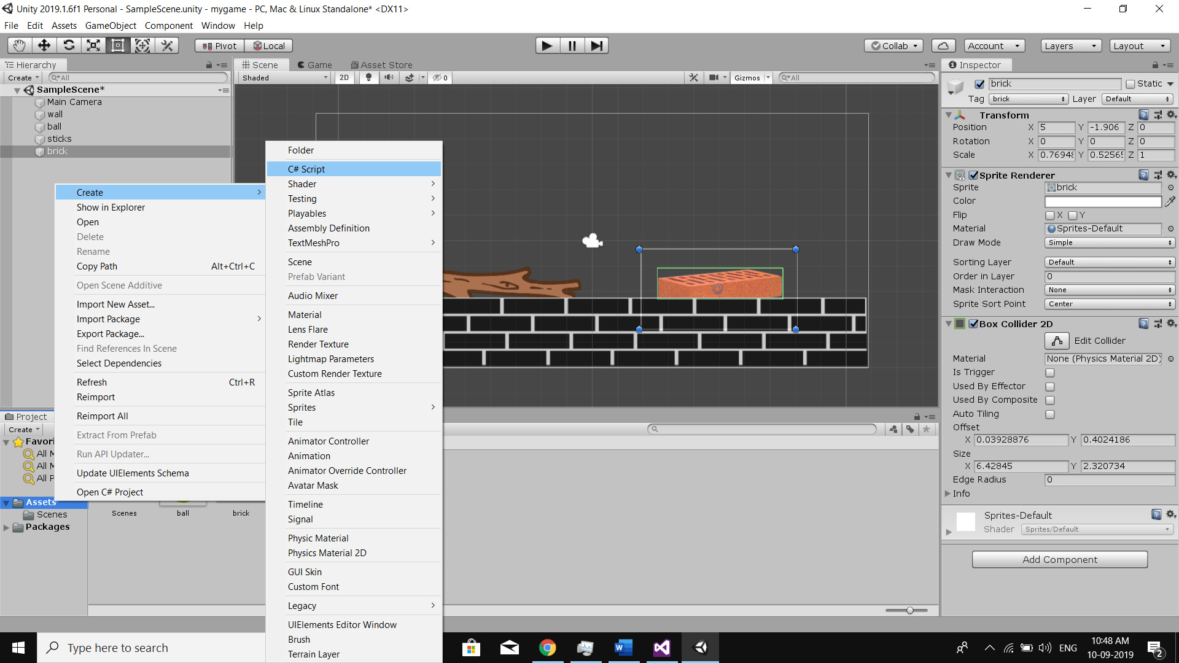

**Bouncescript.cs**

using System.Collections;

using System.Collections.Generic;

using UnityEngine;

public class bouncescript : MonoBehaviour

{

Rigidbody2D ball;

void Start()

{

ball = GetComponent<Rigidbody2D>();

}

void Update()

{

var x = Input.GetAxis("Horizontal") * Time.deltaTime * 150.0f;

var z = Input.GetAxis("Vertical") * Time.deltaTime * 3.0f;

transform.Rotate(x, 0, 0);

transform.Translate(z, 0, 0);

}

// Update is called once per frame

void OnTriggerEnter2D(Collider2D col)

{

if (col.tag == "wall")

{

ball.velocity = new Vector2(0, 0);

ball.AddForce(new Vector2(0, 8), ForceMode2D.Impulse);

}

if (col.tag == "sticks")

{

ball.velocity = new Vector2(0, 0);

ball.AddForce(new Vector2(0, 12), ForceMode2D.Impulse);

}

else

{

ball.velocity = new Vector2(0, 0);

ball.AddForce(new Vector2(0, 8), ForceMode2D.Impulse);

}

if (col.tag == "brick")

{

ball.velocity = new Vector2(0, 0);

ball.AddForce(new Vector2(0, 5), ForceMode2D.Impulse);

}

else

{

ball.velocity = new Vector2(0, 0);

ball.AddForce(new Vector2(0, 8), ForceMode2D.Impulse);

}

}

}

**Attach bouncescript to ball:**

**Use W & S to play:**

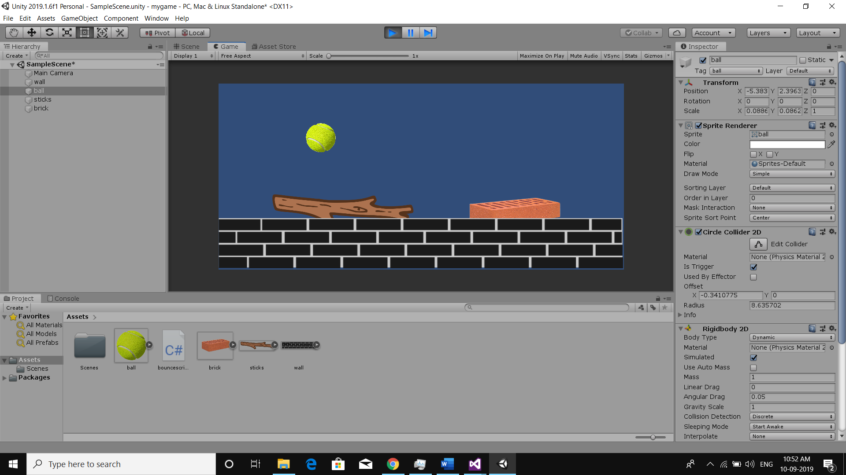

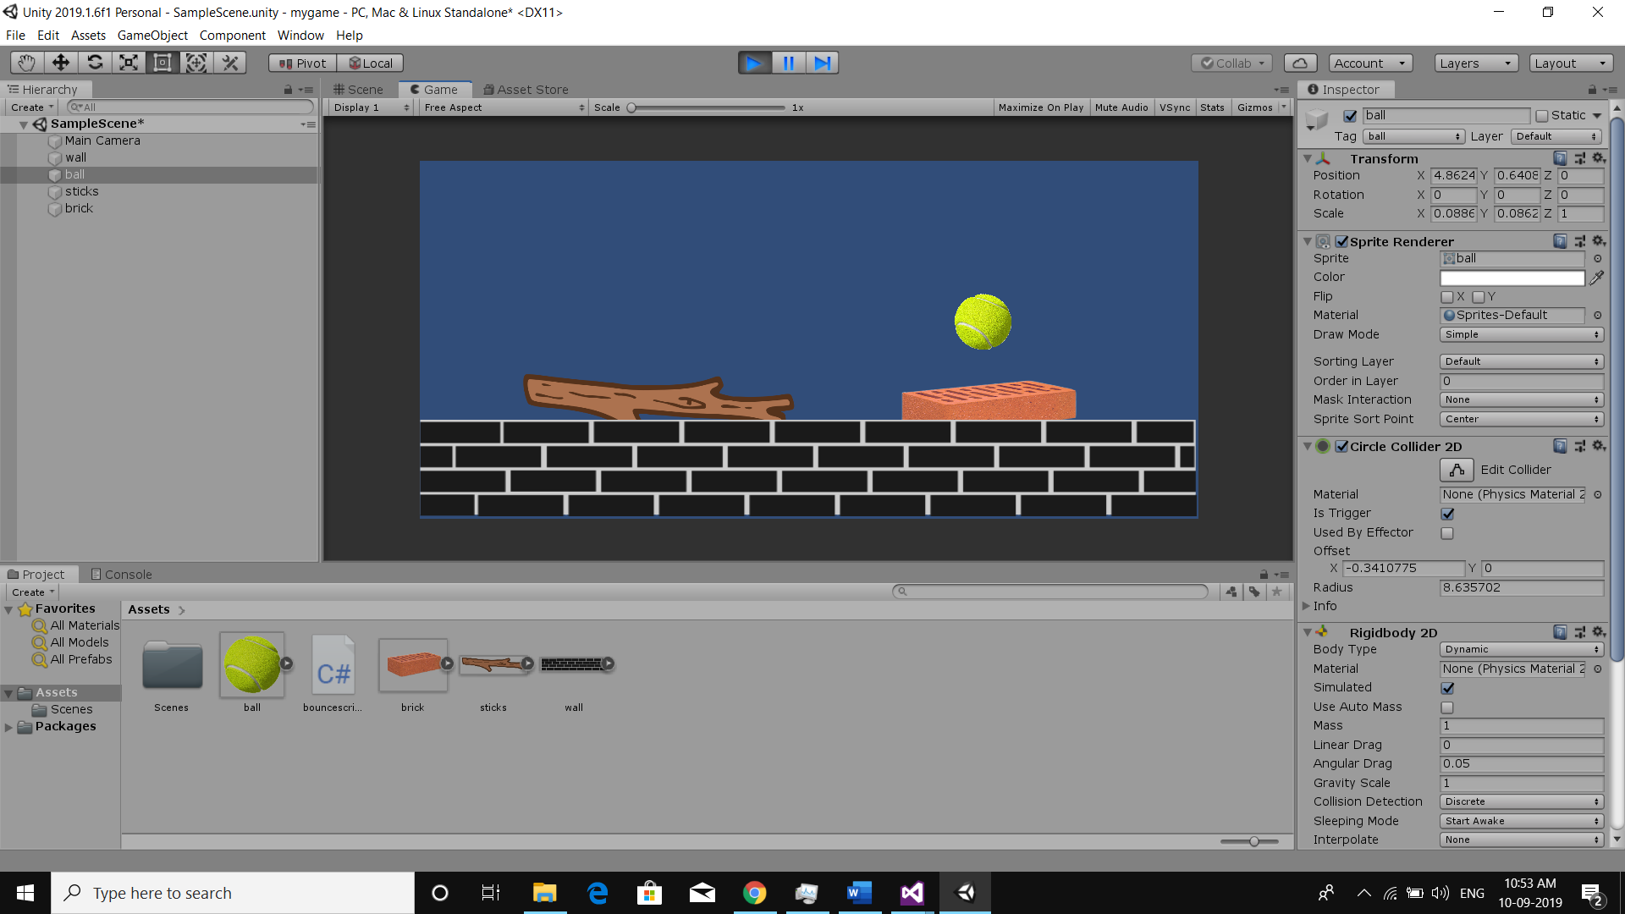

Extra Practical 2

**AIM : Creating a 2D game in unity in which coins should be collectable from human player object**

**Step 1) Open a unity and create a new project named mygame1**



**Step 2) Create a folder in the project window : myAssets**

Copy and Paste the assets into the myAssets folder

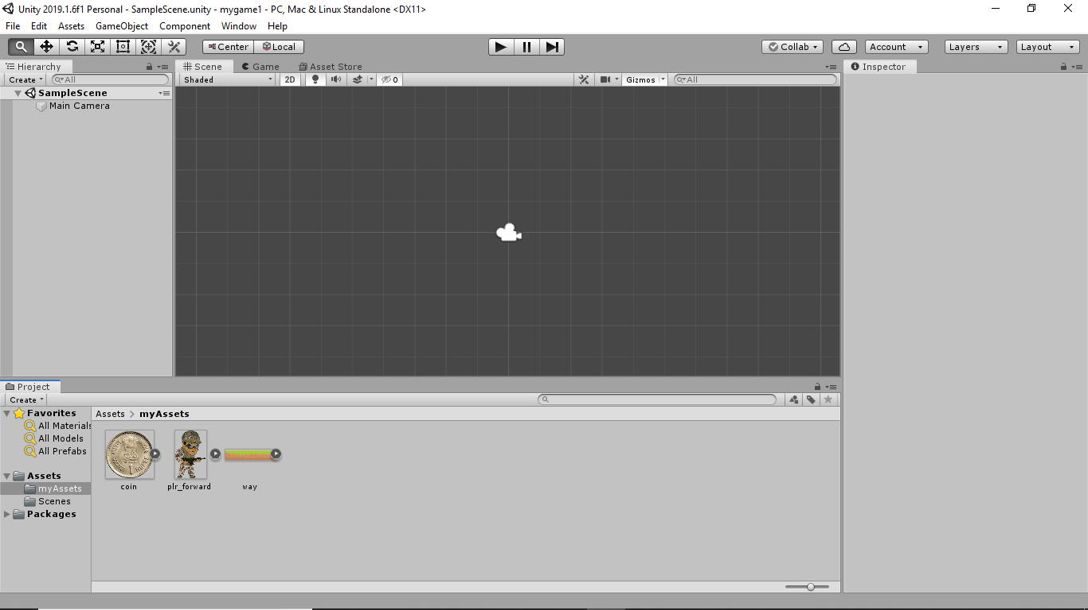

**Step 3) Now Drag and Drop all the three Assets in the hierarchy window**

First should be way.png

Second layer should be player.

Final layer should be one rupee coin.

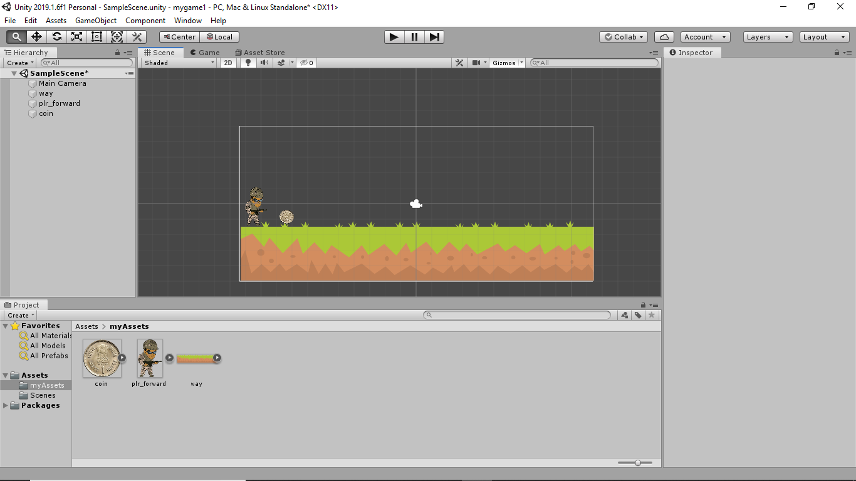

**Step 3) Add a Box Collider to first layer way.png**

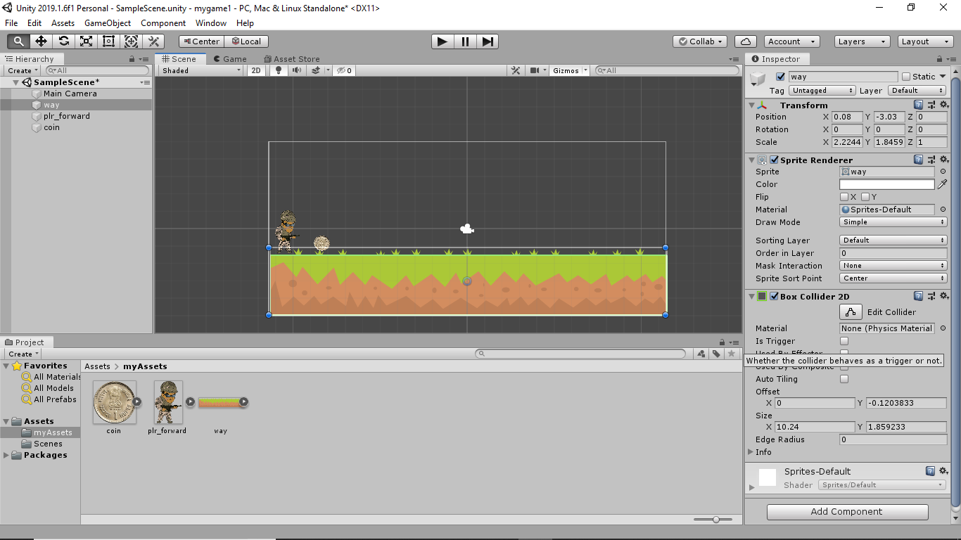

Similary add BoxCollider to player object also :

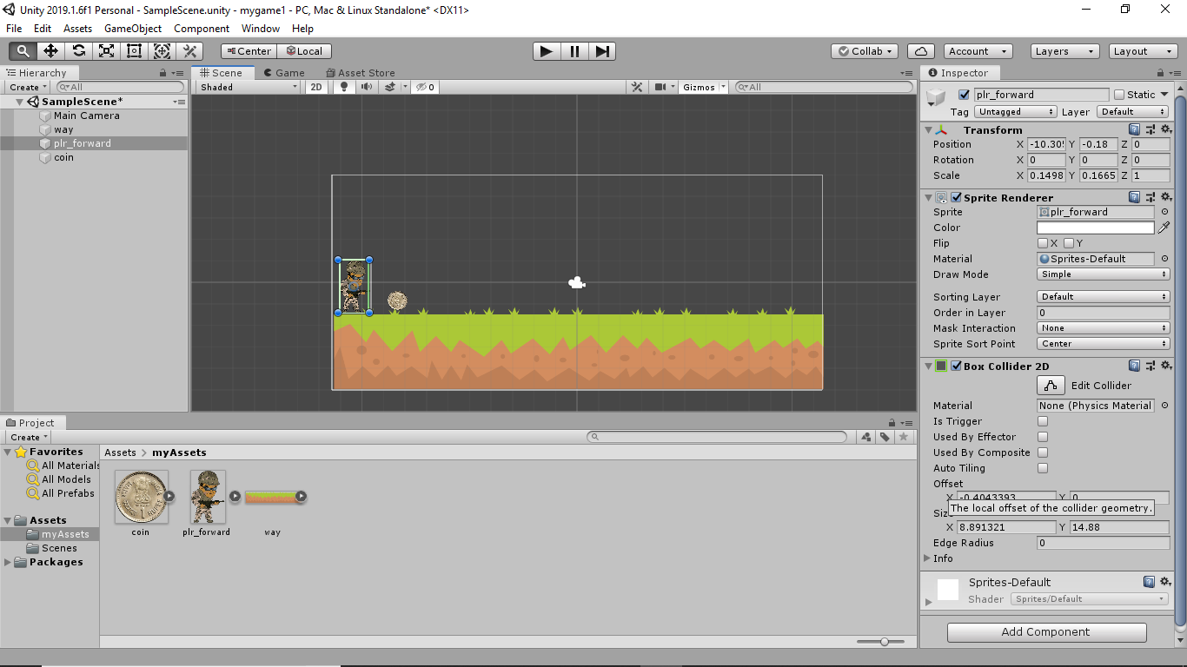

Also add Circle Collider2d to coin Game Object :

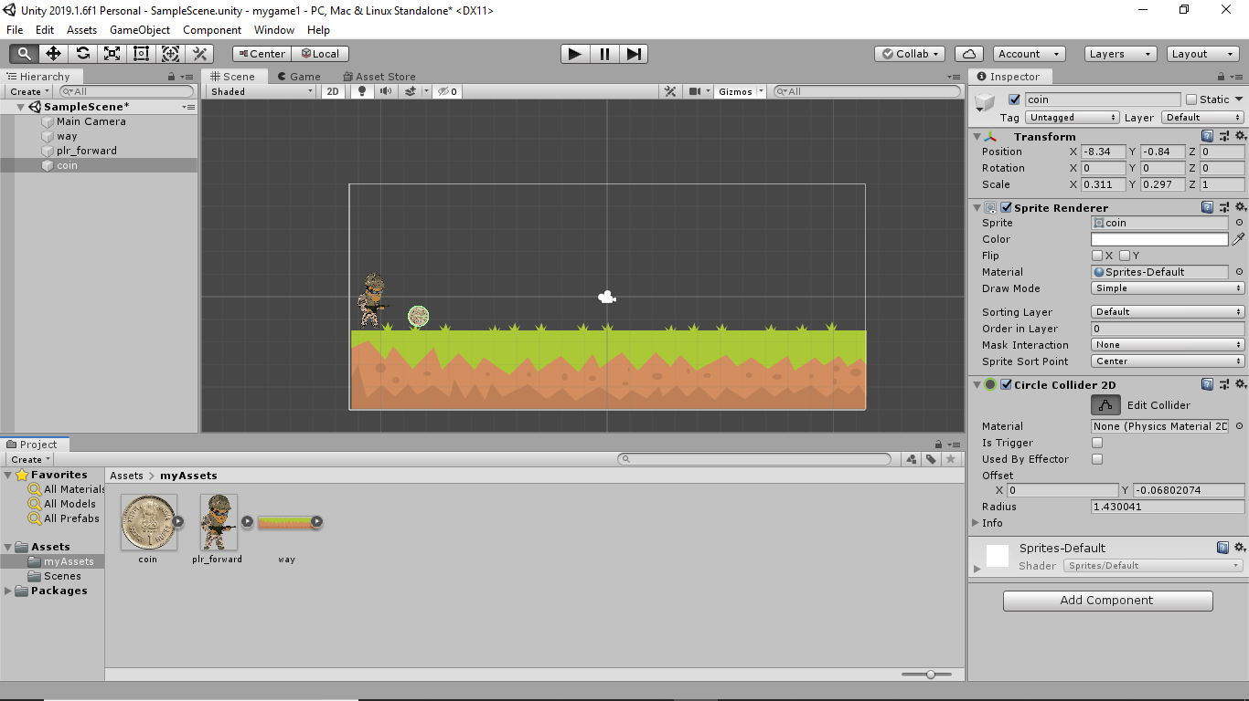

**Step 4) Create a new Scripts folder in your project and then create a c# script by right clicking…..**

Add movescript, coinscript and scorescript

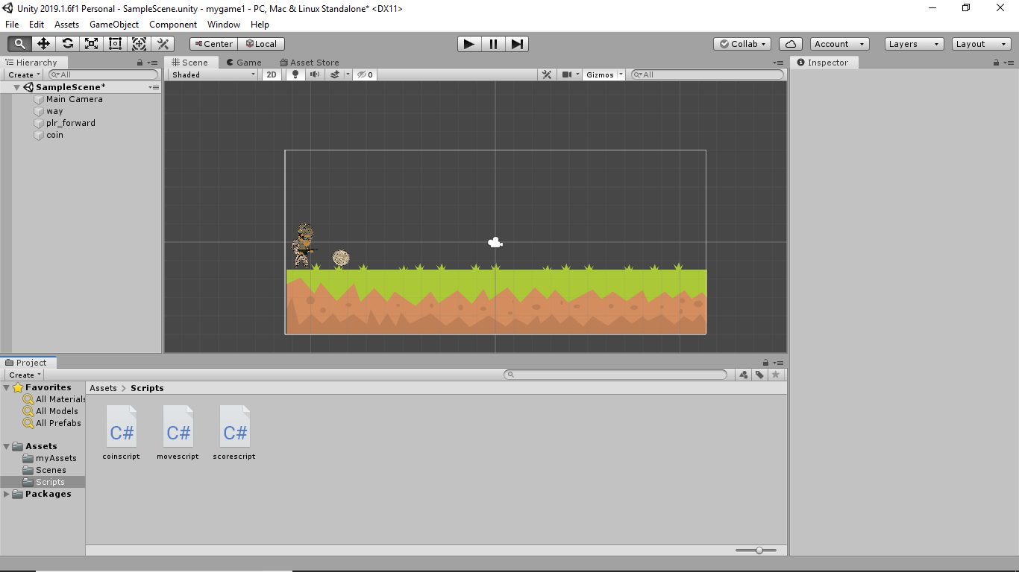

**Step 5) Add a rigidbody to the player game object and set the gravity 0 and collision as** continuous :

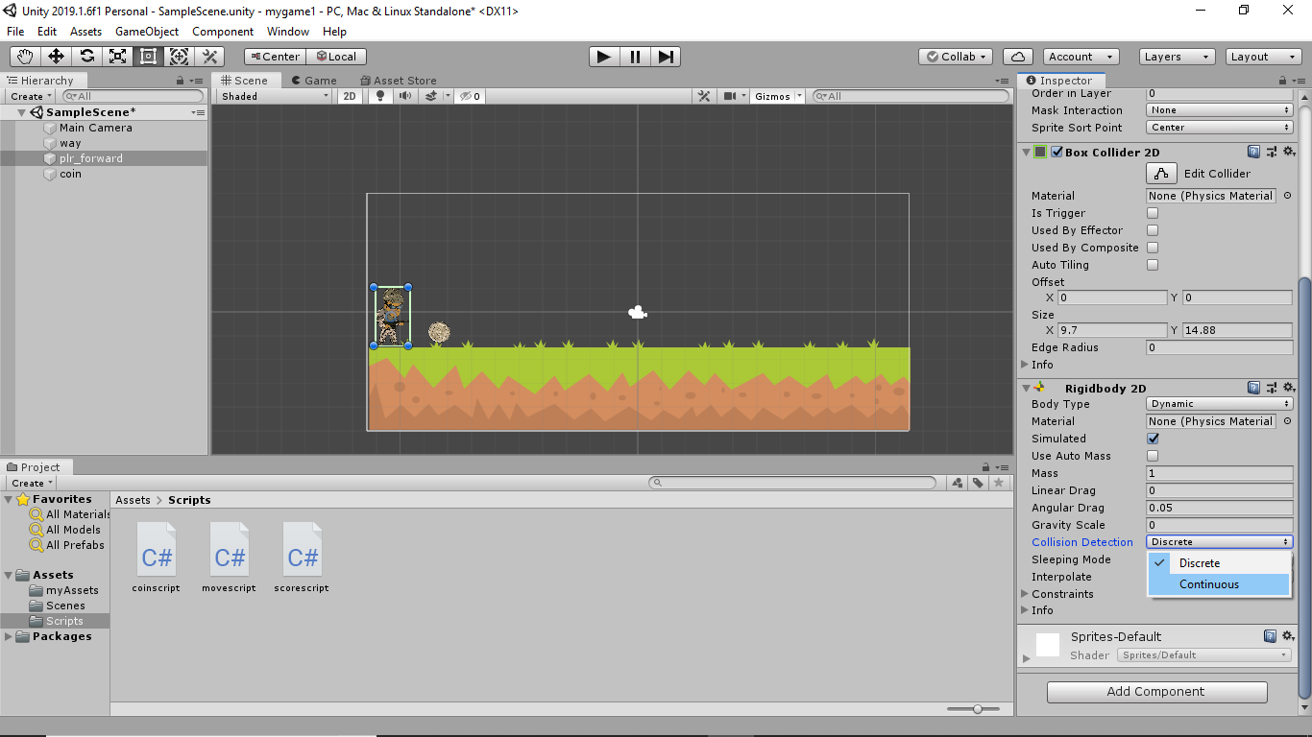

**Step 6) Now add this script file to the player object by dragging the script file onto the player object.**

**Step 7) Now add the coins .. and add the circle collider to it. Now checkmark the Is Trigger method...**

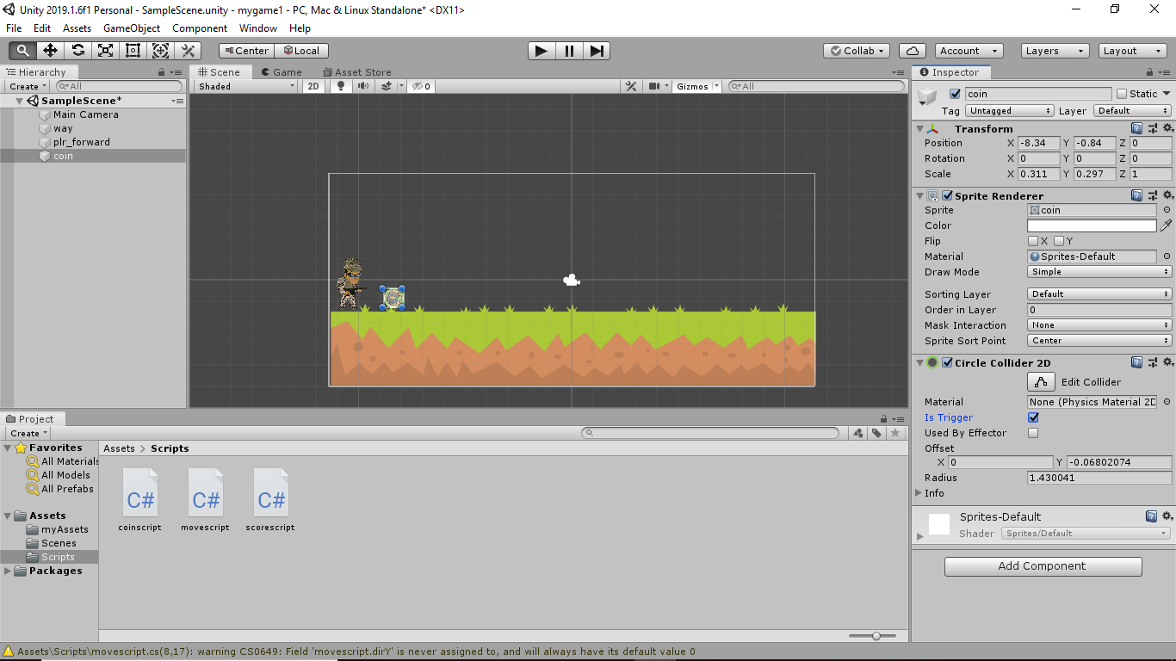

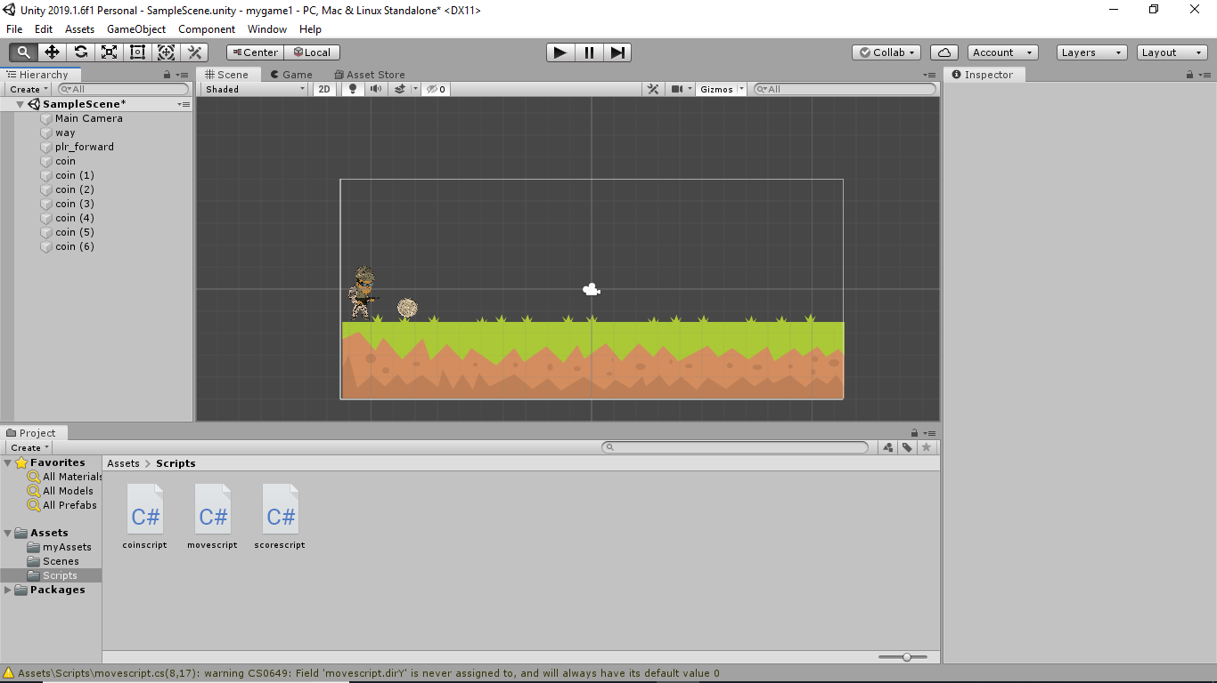

**Step 8) Now open the movescript.cs and add these lines of code**

using System.Collections;

using System.Collections.Generic;

using UnityEngine;

public class movescript : MonoBehaviour {

float dirX, dirY;

public float moveSpeed = 5f;

Rigidbody2D rb;

void Start () {

rb = GetComponent＜Rigidbody2D＞();

}

void Update () {

dirX = Input.GetAxis("Horizontal");

dirX = Input.GetAxis("Vertical");

}

void FixedUpdate() {

rb.velocity = new Vector2(dirX * moveSpeed, dirY * moveSpeed);

} }

Step 7) Now add the coinscript.cs file to each and every coin gameobject. Then copy paste it like this... and arrange them sequentially...

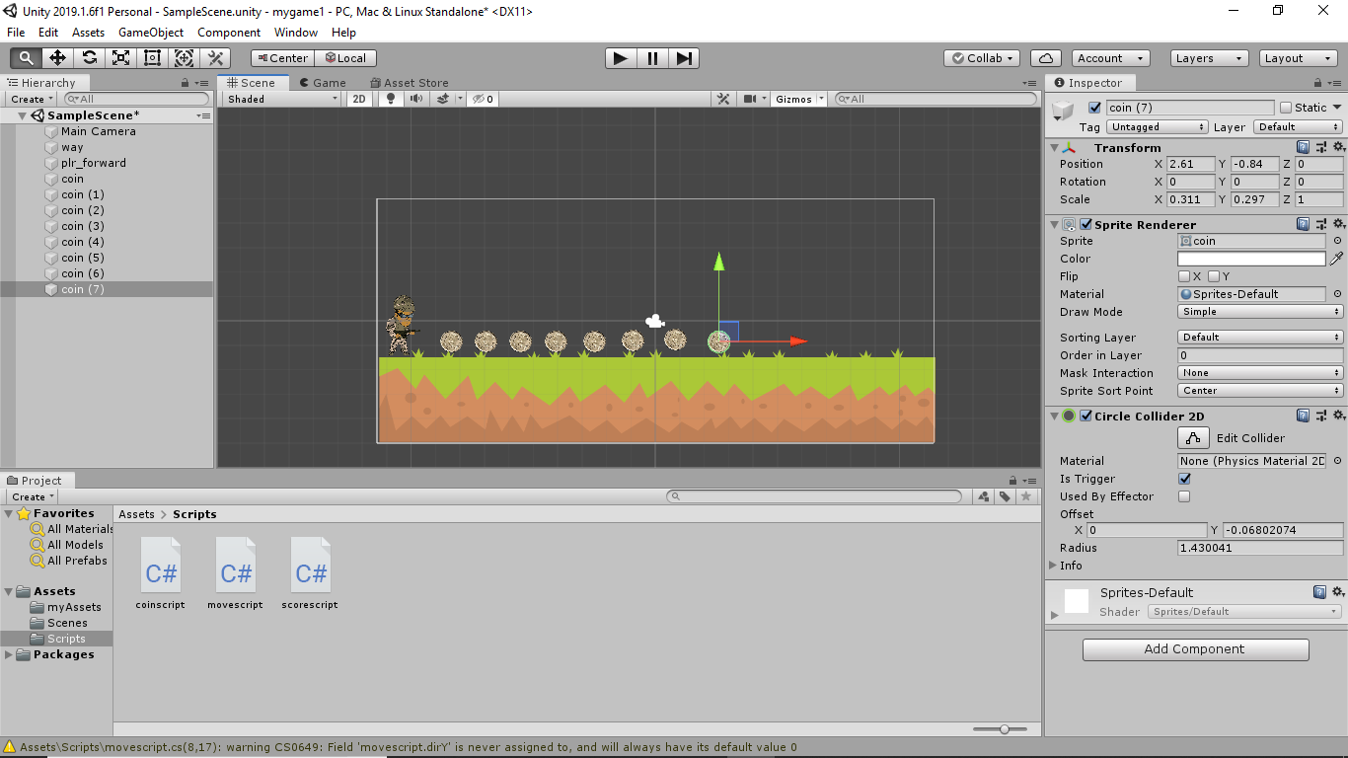

**Step 8) Open the coinscript.cs file, remove the predefined methods and add the following lines of code**

void OnTriggerEnter2D(Collider2D col)

{

scoreScript.coinAmount+=1; Destroy(gameObject);

}

**Step 9) Now create a text right click and adding the UI ＞ Text then align it as shown... and set the color as white and fontsize as 30 and alignment as center.**

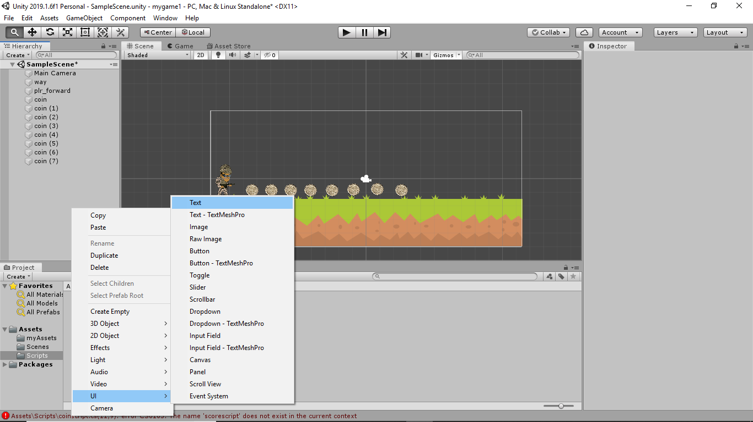

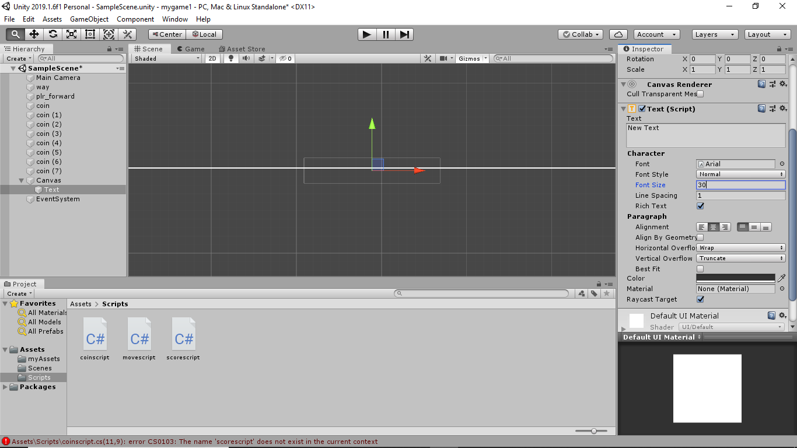

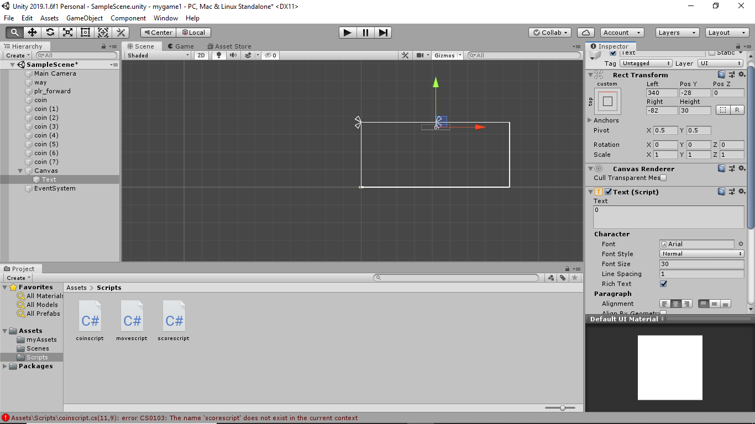

**Step 10) Add image**

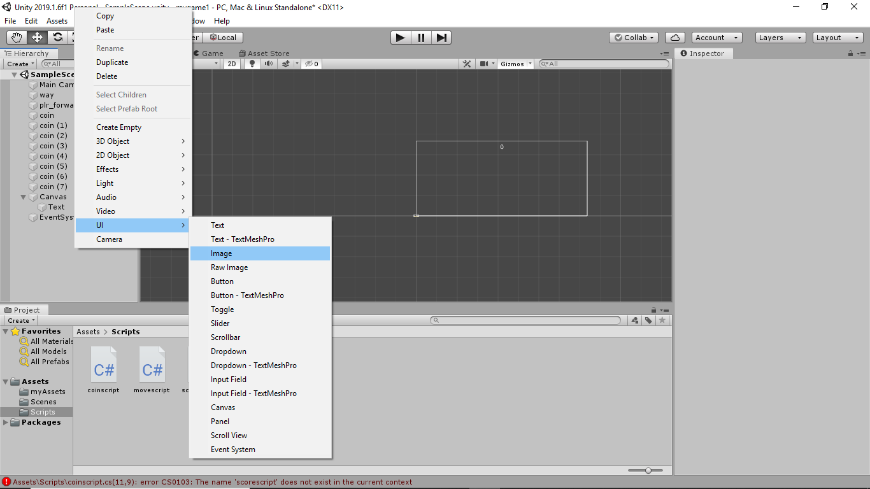

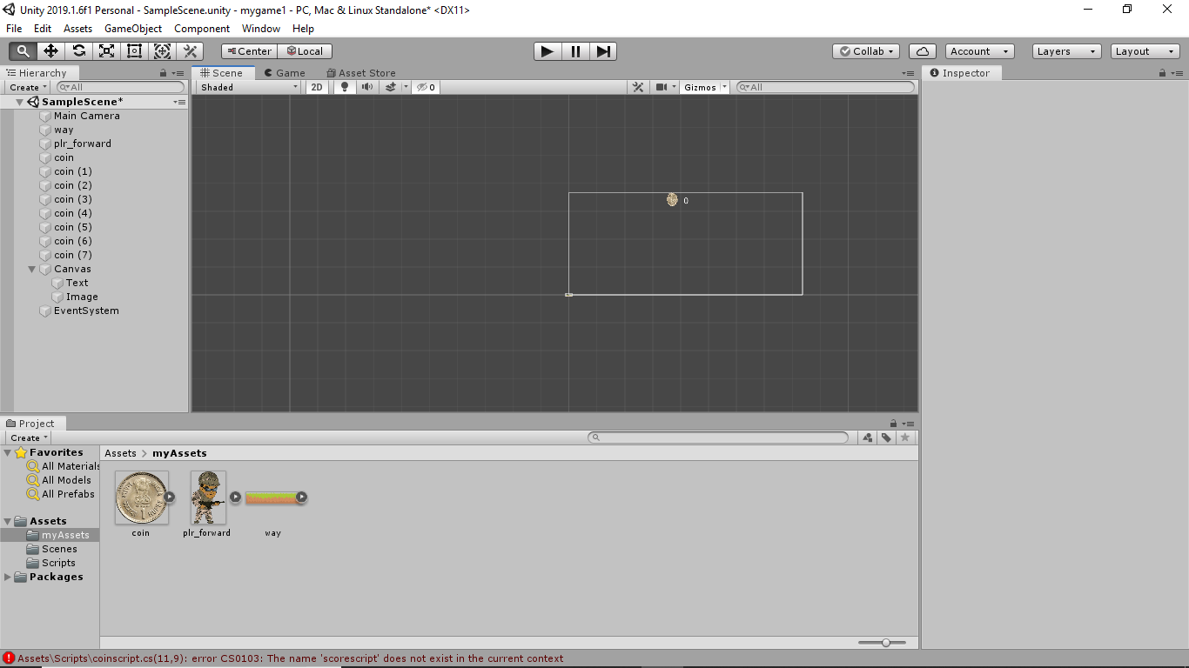

**Step 11) Now open scorescript.cs add the following line of code**

using System.Collections;

using System.Collections.Generic;

using UnityEngine;

using UnityEngine.UI;

public class scorescript : MonoBehaviour

{

Text text;

public static int coinAmount;

void Start () {

text = GetComponent＜Text＞();

}

void Update () {

text.text = coinAmount.ToString();

} }

**Step 12) add coinscript to all coins and scorescript to text gameobject..**

**Step 13 ) Now run the game to check use W and S to move forward and backward or else UP and DOWN arrow key too...**

